Engineering Village
Printed Documentation
Table of Contents
Engineering Village Overview 1
Combined Databases 2
Content Sources 9
Additional Search Sources 9
Intute 9
esp@cenet 9
GlobalSpec 9
Scirus 9
USPTO Patents 10
IHS Standards 10
LexisNexis News 10
CBNB 11
Chimica 12
EnCompass Bulletins 13
EnCompassLIT 14
EnCompassPAT 14
GEOBASE 16
GeoRef 17
Inspec 18
Inspec Archive 19
NTIS 20
PaperChem 21
Account Login 23
Account Registration 25
Ask an Expert 27
Autostemming 31
Blog This! 33
Boolean Operators 35
Browse Indexes 37
Case Sensitivity 41
CBNB Search Fields and Limits 43
Chimica Search Fields and Limits 47
Cited by Count from Scopus 51
Compendex and Engineering Index Backfile Search Fields 53
Compendex and Engineering Index Backfile Search Limits 65
Content Sources Introduction 69
CRC ENGnetBASE 71
Creating Groups 73
Date Limits 77
Deduplication Feature 79
Easy Search 81
eBook Search 83
Referex Search Results 85
Ei Patents 91
Ei Patents Search Limits 92
EnCompassLIT Search Fields and Limits 93
EnCompassPAT Search Fields and Limits 101
Engineering Index Backfile-Specific fields 107
Exact Phrase Searching 109
Executing the Search 111
Expert Search Fields and Field Codes 115
Faceted Searching on Patent Information 120
Facets' Export 123
Facets Graphs 124
Full-text Links 127
Further Assistance 129
GeoRef Search Fields and Limits 133
The following fields are searchable in GeoRef: 133
Including & Excluding Terms 137
Indexes 141
Inspec and Inspec Archive Search Fields 143
Inspec and Inspec Archive Search Limits 150
Lead-in and Prior terms 153
Limits 155
Linda Hall Library Document Delivery Service 157
Link to Local Holdings 159
Locating Terms 161
Managing Your Results 163
Mapping tool 165
NTIS 169
OpenURL Link Resolvers 173
Options 175
PaperChem Search Fields and Limits 177
Patents Results Sorting 183
Proximity/Near Operator 185
Quick Search 187
Record Attributes 189
Referex Keyword Cloud 191
Referex Search Fields 193
Referex Search Overview 195
Refine Within Easy Search 197
Refine within Quick Search or Expert Search or Thesaurus Search 199
Reset 203
RSS Feature 205
Scope Notes 207
Search History Features 209
Search Overview 213
Search Results 215
Searching Fields and Limits Introduction 217
Select Database 219
Select Thesaurus 221
Selecting Terms 223
Session Information 225
Software Requirements for Viewing Referex eBook Content 227
Sorting From the Search Form 229
Sorting Results 231
Special Characters 233
Stop Words 235
Tagging a Record 237
Introduction to Tags & Groups 241
Thesaurus Search 243
Top Terms 245
Update Account Information 247
USPTO Patent Search 249
View the Patents Records 255
Viewing Tags and Groups 261
Viewing your Referex Results 262
Wildcards and Truncation 267
Glossary 268
Index 273

Engineering Village Overview
Engineering Village is the information discovery platform of choice for the engineering community. In a single interface, researchers get access to today’s most important engineering content.
Engineering Village links to multiple engineering literature databases from a range of trusted sources: Scholarly journals, trade publications, patents, government reports, reference books, conference proceedings, and more. Hyperlinked records and full-text links give researchers meaningful results through a more comprehensive view of the information. Powerful search tools plus an intuitive user interface boost research productivity.

Combined Databases
Searching both patents and bibliographic information
When you select patent database(s) and bibliographic database(s) you will notice the following changes in your search screen:
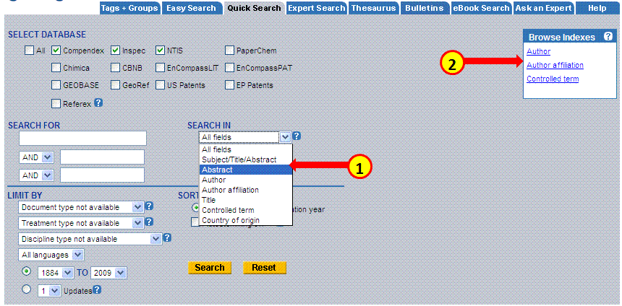
1. Search In Fields: this option will now have the following fields available for searching:
Subject/title/abstract - search key words in the records subject field, title or abstracts.
Abstract - search key words in the abstract only
Author (inventor) - use a key word search for an author name or inventor name
Author affiliation (assignee) - use a key word search for an author affiliation or assignee (institution or company the author belongs to)
Title - search key words in titles
Controlled term - use a key word search for a controlled term (index term)

2. Indexes: the indexes presented in a combined search are author / inventor, author affiliation/ assignee. When searching these indexes you will be able to conduct a search on author and inventor names as well as assignee and affiliation names. These indexes accommodate both patent data and bibliographic data.

Facets change
When you search patents and bibliographic information together, the facets for refining your search change accordingly and will accommodate data retrieved from the different databases. The facets that will change are:
1. Databases
This facet reveals how many records were retrieved from each of the databases that you selected for your search. You can refine your search by selecting one or more databases and including or excluding them from your search. The number in brackets identifies how many records were retrieved.
2. Author/inventor In a combined patent / bibliographic search, this facet will now contain the most prominent authors as well as inventors.
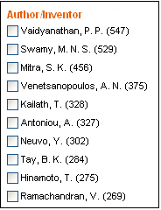
Notes:
- When selecting an author/ inventor whose publications are found within one type of database (i.e. patents or bibliographic), the facets will automatically change accordingly. For example, if you select an author that only appears in the Compendex database and doesn't have any patents records, the facets on your search result screen will show only those that are applicable to Compendex omitting any facet that is derived from the patents databases.
- In order to go back and see the patents' facets, you will have to delete that author/s from your search by clicking the red 'x' sign next to the added author/s name/s.
Author affiliation/assignee
In a combined patent / bibliographic search, this facet will now contain the most prominent institutions and companies publishing patents or other scientific documents on the searched topic.
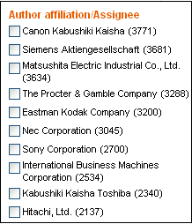
In order to discover if the institution or company published mostly patents or other publications, select the name/s and include them in your search. From the search results page you will be able to sort by 'source'. The source will contain either the bibliographic database/s or the patent database/s.
Document type
This facet reveals what types of documents were mostly published on the topic. The number in brackets is the number of records retrieved for each from the document type. From this list you can isolate certain types of documents to be searched by selecting them and including them in your search. You can select more than one document type to be included or excluded from your search.
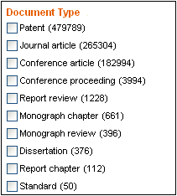

Combined Search Fields
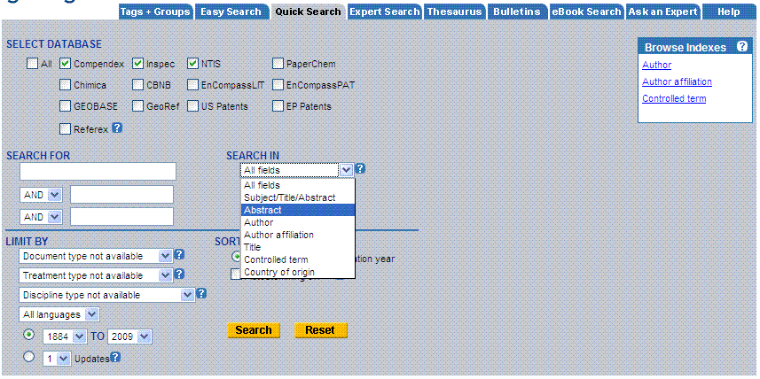
Combined searches allow you to search multiple databases simultaneously and remove duplicate records. The databases available are determined by the subscriptions held by your institution.
The fields available depend on the databases selected. Only fields that are common to all available databases will be searchable in Quick Search. For example, CODEN is not available in NTIS so will not appear in the Search In drop-down menu for any combination of databases containing NTIS.
In Expert Search, the Search Codes box contains an amalgamated list of all search codes from all databases, with a letter identifying the source database: C for Compendex, I for Inspec and N for NTIS. These help identify which fields are available in each database; e.g. Accession number (C,I,N) for a field common to all three, or Monitoring agency (N) to designate a field unique to NTIS, which would return zero hits in Compendex and Inspec.
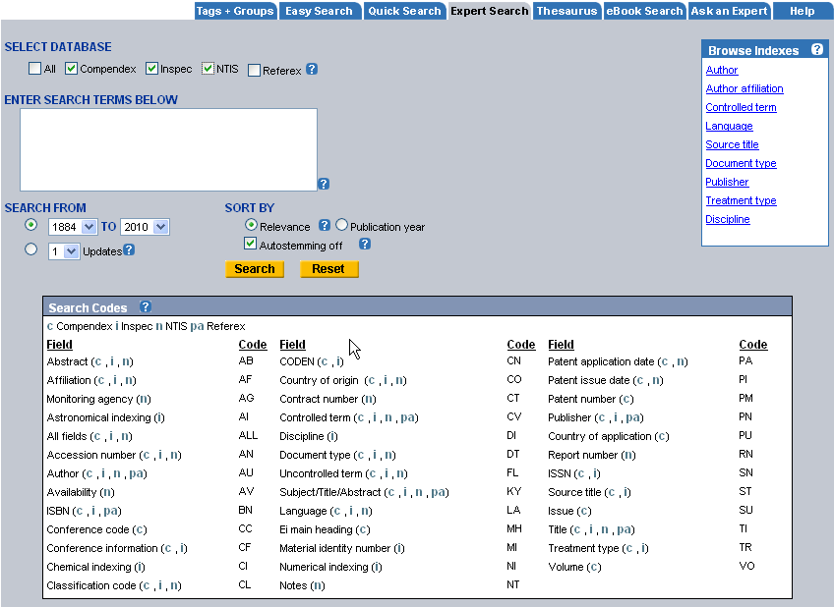
It is important to remember that the different databases have different policies, or may contain different information, for similar fields. For example, author names in Compendex may contain the author's first and middle name, while in Inspec, only initials are used for first and middle names. The controlled terms for Compendex, Inspec and NTIS may not be the same. Each database also has its own classification codes. The field descriptions for each database should be consulted.

Combined Search Limits
The limits provided are restricted to limits common to combined databases, e.g. publication year, language, etc.
The search limits for each database should be consulted.

Browse Indexes
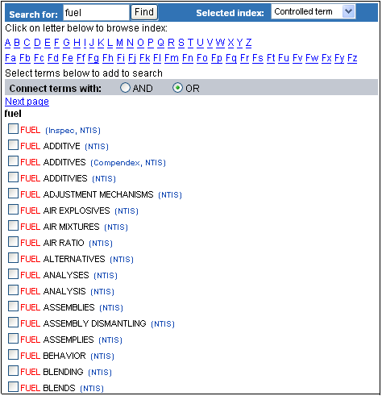
The Browse Indexes help you select appropriate terms for your search.
The Browse Indexes provided are restricted to indexes common to combined databases.
The Browse Indexes for combined searches have the database containing terms indicated after each entry.
The field preference takes precedence over the database preference. If, for example you select 'Full text' from the field preference and 'Compendex' from the Database preference and there are no full text records in Compendex, the system will retrieve full text records from Inspec although Compendex was your preferred database.

Content Sources


Additional Search Sources

Intute
Intute: Science, Engineering and Technology offers a free, easy to use and powerful tool for discovering the best Internet resources for teaching, learning and research, covering the physical sciences, engineering, computing, geography, mathematics and environmental science.
Intute: Science, Engineering and Technology has been created by bringing together three of the Hubs of the Resource Discovery Network (RDN): EEVL (Engineering, Mathematics and Computing), GEsource (Geography and Environment), and PSIgate (Physical Sciences).

esp@cenet
esp@cenet provides access to patents produced by national patent offices in Europe as well as the European Patent Office (EPO), the World Intellectual Property Organization (WIPO) and Japan.
Further information on this database is available at http://ep.espacenet.com.
Most of the patent data goes back to 1970. Some of the patenting agencies provide patent images going back to 1920.
esp@cenet is produced by the European Patent Office.

GlobalSpec
GlobalSpec is a leading business-to-business Web site, http://www.globalspec.com, which connects engineers and technical buyers with products and services they need. GlobalSpec leverages the Internet, searchable database technology, and engineering specifications to provide extensive search capabilities for engineers and technical buyers worldwide. Visit the GlobalSpec website for more information on this resource.

Scirus
Scirus is the most comprehensive science-specific search engine available on the Internet. Driven by the latest search engine technology, it enables scientists, students and anyone searching for scientific information to pinpoint data, locate university sites and find reports and articles quickly and easily.
Use Scirus to retrieve results from all science and science-related sites on the Worldwide Web, including access-controlled sites. Scirus covers science-related Web pages, as well as sources such as ScienceDirect, MEDLINE on BioMedNet, US Patent Office, E-Print ArXiv, Chemistry Preprint Server, Mathematics Preprint Server, CogPrints and NASA.
Scirus is produced by Elsevier.

USPTO Patents
The United States Patent and Trademark Office (USPTO) offers access to its full text patent database. Full text patents are available from 1790 to date, with weekly updates. Further information on this database is available at the USPTO Web site, http://www.uspto.gov/patft/index.html

IHS Standards
IHS Global allows you to search the world's largest collection of technical standards from over 460 standard developing organizations. Over 500,000 standards are available for electronic download. Standards are searchable by document number, title, keyword or standard developing organization. Standards can be ordered by credit card. Users should check with their library to determine if the standards are already available.

LexisNexis News
LexisNexis provides press releases related to engineering. The site is updated daily. Use the search box to find articles containing specific words or phrases. You can search for a single word or phrase, or use the connectors AND or OR to join search words and identify the relationship between them. Titles are hyperlinked. Clicking the hyperlink will retrieve the press release.

CBNB
Chemical Business NewsBase (CBNB) contains news, in-depth commentary and insightful analysis on the chemical industry and its allied end-user sectors. The leading provider of worldwide chemical business news and information, CBNB covers over 300 core trade journals, newspapers and company newsletters, market research reports, annual and interim company reports, press releases and other “grey literature” sources.
CBNB gives you access to financial information from the most influential chemical companies, the latest chemistry R&D news, information on current and upcoming changes to government legislation and analysis of economic trends that will affect the chemical industry.
Search for facts, figures, views, and comments on the chemical industry worldwide, from 1985 to the present. CBNB is updated weekly.

Chimica
Chimica provides access to over 600 of the most influential international journals related to chemistry and chemical engineering. Chimica provides exceptional focus on applied and analytical chemistry, and extends to cover physical chemistry, health and safety, organic and inorganic chemistry, and materials science.
Each title is carefully selected to enhance your research process and bring you quality results. Coverage in Chimica starts in 1970.

EnCompass Bulletins
In addition to EnCompassLIT and EnCompassPAT, EnCompass Bulletins are also available. Sent weekly via email, subscribers can choose particular areas of interest for updates on additions to the database--a great way to keep up-to-date on trends.
EnCompassLIT Bulletins:
• Automotive
• Catalysts/Zeolites
• Fuel Reformulation
• Health and Environment
• Natural Gas
• Oil Field Chemicals
• Petroleum Refining and Petrochemicals
• Petroleum Substitutes
• Transportation and Storage
• Tribology
EnCompassPAT Bulletins:
• Catalysts/Zeolites
• Chemical Products
• Environment Transport and Storage
• Fuel Reformulation
• Oil Field Chemicals
• Petroleum Processes
• Petroleum and Specialty Products
• Petroleum Substitutes
• Tribology

EnCompassLIT
EnCompassLIT™ is a bibliographic database specifically devoted to covering technical literature published worldwide on the downstream petroleum, petrochemical, natural gas, energy and allied industries. Upstream coverage focuses solely on oil field chemicals. The EnCompass Thesaurus facilitates precision searching via controlled vocabulary, meaning that all records in EnCompassLIT™ are specially indexed for accurate, relevant results.
Dating back to 1964, EnCompassLIT covers over 1500 scientific journals, trade magazines, conference papers and technical reports from 20 countries, in 10 languages. The EnCompass Source Guide has a section listing Publications by Category, Country of Publication Index, as well as information about the year EnCompass coverage began, title changes, and scope of coverage for each publication. The database contains over 860,000 records and more than 25,000 records are added annually. EnCompassLIT is updated weekly.

EnCompassPAT
EnCompassPAT is the most authoritative patent database uniquely devoted to covering worldwide patents on the downstream petroleum, petrochemical, natural gas, energy and allied industries. All patents are specially selected by experts and indexed based on the EnCompass Thesaurus, facilitating precision searching via controlled vocabulary for accurate, relevant results.
EnCompassPAT database back to 1964 and contains over 450,000 records, and contains especially selected patents from 40 patenting authorities throughout the world, indexed on the basis of the EnCompass Thesaurus. More than 22,000 records are added annually, in weekly updates.
The following sections from the Derwent World Patents Index (DWPI) are the sources of patent abstracts:
Chemical Patents Index (since 1972):
Section A: (Polymers and Plastics)
Section D: (Food, Detergents, Water Treatment and Biotechnology)
Section E: (General Chemicals)
Section H: (Petroleum)
Section J: (Chemical Engineering)
Section M: (Metallurgy)
General & Mechanical Patents Index (since 1972, only US, GB & EP patents):
Section P: (General)
Section Q: (Mechanical)
The DWPI basic (alert) abstracts are used to make selections for electronic Patent Abstract bulletins and EnCompassPAT; the corresponding Derwent documentation abstracts, which contain more detailed information, are used for indexing.
From 1964-71, abstracts were written at EnCompass from copies of the original patents or from patent abstracts where available. From countries other than the US, abstracts were based on information in the official journal of the patent office, which sometimes was no more than the title of the patent plus names and dates .In the past, CAS abstracts were indexed for the countries for which Derwent did not write abstracts.

GEOBASE
GEOBASE is a multidisciplinary database of bibliographic information and abstracts that deeply indexes research literature across the earth sciences including geology, human and physical geography, environmental sciences, oceanography and geomechanics. Spanning over 25 years (1980-present) of research literature, GEOBASE addresses increasingly important environmental issues such as alternative energy sources, pollution, waste management and nature conservation. Covering over 2,000 titles including peer-reviewed journals, trade publications, book series and conference proceedings, GEOBASE has the most international coverage of any database in the field, covering publications from over 60 countries. Updated weekly, GEOBASE contains 1.8 million records with over 100,000 new records added annually.

GeoRef
GeoRef is a database of abstracted and indexed geosciences literature published by the American Geological Institute (AGI). GeoRef provides a comprehensive history of geology and its subfields with expertly indexed records from over 3,500 scholarly journals, books, maps, and conference proceedings. In addition, the database includes all publications of the US Geological Survey and masters’ theses and dissertations from United States and Canadian universities.
GeoRef gives researchers access to the information they need to efficiently evaluate geology and its role in the context of history, economics, engineering, and more. Unique to Engineering Village, GeoRef offers a new results-based mapping tool that plots geographical features from a result set onto a digital map, providing both context and insight into search results.
GeoRef contains over 2.9 million abstract records over 200 years of geological literature from North America (1785-present), plus 75 years of geological literature from the rest of the world (1933-present). GeoRef's accurate, relevant records are indexed specifically for geosciences research using controlled vocabulary from the GeoRef Thesaurus. GeoRef is updated weekly and there are 90.000 new records that are added annually.

Inspec
Inspec is a leading bibliographic database providing access to the world's scientific literature in electrical engineering, electronics, physics, control engineering, information technology, communications, computers, computing, and manufacturing and production engineering. The database contains over 11.2 million bibliographic records from scientific and technical journals and conference proceedings. Approximately 600,000 new records are added to the database annually.
Online coverage is from 1969 to the present, and records are updated weekly. Inspec is produced by the Institution of Engineering and Technology (IET).

Inspec Archive
The Inspec Archive provides access to historical scientific records in the fields of physics, electrical engineering, electronics computing, and control engineering. With the digitizing of the entire collection of Science Abstracts Journals, which were the precursors to the Inspec database, librarians, academics, and students are provided access to nearly one million abstract records spanning the years 1898 through 1968.

NTIS
The National Technical Information Service (NTIS) database from the U.S. Department of Commerce is the premier source for accessing unclassified reports from influential U.S. and international government agencies. The database contains access to over two million critical citations from government departments such as NASA, the U.S. Department of Energy and the U.S. Department of Defense. More information is available from: http://www.ntis.gov/products/ntisdb.aspx
The database also includes audiovisual training materials in such areas as foreign languages, workplace safety and health, law enforcement, and fire services.
The database is updated weekly. The NTIS database was created in 1964, but the material cited in it can date back as far as 1899.

PaperChem
PaperChem is a comprehensive bibliographic database covering international literature related to pulp and paper technology. It includes abstracts of journal articles, conference papers and technical reports with more than 590,000 records.
Subjects covered are: Chemistry of Cellulose, Corrugated and Particle Board, Engineering and Process Control, Films, Foils and Laminates, Forestry and Pulpwood, Graphic Arts (prior to 1998), Lignin and Extractives, Mill Construction and Operation, Pulp, Paper and Board Pollution, Silver Chemicals and Residues, Tissue Culture, Corrosion, Economics and Research, Fiber Webs and NonWovens, Finishing and Converting, Gluing, Labeling, and Sealing, Hemicellulose, Machinery Equipment and Maintenance, Packaging, Power, Spent Liquors and Pollution Control and Water.
The database was created in 1967 but there are also some records in the database with publication years prior to 1967. Weekly updates ensure that users are kept abreast of new developments, with over 15,000 records added annually.

Referex (eBooks)
A specialized electronic reference database, Referex Engineering draws on hundreds of premium engineering books to serve as a pool of answers to your reference questions. Referex Engineering has six editorially crafted collections of professionally focused e-books that bring together key sources of reference material. Referex is fully searchable and instantly delivers full-text content of over 1,600 e-book titles across the following collections:
• Chemical, Petrochemical and Process Engineering
• Mechanical Engineering and Materials
• Electronics and Electrical Engineering
• Civil and Environmental Engineering
• Computing
• Networking and Security
Each collection includes:
• Handbooks of engineering fundamentals
• Situational reference
• Titles focused on technique and practice
• “How to” guides
• Highly specialized professional information

Account Login
You must log in to your Personal Account whenever you want to save searches, save records, or create email Alerts. At the login prompt, enter the email address and password that you provided when you registered for your Personal Account.

If you forget your password, you can submit your email address that you used creating your personal account and have the password sent to you.
If you have not already set up a Personal Account, click on the Register Now link within the Personal Account Login box on any Quick, Expert, eBook, or Thesaurus Search.

Account Registration
You can set up a Personal Account for greater control over your searches in Engineering Village. With a Personal Account, you can save records and searches and receive weekly email alerts. Email alerts are messages sent after every weekly database update that contain any new records that match a saved query.

To set up a Personal Account, click Register and enter your name and email address; choose and confirm a password between 6 and 16 characters long.

Ask an Expert
The “Ask an Expert” feature provides users with the opportunity to ask questions of either an EV Engineer, the Product Specialist, or the librarian of that user’s organization. The EV engineers are experts in chemical, mechanical, industrial, electrical, manufacturing, materials and computer-related engineering topics. All Ask an Expert services are complementary with the Engineering Village subscription.
Clicking the “Ask an Expert” tab on the www.engineeringvillage.com home page clearly displays three options of where to direct questions for a more user-friendly experience.
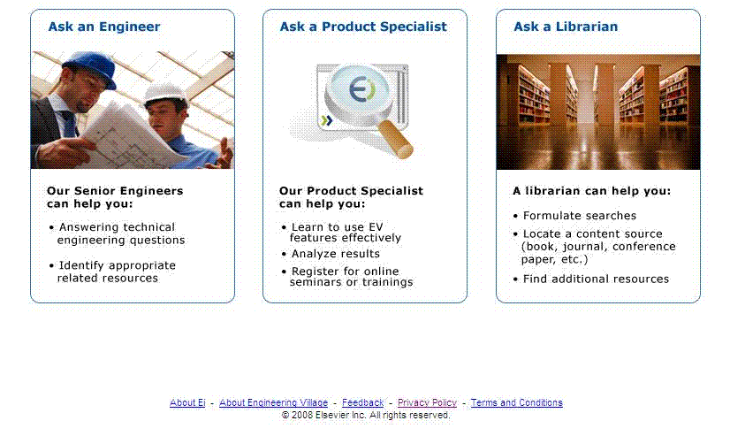
For “Ask an Engineer” inquiries, the user can choose by subject area which engineering expert to email.
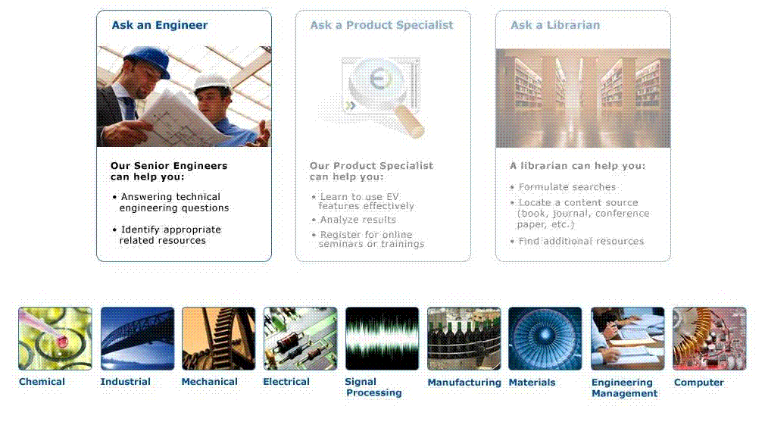
Clicking on a particular speciality will open more options within that speciality. Clicking on the names of the experts will run a search for publications and/or patents that each expert is responsible for. Clicking the terms under each engineer's "area of expertise" will open search results for that term including controlled vocabulary and/or other fields.
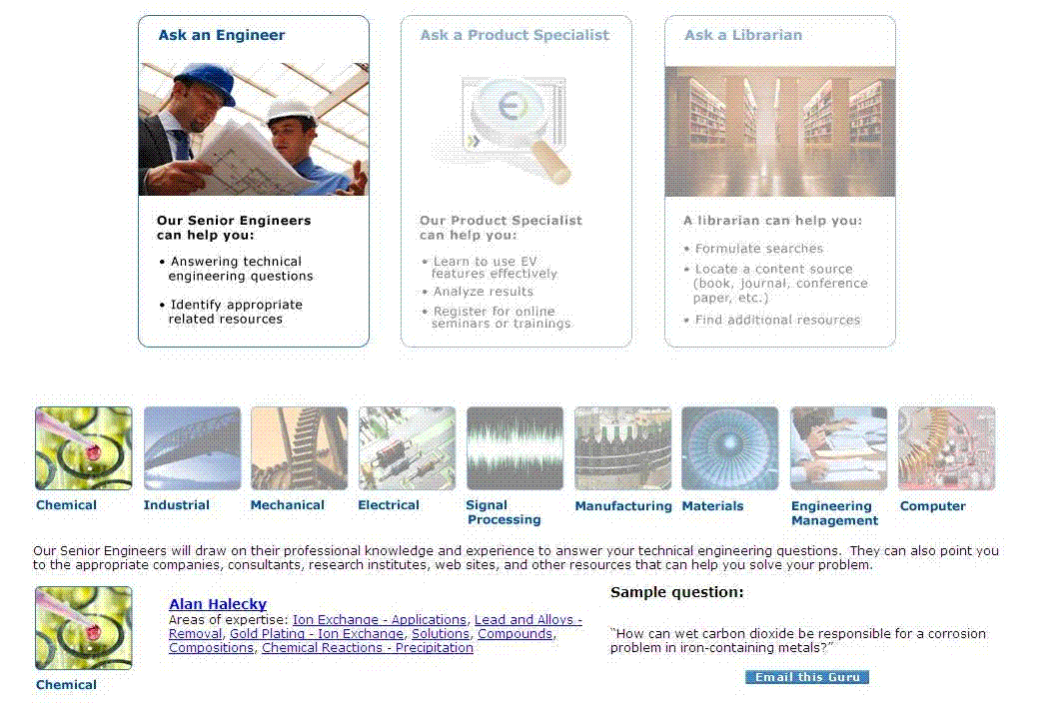
In the “Ask a Product Specialist” section, users can ask EV’s Product Specialist about how to analyze results, learn more about using EV, or link to www.ei.org to view automated product tours and/or register for trainings. There is also a list of FAQs offering further assistance.
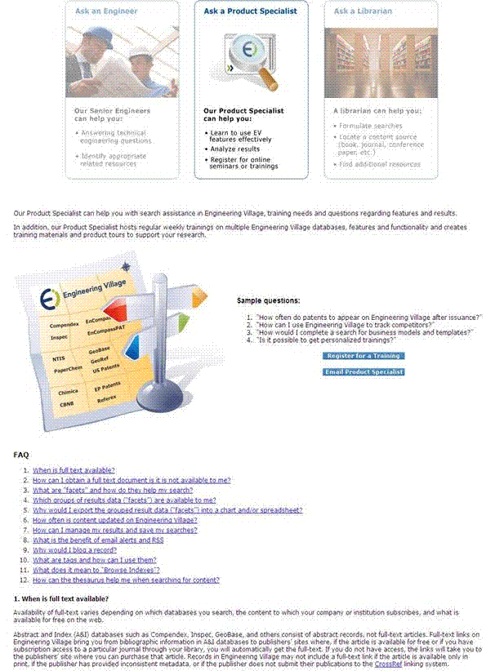
EV's Product Specialist provides regular online training sessions to customers and end users of Engineering Village. You must have simultaneous access to an Internet connection and a voice phone line to carry the audio. To sign up for a training session please click the "Register for a Training" button or contact eitraining@elsevier.com for additional details. Online seminars on Engineering Village are provided as a complementary service and are included in the library's subscription to the product.
Users who have questions about how to formulate expert searches, identify and locate a source for a book or an article, or find additional resources available at their institution or organization can contact their Librarian with one click using the “Ask a Librarian” Feature.
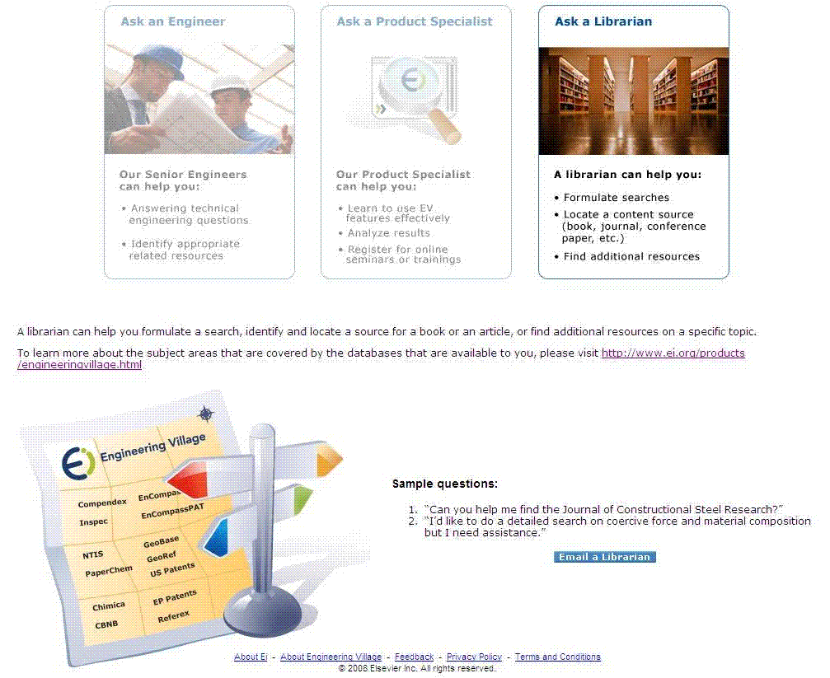
Users can also link to www.ei.org to view automated product tours by clicking on the image above.
Please note: If a customer has chosen not have the “Ask a Librarian” feature turned on or we do not have current contact information for that librarian, “Ask a Librarian” questions from that organization will be sent to the EV Product Specialist.

Autostemming
Stemming uses an algorithm that determines the suffixes of words and allows you to search for the term as entered, the root word and other words formed with other possible suffixes. For example, if you enter the term controllers, you will get results for:
controllers
control
controlling
controlled
controls, etc.
Stemming will provide you with much broader search results automatically. You would not need to search for all the variations of the word.
Stemming will not find variants between British and American spellings. For example color will not find colour or coloured. But colour will find colourful or colours. To be inclusive, in this case you would need to search for color or colour.
The system automatically Autostems all key words except for Author names and words in quotations and/or braces. If you would like to avoid this, you can select 'Autostemming off'.
In the example below, the phrase "micro computer" was put into the system, while the word 'Micro' was stemmed and "Computer" was not.
I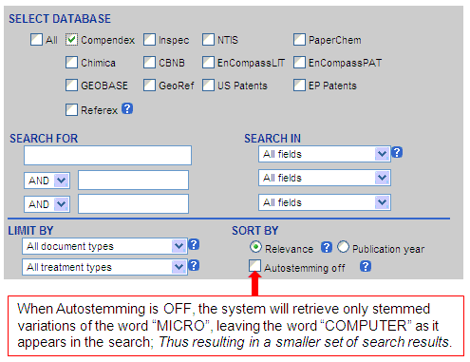

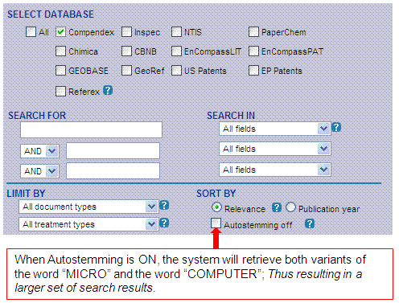

Blog This!
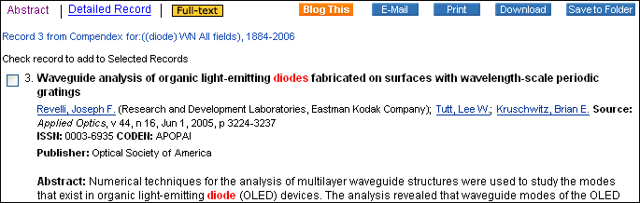
What is a Blog?
A blog is a short form for web log; a personal journal published on the Web. This is a frequent, chronological publication of personal thoughts and Web links. More information on blogs can be found at Wikipedia. There are numerous blog hosts on the internet such as Blogger.com (www.blogger.com), Blogcity (www.blog-city.com), and others.
Click the "Blog This" button and select the content that is showing in the box and paste it in your post. Once you publish your post the title of the record will appear in your blog.
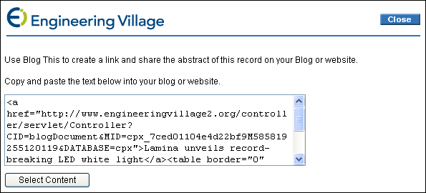
Below is a sample of a how a record looks in a blog.
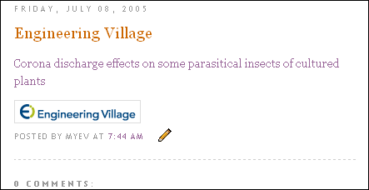

Boolean Operators
Boolean operators allow you to combine terms using the AND, OR, or NOT.
To broaden a search, or to allow for variant spellings, combine terms using OR (results contain any specified term).
To narrow the scope of a search, combine terms using AND (results contain all specified terms).
Use the NOT operator to eliminate terms from a search.

In Quick Search, terms are searched in the order of entry -- terms entered within the first box are searched first, and so on.
a AND b OR c will be searched as (a AND b) OR c
a OR b AND c will be searched as (a OR b) AND c
a OR b NOT c will be searched as (a OR b) NOT c

If you need to combine more terms within your search, use Expert Search or, alternately, use the Combine Previous Searches feature, by clicking on the
Search History tab in the top navigation.

In Expert Search, the search terms are linked using Boolean operators and searched from left to right.

Example:
Gilbert, Barrie wn AU AND Analog Devices wn AF
"Rapid transit" wn ALL or "light rail" wn ALL and signals wn TI
To broaden a search, combine terms using OR (results contain any specified term).
"rapid transit" OR "light rail" OR subways

To narrow the scope of a search, combine terms using AND (results contain all specified terms).
Example:
prosthetics AND biocontrol

To eliminate terms from a search, use the NOT operator. A search for mining might be done as:
(mines or mining) wn ky NOT "data mining" wn ky

In Expert Search, you can use parentheses to specify the order of operation. Terms and operations within the parenthesis are executed before terms and operations outside the parenthesis. Multiple parentheses can be used.
(International Space Station OR Mir) AND gravitational effects AND (French wn LA OR German wn LA OR English wn LA)

Results from this search will contain either International Space Station OR MIR plus all the records will contain gravitational effects. All of the results will be in French, German or English.

If you do not use parentheses to specify the order of operation, then the operations will be performed from left to right
Remember that if you enter a phrase without quotation marks, braces or parenthesis, AND is assumed.

Browse Indexes
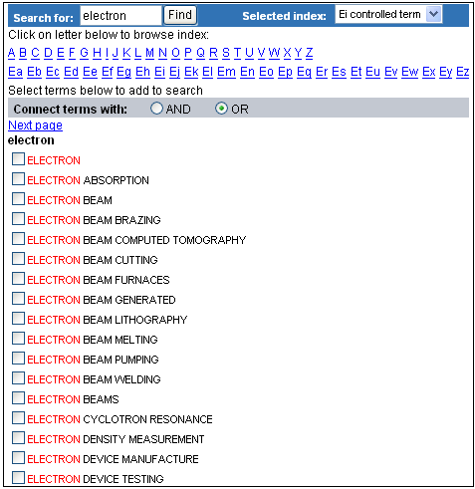
From the Browse Indexes box (located on the right side of Quick and Expert Search), select the index you wish to use by clicking on the link.
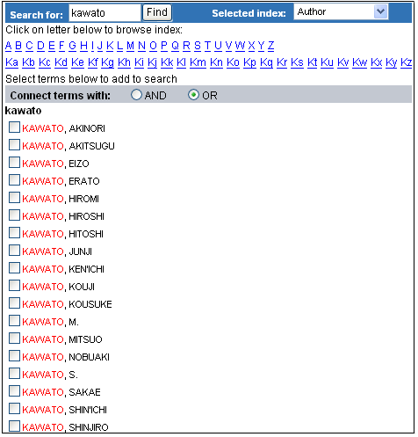
Once the index is loaded, you can navigate by either selecting the first letter(s) of the term you wish to search for or by typing in the first few letters of the term in the SEARCH FOR box and clicking on "Find."
In Quick Search, when you select a term from the index, it is automatically pasted into the first available search box. The SEARCH IN box will also be changed to the appropriate field. Un-selecting the term from the index will remove it from the search box. If you select more than three terms, the fourth term will overwrite the term in the third search box.
You can also choose to have the second and third index terms pasted from the indexes with either a Boolean AND or OR connecting them.
In Expert Search, when you select a term from the index, it is automatically pasted into the search box with the wn (within) command and the field code. You can select as many terms as needed.
The Author Browse Index is useful for searching on author names, especially for
searching for authors with very common surnames. For example:
Searching on author Alan Smith, as Smith, A* will retrieve records by other authors such as Smith, Albert or Smith, Alex.

Ei Patents Indexes
When searching the patents databases alone, two indexes are available:
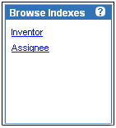
Inventor - This field contains the inventor(s) names of patented item. You can search the index for a specific inventor by typing in the first letters of the name and clicking find. Next to each name, the patent database will be indicated in brackets i.e. US patent or European patent.
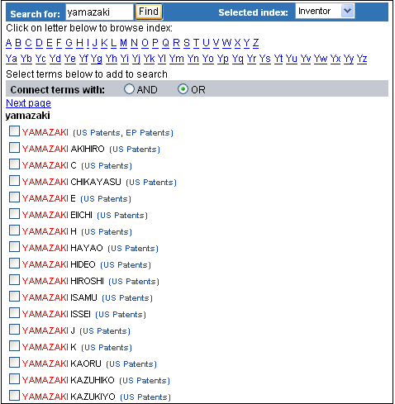
Patent Assignee - This field contains the name of the individual or entity to which ownership of the patent was assigned at the time of patent issue. You can search the index for a specific assignee by typing in the first letters of the name and clicking find. Next to each name, the patent database will be indicated in brackets i.e. US patent or European patent.

Case Sensitivity
The Engineering Village interface is not case sensitive.
Text can be entered in upper or lower case

CBNB Search Fields and Limits
The following fields are searchable in CBNB:
Click here for a full list of all available search fields on Expert search
All fields
"All Fields" will retrieve results from any of the following fields: title, source title, document type, scope, CODEN, ISSN, language, company name, CAS Registry Number, industrial sector and sector code, and abstract.
Subject/Title/Abstract
"Subject/Title/Abstract" will retrieve results from any of the following fields: title, company name, CAS Registry Number, industrial sector and sector code, and abstract.
Company
All companies for which information is given in the abstract are indexed. The legal designations of the status of a company are not used in indexing, e.g. "ICI" is used rather than "ICI PLC".
Subsidiaries of multinationals are separately named. The parent company will be indexed if it is mentioned in the abstract, but there is no automatic linking of subsidiaries and parents.
Full names are not reversed, but initials in company names are reversed, e.g. "FH Faulding" is indexed as "Faulding, FH."
An 'e' is inserted where a German umlaut occurs, e.g. "Ruetgerswerke."
Acronyms are given when they are commonly used, e.g. "Mines de Potasse d'Alsace" can also be searched as "MDPA."
Title
Title searches for words that appear in the title (or English translation title) of the article. This is very useful if you are looking for articles on a very broad topic. Words in a title are often an indication of the importance of those terms to the article.
Source title
Select "Source Title" if you want to find articles from a specific journal.

Limiting your search
Searches may be limited by document type, language, and/or publication year.
Document type
You can select one of the following document types to limit your search:
All document types
Journal article
Advertisement (discontinued January 2001)
Book
Directory
Company report
Stockbroker report
Market research report
Press release
Language
You can select one of the following languages to limit your search:
All languages
English
Chinese
Danish
French
German
Italian
Russian
Spanish
Swedish
Limit by Date
Year Limits
If you do not find what you need, broaden your search by selecting the date range limit and expanding the range of your search to the last year, the last five years, etc.
Updates
Selecting this option allows you to limit your search by the 1, 2, 3, or 4 most recent database updates. CBNB is updated weekly.
Browse indexes
From the Browse Indexes box (located on the right side of the page), select the index you wish to use by clicking on the radio button next to it and then clicking on "Browse."
Once the index is loaded, you can navigate by either selecting the first letter(s) of the term you wish to search for or by typing in the first few letters of the term in the SEARCH FOR box and clicking on "Find."
In Quick Search, when you select a term from the index, it is automatically pasted into the first available textbox. The SEARCH IN box will also be changed to the appropriate field. Un-selecting the term from the index will remove it from the textbox. If you select more than three terms, the fourth term will overwrite the term in the third textbox.
You can also choose to have the second and third index terms pasted from the indexes with either a Boolean AND or OR connecting them. For more information, refer to the Boolean Operators section.

Chimica Search Fields and Limits
The following fields are searchable in Chimica:
Click here for a full list of all available search fields on Expert search.
All fields
All fields will retrieve results from any of the following fields: title, author, corresponding author's affiliation, source title, CODEN, ISSN, language, controlled and uncontrolled terms, EMTREE Classification Code, CAS Registry Number, and abstract.
"All Fields" is the default for Chimica.
Subject/Title/Abstract
"Subject/Title/Abstract" will retrieve results from any of the following fields: title, controlled and uncontrolled terms, EMTREE Classification Code, CAS Registry Number, and abstract.
Author
Since author names may be cited in a variety of formats, use of the Author Browse Index is highly recommended. Author names can be truncated by using an asterisk (*) as the truncation symbol:
Smith A* will retrieve Smith A., Smith A. C. Smith Agnes etc.
Be aware that this strategy may lead to false hits because there are many authors with the same last name and first initial.
When records are displayed, author names are hyperlinked. Click on an author hyperlink to retrieve records by that author from the entire date range of the database.
Author affiliation
The formats and abbreviations used in author affiliations have changed over the years. Use of the author affiliation Browse Index is highly recommended. Author affiliations are displayed in the detailed record.
Source title
Search on the "Source Title" field if you want to find articles from a particular journal.

Title
If you want to search for specific terms within the title, search on the "Title" field. Words in a title are often indicators of the main focus of the article.
"Chlorophyll" in the title will likely find articles where "Chlorophyll" is an important aspect of the article.
Index Term
The controlled vocabulary used to index records in Chimica can be found in the EMBASE Thesaurus.
These terms appear hyperlinked in the abstract and detailed record format. Clicking on any of these will retrieve records spanning the default time period of the database.
Limiting Your Search
Language You can limit your search to any language listed in the drop-down menu: All languages, English, Chinese, French, German, Japanese, Russian or Spanish.
To search for more than one language, or to search for a language not listed in the Quick Search pull-down menu, use Expert Search. A complete list of available languages within the Chimica database is in the Language Browse Index in Expert Search.
The language of the document is given at the end of the citation if it is other than English.
If more than one language is given, they are separated by a comma, for example:
French, German
Limit by Date
Year Limits
If you do not find what you need, broaden your search by selecting the date range limit and expanding the range of your search to the last year, the last five years, etc.
Updates
Selecting this option allows you to limit your search by the 1, 2, 3, or 4 most recent database updates. Chimica is updated weekly.

Browse indexes
From the Browse Indexes box (located on the right hand side of the page), select the index you wish to use by clicking on the radio button next to it and then clicking on "Browse."
Once the index is loaded, you can navigate by either selecting the first letter(s) of the term you wish to search for or by typing in the first few letters of the term in the SEARCH FOR box and clicking on "Find."
In Quick Search, when you select a term from the index, it is automatically pasted into the first available textbox. The SEARCH IN box will also be changed to the appropriate field. Un-selecting the term from the index will remove it from the textbox. If you select more than three terms, the fourth term will overwrite the term in the third textbox.
You can also choose to have the second and third index terms pasted from the indexes with either a Boolean AND or OR connecting them. For more information, refer to the Boolean Operators section.
The Author Browse Index is useful for searching on author names, especially for searching for authors with very common surnames. For example:
Searching on author Alan Smith, as Smith, A* will retrieve Smith A., Smith A.C., Smith A. E., Smith Allen, Smith Andrew T., etc.
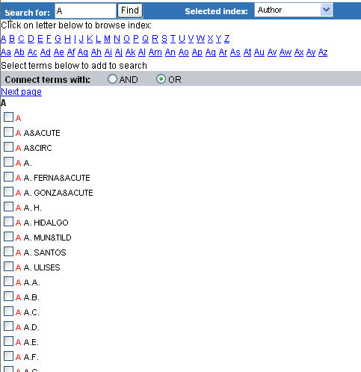

Cited by Count from Scopus
The Cited by count appears in each Compendex article that contains one or more citations within Scopus. Following is an example of a Cited by count:
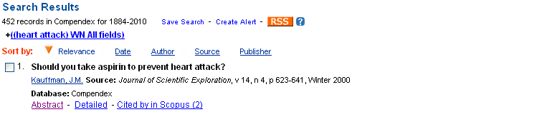
The number of documents that cite the article appears in parentheses, as shown in the example. If an article has no citations, the Cited by feature does not appear. All EV users will have to Scopus, regardless of their Scopus subscription status.
When you click the Cited by link, a window appears where you can view a list of articles that cite the current article. Non-subscribers of Scopus can view all articles on the Scopus Preview page with limited functionality.
Viewing the Article's Abstract
Click the Abstract link to see an abstract of the article similar to this:
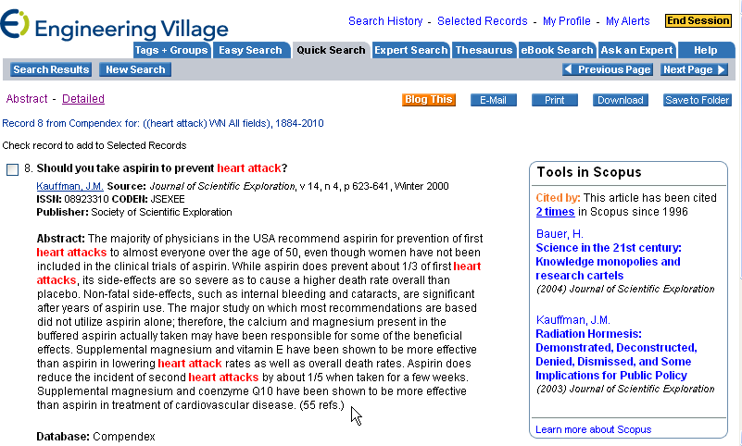
Opening Scopus from EV
Under "Tools in Scopus" click the number of times (in the example above, 2 times) to open Scopus and use additional functions, as shown below:
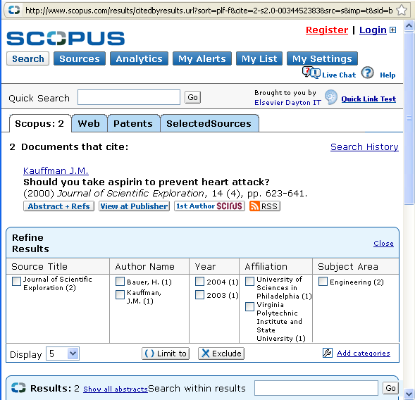
Other Views Possible
- Detailed - Click Detailed (beside the Abstract link) to see the abstract plus an easy-to-read list of details, including the abbreviated source title, language the article is written in, and the number of references in the article.
- Article title under "Tools in Scopus" - Under "Tools in Scopus" click the hyperlinked title of the article to open a Scopus view similar to the one shown above.
- Learn more about Scopus - Under "Tools in Scopus" click this link to gain a better understanding of the Scopus application.
For more information about Scopus, go to http://info.scopus.com/about/

Compendex and Engineering Index Backfile Search Fields
The following fields are searchable in Compendex and Engineering Index Backfile.
Click here for a full list of all available search fields on Expert search
All fields
Searching All Fields retrieves results from any of the following fields: Abstract, Title, Translated Title, Author, Author affiliation, Source title, Volume title, Monograph title, CODEN, ISSN, E-ISSN, ISBN, Publisher, Accession number, Ei classification code, Conference code, Conference name, Conference date, Conference location, Sponsor, Ei controlled term, Ei main heading, Uncontrolled term, Language, Document type, Treatment type and Patent information (Assignee, Country of publication, Filing date, Issue date, Patent number, Engineering Index Backfile only).
All Fields is the default for Compendex.

Abstract
Searching Abstract finds terms in the abstract field.
(gold or au) wn AB
Accession number
The accession number is a unique number assigned to each record in Compendex. It is only displayed in the detailed record format. Accession number can be searched in All Fields in Easy, Quick or Expert Searches or by itself in Expert Search.
20101812909933 wn AN

Author
Since author names may be cited in a variety of formats, use of the Author Browse Index is highly recommended, e.g., Rigby, Alan A. or Rigby, A.A. Author names are cited as they appear in the original document. Surnames appear first, usually followed by a comma and the remainder of the name as it appears in the original document.
If the author is cited by initials and a surname, but a full name is indicated somewhere in the original publication, such as in the table of contents, then all the known information is provided. Titles such as Sir and Mister and educational degrees are not included in the current Compendex database. They may appear in the Salutation field in the Engineering Index Backfile.
Since 1976, if no personal author name appears on the document then the institutional author is added to the author affiliation field and Anon will then appear in the author field.
Author names can be truncated by using an asterisk (*) as the truncation symbol:
Smith, A* will retrieve
Smith, A.
Smith A.A.
Smith A.B.
Smith, A. Brandon
Smith, Aaron
Smith Aaron C., etc.

Be aware that this strategy may lead to false hits because there are many authors with the same last name and first initial.
Note that only authors whose names are presented in the format given will be retrieved.
Searching on Smith, A. B. will not retrieve articles with the author cited as Smith, A.
If a single word surname is entered as the author's last name, all of the forms of that name will be retrieved.
Bers will retrieve:
Bers, A.
Bers, D. M.
Bers, Donald M., etc.
To further refine this search, add the truncation symbol after the first initial.
Bers, D* will retrieve:
Bers, D. M.
Bers, D.M.
Bers, Donald M., etc.

Editors and compilers are also listed in the author field. They are distinguished from authors by the notations (ed.) or (compiler) in parentheses following the names.
To search on the name of a person who could be an author, an editor or a compiler of a document, truncate after the known part of the name. This will allow for retrieval of the notations (ed.) or (compiler).
When records are displayed, author names are hyperlinked. Click on an author hyperlink to retrieve additional records by that author from the entire date range of the database (1970-present, or 1884 to present if you have the Engineering Index Backfile).

Author Affiliation
In the past, the official Compendex policy was to provide the institutional affiliation of the first author or editor, if it could be determined from the source document. Later, the affiliation of the corresponding author, who is often the first author, was displayed. Now affiliations are displayed for all authors. Email addresses are also provided, when available, for the corresponding author.
In addition to this policy change, in some given affiliations (if it can be determined from the source document) more than one level of the organization is cited.
The formats and abbreviations used in author affiliations have varied over the years. For example, in the 1970s, an affiliation might be cited as follows:
Nippon Telegr & Teleph Public Corp,
Ibaraki Electr Electr Commun Lab
In the 1980s:
Inst of Electrical Engineers of Japan,
Committee on Electrical Insulating Materials,
Jpn, Insulating Materials, (Jpn)
1990s to present:
Sch. of Electrical and Computer Eng., Purdue University,
1285 Electrical Engineering Building,
West Lafayette, IN 47907, United States
Some commonly used abbreviations are :
Academy
Acad
Association
Assoc
Bureau
Bur
Center/re
Cent
College
Coll
Company
Co
Corporation
Corp
Department
Dep
Division
Div
Incorporated
Inc
Institute
Inst
Institution
Inst
International
Int
Laboratory
Lab
Limited
Ltd
National
Natl
Published
Pub
Publisher
Pub
School
Sch
Society
Soc
University
Univ

Corresponding non-English terms (e.g., Akademy) may also be abbreviated.
Other variations in affiliation names may occur for some of the following reasons:
An organization's name may be given in different forms in different source documents. Variations may be due to language, for example:
Goteborg Univ.
Gothenburg Univ.
An organization's name may change over the course of time, e.g.:
Mobil is now named Exxon Mobil

Classification Code
The Compendex classification scheme, available in print form in the Ei Thesaurus, is a numerical hierarchy of general subject categories. These subject categories are used to place a term into context when the meaning can vary depending on its usage. As an example, windows can refer to building materials or software. The classification codes for building materials (42*) and computer and data processing (72*) will limit the search to the proper area. Classification codes can be found in the Abstract and Detailed views and also in the Thesaurus view.
Searching by classification code can retrieve a large, relevant set of results without using synonyms. The Classification Code field is not searchable in the Engineering Index Backfile.
72* wn CL
"804.2" wn CL

CODEN
CODEN are six-character representations of source titles. They can be used to limit results to a specific journal. CODEN can be found in Ulrich's Periodicals Directory and CASSI: Chemical Abstracts Service Source Index. You can also find a journal's CODEN at the abstract and detailed level of a record.
MMPRE8 wn CN

Conference Code
A Conference Code is a number assigned to a conference proceedings record and every paper from that conference covered by Compendex. This allows you to locate every paper from a conference once you have found one paper. The conference code can be found in the detailed record format.
The conference code was first used in 1982. Conferences covered in Compendex prior to 1982 do not contain conference codes.
13969 wn CC
Conference Information
Conference information includes the name, date, location and sponsor of a conference as well as the conference code number.
"Salt Lake City" wn CF

Controlled Term
The controlled vocabulary used to index records in Compendex can be found in the Ei Thesaurus. The 64th edition of the Ei Thesaurus contains 19,676 terms; 10,256 are descriptors (preferred terms) and 9,420 are entry terms (non-preferred). In the 6th edition, 371 new descriptors were added, as well as 50 new entry terms. The terms can now be identified by using the thesaurus function from the navigation bar.
Ei's controlled vocabulary is a list of subject terms used to describe the content of a document in the most specific and consistent way possible. These terms can also be browsed in the Ei Controlled term Browse Index in Engineering Village.
These terms also appear hyperlinked in the abstract and detailed record formats. Clicking on any of these will retrieve records spanning the default time period of the database. In 1993, Ei updated the format of its controlled vocabulary. Pre-1993 records retained their former format.
The former heading-subheading organization was abandoned. Each index term now stands alone. Old heading-subheading controlled terms have been updated in several different ways:
Electromagnetic waves - Absorption
is now indexed as:
Electromagnetic wave absorption
The aspect of Electromagnetic waves called Absorption is now part of the main heading.
Electronic circuits, Frequency dividing
is now
Frequency dividing circuits
The main heading subheading structure is converted to natural language.
Electron tube - Reliability
is now:
Electron tubes and Reliability
The two aspects represented in this main heading, subheading are separated as individual terms.
Light - Coherent
is now
Coherent Light
When a subheading modifies, or adds additional explanation to the main heading, the order is now reversed presented as a single term.
In Expert Search, use CV to search for controlled terms:
Geochemistry wn CV
"environmental impact" wn CV
{gold ore treatment} wn CV
Users searching on controlled terms for material published before 1993 will find it helpful to use both the Ei controlled term look-up indexes and the online thesaurus as aids in determining all the appropriate terms.
Most Compendex records are assigned a heading that serves to represent the major subject aspect of the document (Main Heading). The subject terms that follow describe additional concepts dealt with in the article.

ISBN (International Standard Book Number)
The International Standard Book Number (ISBN) is a formerly 10-, now 13-digit number that uniquely identifies a specific title and edition of a monograph or monographic series. The number can be used to find chapters from the same monograph or papers from the same conference. The ISBN appears at the abstract or detailed level of a record. An ISBN is searchable in All Fields for Easy, Quick or Expert Search or individually according to the specific search code in Expert Search.
978-0-87339-255-8 wn BN

ISSN (International Standard Serial Number)
The ISSN is a standardized international alphanumeric code that is a unique and precise identifier for a serial publication. The format of the ISSN is an eight-digit number, divided by a hyphen into two four-digit numbers. The last digit, which may be 0-9 or an X, is a check digit. It can be used to limit search results to a specific journal or serial conference proceeding. It can be searched with or without the hyphen. The ISSN is displayed in abstract and detailed formats. There may be an E-ISSN displayed, which is assigned to the electronic version of a serial.
0747-9812 wn SN

Issue and Volume
Searching on Issue and Volume is most useful and effective when you have a specific ISSN to search on. The search would be on the ISSN (which is a unique identifier of a source) and then on the volume or volume/issue. It is less effective (i.e., returning too many results) if you only search on volume or issue, as many different sources may have the same volume or issue numbers, e.g., vol. 5/issue 6.
So, if the ISSN is, for example, 10895639, and the volume you want to find is v. 113, and the issue is 52, then the search would be this:
10895639 and 113 wn VO and 52 wn SU
Using the above example, you could also just search on the ISSN and volume, or ISSN and issue, but the latter would be less useful because issue 52 could be from volume 110, 112, or 113, etc.
Main Heading
Most Compendex records are assigned a main descriptor, which is a subject classification that serves to represent the main topic of the document, i.e., the Main Heading. Descriptors are referred to as controlled vocabulary terms, and all Main Headings are also controlled vocabulary terms. The controlled vocabulary terms that follow the Main Heading represent additional concepts found in the article.
"ammonium compounds" wn MH
Publisher
Search on the Publisher field to identify publishers, or find the journals published by a particular publisher. Be sure to look for all versions of a publisher's name. To do so, it is helpful to refer to the Publisher Browse Index. For example, American Institute of Physics is also referred to as:
AIP
AIP Press
Am Inst Phys
American Inst Phys
In Expert Search, use PN to search this field:
Elsevier wn PN
"American institute of physics" wn PN
{AIP Press} wn PN

Source Title
Search on the Source Title field if you want to identify source titles, e.g., journals, monographs or conference proceedings, from your area of study.
Searching for polymer* in the "Source title" field will retrieve citations whose sources will include:
Polymers for Advanced Technologies
Journal of Applied Polymer Science, etc.
To conduct an exact source title search, enclose the full title in braces or quotation marks.
{X-Ray Spectrometry} wn ST
"Journal of X-Ray Science and Technology" wn ST
As variations of source title names sometimes occur, it is a good idea to use the Source Title Browse Index. The look-up index also includes monographs and conference titles.

Subject/Title/Abstract
Searching Subject/Title/Abstract retrieves results from any of the following fields: Abstract, Title, Translated title, Ei controlled terms, Ei main heading and Uncontrolled terms.
This is an effective way to maximize the relevance of your search results.
To search for an exact phrase, enclose terms within braces or quotation marks. For example:
{international space station}
"linear induction motors"

Title
If you want to search for specific terms within the title, search on the Title field. Words in a title are often indicators of the main focus of the article.
"Radio frequency" in the title will likely find articles where radio frequency is an important aspect of the article.
Diffusion wn TI
"radio frequency" wn TI
{radio frequency} wn TI
For English language documents, the original title is displayed word for word.
If the document is written in a language other than English, but uses the western alphabet, an English language translation is often provided, as well as the title in the original language. Our current policy is to provide title translations only for the following languages: Dutch, French, Germany, Italian, Portuguese, and Spanish.
For languages not using the Roman alphabet, a translated or transliterated title may appear.

Uncontrolled Term
Uncontrolled terms, also known as free language terms, are additional entry, or non-preferred, subject terms. These terms are not assigned from the Ei Thesaurus, rather are derived from the abstract and author keywords. New terminology is displayed in this field. The uncontrolled terms allow for further specificity in indexing that is not available using controlled vocabulary. Uncontrolled terms are reviewed periodically as candidate terms that my eventually be incorporated into the Ei Thesaurus.
Uncontrolled terms are searchable in All Fields for Easy, Quick, or Expert Search or individually according to the specific search code in Expert Search. These terms are also searchable in the Subject/Title/Abstract search in Quick Search.
"Auger ionization" wn FL
{stationary phase methods} wn FL

Compendex and Engineering Index Backfile Search Limits
Click here for a full list of all available search fields on Expert search
Document Type
Document types identify an item type within a source, such as journal article or conference article. The document type field was added in 1985. Please note that limiting a search in Compendex to a particular document type will exclude items added from 1970 to 1985. The field "Document Type" can be found in the Ei Backfile, 1884-1969.
In Quick Search, Document Type can be applied as a limit in the Document Type pull-down box.
In Expert Search, the document type can be selected from the Document Type Browse Index or searched directly:
ca wn DT
The Document Types Used in Compendex are:
All document types (default)
Journal article - An independent section of text, usually with its own title and author statement, appearing in an issue of a journal, a journal being a periodical appearing at regular intervals (generally more frequently than annually) and intending to be continued indefinitely
Conference article - A conference paper issued as part of a proceeding whether published in a conference proceeding or in a journal
Conference proceeding - Publication containing papers presented at a conference, symposium, or other meeting and describing the publication of those proceedings as a whole
Monograph chapter - An individual section of a monograph with its own title and author statement
Monograph review - A systematic and complete treatise on a particular subject, published either complete in one volume or in a finite number of volumes
Report chapter - An individual section of a report with its own title and author statement
Report review - An official or formal record of research results, research-in-progress, or other technical studies, generally published non-commercially by, and obtainable through, the agency conducting the research
Dissertation - A lengthy or formal treatise or thesis usually written for advanced academic degrees
Unpublished paper - Unpublished papers prepared in advance of formal publication
The Engineering Index Backfile also includes a document type for Patent (before 1970).
Treatment Type-The treatment type is used to specify the slant or approach taken in the document.
In Quick Search, Treatment Type can be applied as a limit in the Treatment Type pull-down box.
In Expert Search, the treatment type can be selected from the Treatment Type Browse Index or searched directly:
HIS wn TR
Treatments types were added to Compendex records in 1985 and continue through mid-2008. Therefore, a search with a treatment limit is restricted to 1985 to mid-2008 records only.
A record may have one or more Treatment Type. However, not all records have been assigned Treatment Types.
The following treatments are used in Compendex:
Applications - Used for documents describing the actual or potential use of a material, device, concept, computer program, instrument, system, technique or other innovation. This code is also used for product reviews/technical disclosures.
Biographical - Used for documents containing or consisting of the facts or events in a person's life.
Economic - Used for documents focusing on an overview or analysis of a topic from an economic, cost data, or marketing perspective. Includes market studies.
Experimental - Used for documents pertaining to, or based on, experimental method, including descriptions of experimental methods, apparatus or results.
General Review - Used for documents providing an overall view of the subject, discussing its development, current research/status, state of the art, etc.
Historical - Used for documents that consider a subject in its origin and/or subsequent historical developments.
Literature Review - Used for documents containing or consisting of extensive references, bibliographies or other summaries of literature relevant to the topic of the document.
Management Aspects - Used for documents that deal with some management aspect of a topic, and/or management methods in general. The management sciences and technology applicable to research, development, design and production are included. This treatment type is also assigned to documents concerning socio-economic impacts of technology on society.
Numerical - Used for documents that include numeric data compilations and/or statistical analysis. The numeric information contained may be physical properties, production, consumption or socio-economic statistical data. This treatment type will be assigned to documents reporting statistics of production, exports, imports, growth, etc., for various materials, commodities, products or industries.
This treatment type is not used for mathematical analysis involving numerical techniques.
Theoretical - Used for documents whose emphasis is on theory involving mathematical, deductive or logical analysis. Mathematical analysis using numerical methods for determining the solution is also included in this category.
Language - You can limit your search to any language listed in the Quick Search drop-down menu: All languages, English, Chinese, French, German, Italian, Japanese, Russian or Spanish. To search for more than one language, or to search for additional languages not listed in the Quick Search pull-down menu, use Expert Search. A complete list of available languages within the Compendex database - over 30 in all - is in the Language Browse Index in Expert Search.
The language of the document is given at the end of the citation if it is other than English.
If more than one language is given, they are separated by a comma, for example:
French, German

Content Sources Introduction
Engineering Village hosts several databases. For more information about the databases and resources available on Engineering Village please click on the links below:
Compendex
Engineering Index Backfile
US and European Patents
GEOBASE
GeoRef
Inspec
Inspec Archive
NTIS
Referex
EnCompassLIT
EnCompassPAT
EnCompassBulletins
PaperChem
Chimica
CBNB
Complimentary Information Resources

CRC ENGnetBASE
Your institution's add-on subscription to ENGnetBASE allows you access to some of the world's leading engineering handbooks published by CRC Press. As of November 2004, ENGnetBASE has more than 229 titles available online with many more on the way as new books are published or updated.
Your query is sent to the CRC Press ENGnetBASE site, where the results are presented by the number of times the search term(s) appear within a particular chapter of an individual handbook. You can then review the matching handbook document results (available in PDF format).
All Fields
The full text of the online CRC handbooks is searched to find a match on your search term(s). Enter words or phrases:
{Timber bridges}
thermodynamics
"Computer analysis of nonlinear hybrid systems"
{advances in chemical propulsion}
"Avionics Handbook"
Detailed help in using ENGnetBASE is available from the ENGnetBASE Web page at http://www.engnetbase.com/
Proximity operators, wildcards and internal truncation do not work with CRC ENGnetBASE.
If your organization does not subscribe to CRC ENGnetBASE, you can still search and locate information, but will not be able to view the full text online.

Creating Groups
To create a group click on View/Edit groups.
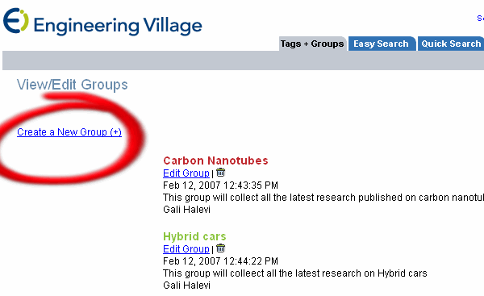
Click on Create a New Group (+).
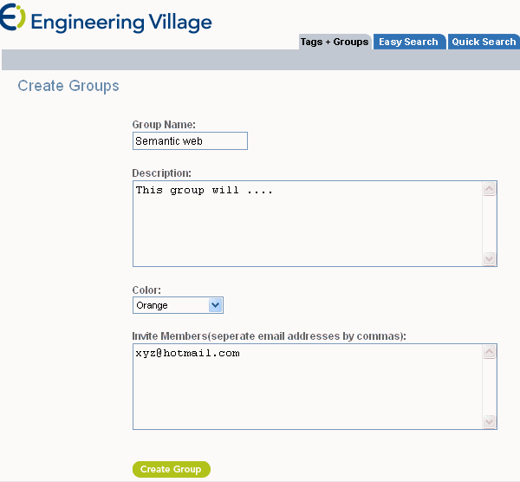
Group Name: choose a name for the group you are creating.
Description: use this space to describe the groups’ interests.
Color: If you are creating more than one group, you can distinguish between them using different colors. Tags that were assigned by members of the group will show in view according to their color. This will assist you in identifying tags which were assigned to records by different groups’ members.
Invite members: separate each name by a semicolon or a new line. There is no limit on the number of members you can invite
When done, click on “create group”
You can cancel the creation of a group by using “cancel”
When a group is created, the next time you will tag a record, you will receive an option to tag to a group.
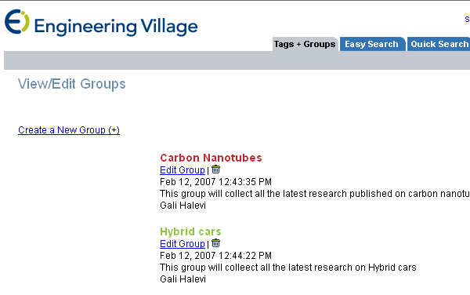
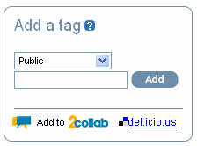
You can also and notify the group when new records are tagged.

Date Limits
Year Limits
If you do not find what you need, broaden your search by selecting the date range limit and expanding the range of your search to the last year, the last five years, etc. This search is conducted using data in the Publication Year field.
Updates
Selecting this option allows you to limit your search by the 1, 2, 3, or 4 most recent weekly database updates.

Deduplication Feature
Deduplication is available for Chimica, Compendex, EnCompassLIT, GEOBASE, GeoRef, Inspec, and PaperChem databases only.
You will see the duplication removal option only when you select more than one database for your search.
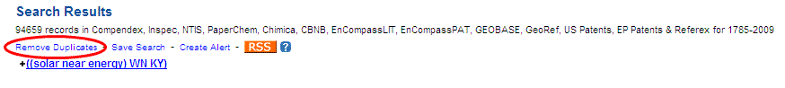
Once the remove duplicates link is chosen, a new screen will open. This screen contains several options for duplicates removal:
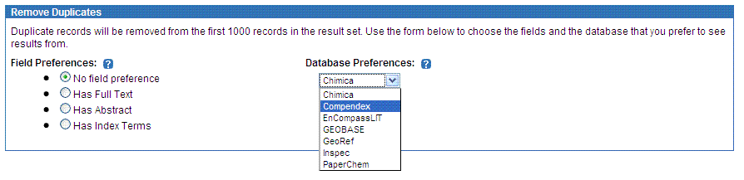
Select the type of records that you will prefer to see. Choose from full text, abstract or index terms. In this option you are given the flexibility to decide which types of records you prefer to see in the deduplicated set of results. For example, if you click 'Has Full Text' the system will remove duplicates that do not have a full text and leave those that do.
Select the database from which you prefer to see results. For example, if you chose "Compendex," the system will remove the duplicates from all of the other databases and leave the unique records from Compendex and vice versa.
After selecting your preferences, click 'continue'.
The new results page, featuring a deduplicated set will appear.
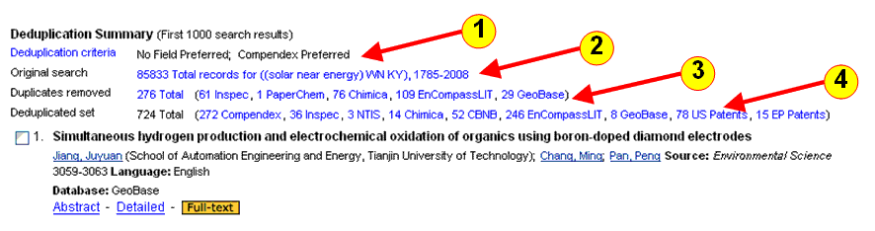
1. Deduplication criteria are presented for your review.

2. The original search is presented.

3. The total number of records removed in the deduplication process is presented. In brackets you can see how many records were removed and from which database.

4. The total number of original deduplicated records from each database is displayed along with the number remaining from each data source.

D Sign. This sign indicates that a duplicate record was removed.

Clicking this sign will open a new window containing the record's detailed format and the database it was removed from.
For example, if Compendex was the preferred database, and a duplicate record, appearing in Inspec was removed from your set, this sign will show you the record in Inspec. This feature keeps you informed about the specific records that were removed and gives you a possibility to look at the record although you chose to remove it.
Note: Once the deduplication button is pressed, Faceted Search Results will no longer appear on the screen.

Easy Search
Easy Search is designed for very simple basic keyword searching. Search terms are entered into a single search box. Easy Search searches all databases your institution may subscribe to without limits applied.
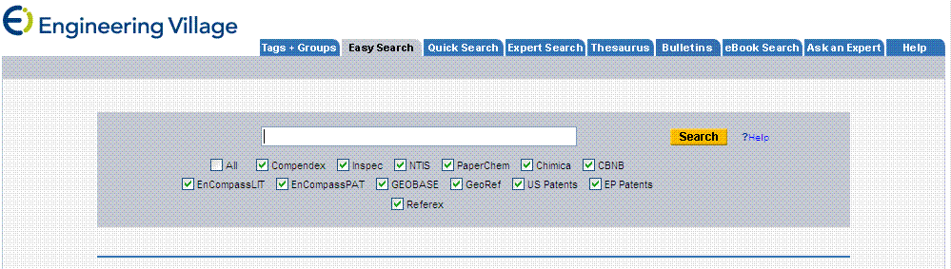
Enter search terms in the search box. A search is performed on all indexed fields of all subscribed bibliographic databases, including Compendex, Engineering Index Backfile, Inspec, Inspec Archive, Ei Patents, and NTIS. No limits are placed on the search.

eBook Search
eBook Search retrieves results from the Referex eBook collections only.

Referex Search Results
Overview
Search results present citations matching your query. In Referex, a citation is a page from a book. These pages or citations are sorted by relevance by default. They can also be sorted by author, source and publisher. The search results view also displays facets vertically arranged in the right panel of the screen under the “Refine Results” heading. These facets can be used to refine your search.
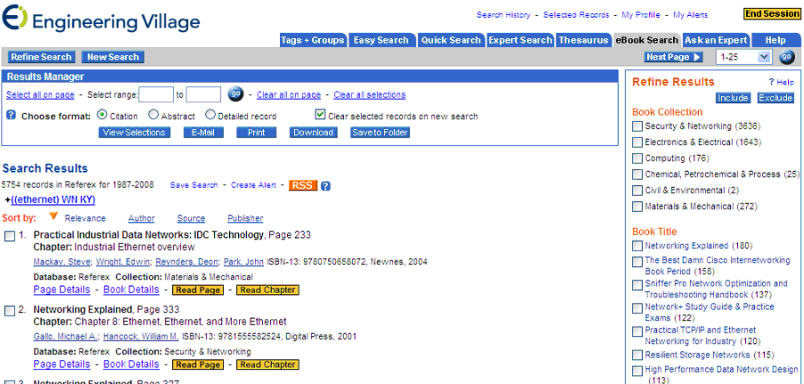

There are four options for viewing specific citations in your search results:
1. Page Details
2. Book Details
3. Read Page
4. Read Chapter
For more information on these options, please see the “Viewing Your Referex Results” section of the Help File.

Refine Results
The eBook search results screen also allows you to quickly refine your search by using the facets on the right. A partial list of facets is displayed below.

Understanding the Facets (Refine Results)
Book Collection: Lists the collections in which search results were found. The number in parentheses is the number of pages within the collection that contain the keyword.
Book Title: Lists the book titles in which the key words were found. The number in parentheses is the number of pages within a title that contain the keyword.
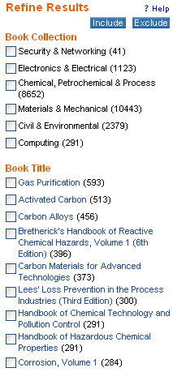
Book chapter: Lists all the chapters (book parts or chapters) within the books in which the keywords were found. The number in parentheses is the number of pages within a specific chapter that contain the keyword.
Keyword: Lists related keywords found in the relevant results. The number in parentheses is the number of pages within the result set that contain the key word.
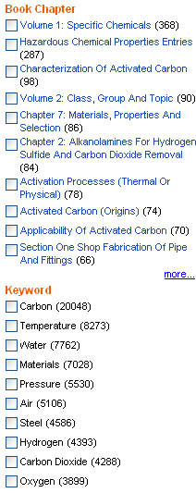
Author: Lists the authors of the books retrieved.
Publisher: Lists the Publishers of the books retrieved.
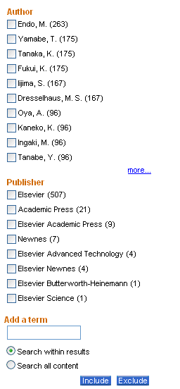
Add a term: You can choose to refine your results by typing additional keywords in the "Add a term" box. You can than search for the keyword within your results or create a new search by choosing "Search all content".
Note: The number in brackets next to each term in the facets relates to the number of pages, not books.
Mapped Search Results
When you place your mouse on the title, a window showing the book cover as well as the author(s), ISBN, publisher, date and database will come up:
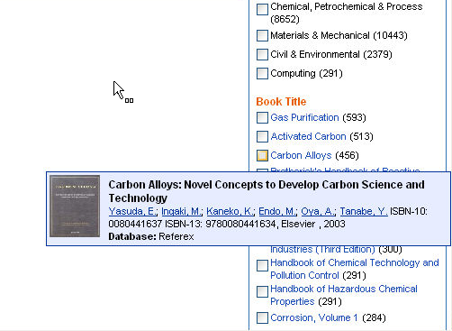

Ei Patents
Ei Patents Search fields
Click here for a full list of all available search fields on Expert search.
Ei Patents Search Fields
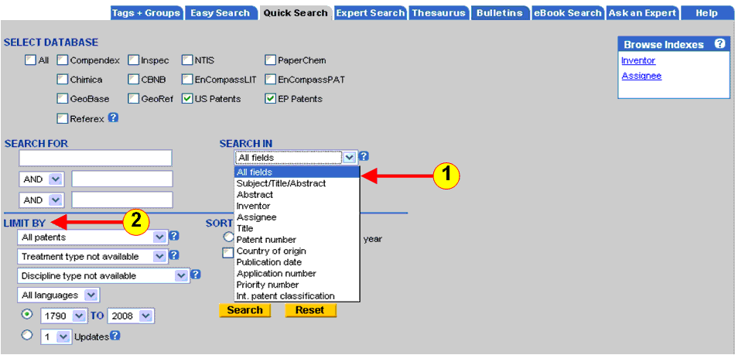
As you select your databases, note that the field list changes accordingly.
When you search patents the following searching fields will be available:
All Fields - search all available fields
Subject/title/abstract - search in the patents' subject (controlled vocabulary terms), title and abstract
Abstract - search the patents' abstracts
Inventor - This field contains the inventor(s) names of patented item.
Patent Assignee - This field contains the name of the individual or entity to which ownership of the patent was assigned at the time of patent issue
Title - This field contains the title of the patent
Patent Number - This field contains the unique number assigned to applications that have issued as patents.
Publication date - This field contains the date the patent was officially issued by the US Patent and Trademark Office
Application number - This field contains the identification number assigned by the US Patent and Trademark Office to applications which have received a filing date.
Priority number - This field contains data indicating in which foreign country an application claims priority. The number is the foreign patent number that was assigned to the patent when first issued.
International patent classifications - This field contains the International classification(s) to which the patent has been assigned.
USPTO classification - This field contains the original and cross-reference classes in which the patent was classified at the time of the most recent PTO Master Classification File.

Ei Patents Search Limits
When searching only the patents databases the 'limit by' option presents the following field only:
Document Type - "Application" is the request for a patent officially accepted by the patent authority
European application - limits your search to retrieve European patent applications only.
US applications - limits your search to retrieve US patent applications only
"Grants" are patents that have been officially granted by the patent authority.
European Grants - limits your search to retrieve European patent grants only.
US grants - limits your search to retrieve US granted patents only.
Other search limitations available are:
Language
You can limit your search to any language listed in the Quick Search drop-down menu: All languages, English, Chinese, French, German, Italian, Japanese, Russian or Spanish.
Year - limits your search for a certain year range. In the patents search, the earliest year available is 1790.
Update - limits your search to 1-4 latest database updates. The patents databases are updated weekly.

EnCompassLIT Search Fields and Limits
All fields
Searching retrieves results from any of the following fields: Subject/Title/Abstract, Abstract, Author, Author affiliation, Title, Conference information, Publisher, Serial Title, Controlled Term and CAS Registry Number.
Subject/Title/Abstract
Searching retrieves results from any of the following fields: Subject, Abstract, and Title, as well as Controlled term, and Uncontrolled terms. To search for an exact phrase, enclose term within braces or quotation marks:
{EMISSION CONTROL}
"DIESEL FUEL"
Search for chemical compounds with subscript or superscript (in fields other than controlled terms). Perform an exact match search using { }, as follows:
{AL sub 3} to search for Al3
{AL sup 3} to search for Al3
Do not use special characters such as <> ( ) in this syntax. Note, the application does not support concatenation of sub and sup.
Abstract
Search by single terms and/or phrases. To search for an exact phrase, enclose term within braces or quotation marks.
{FLUID CATALYTIC CRACKING}
"PETROLEUM DISTILLATION"
Author
Search in the format: LAST NAME - SPACE - FIRST INITIAL - SPACE - MIDDLE INITIAL. This field contains company names as well. Note that the number of initials may vary; also, on some names in older records, a suffix may be included, e.g., JR or III. TONG Y
When the initials are not known, use truncation (*):
MULLENIX*
When searching for authors, or an author, it is recommended that you use the Author Browse Index since author names may be cited in a variety of formats.
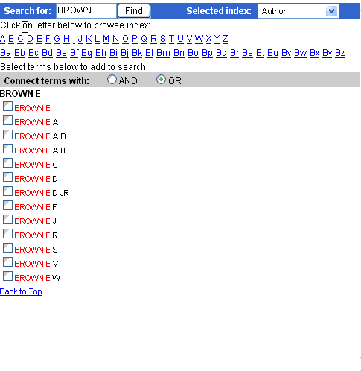
Author affiliation
Search by single words or phrases. To search for an exact phrase, enclose term within braces or quotation marks.
TOTALFINAELF
"LUBRIZOL CORP"
Prior to 2001, the official EnCompass policy was to provide the institutional affiliation of the first author or editor, if it could be determined from the source document. (Note: some author affiliation may appear in the author field.)
In 2001, this policy changed. The affiliation of the corresponding author is now given instead.
When searching for author affiliation it is recommended that you use the Author Affiliation Browse Index since author affiliation names may be cited in a variety of formats.
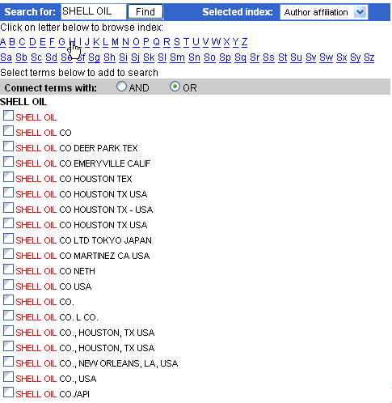
Title
Search by single words or phrases. To search for an exact phrase, enclose term within braces or quotation marks.
"EMISSON CONTROL"
CATALYST AND HYDROCONVERSION
Conference Information
Conference information includes the name, date, location and sponsor of a conference as well as the conference code number.
Conference date is not searchable the way it is displayed. For example, if the conference dates are May 6, 2007 through May 10, 2007, the search should be run for 20070506 AND 20070510.
Publisher
Search on the Publisher field to identify publishers, or find the journals published by a particular publisher. Be sure to look for all versions of a publisher's name. To do so, it is helpful to refer to the Publisher Browse Index.
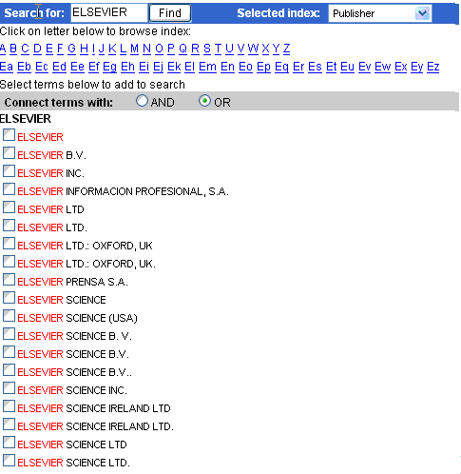
Serial title
Search by single words or phrases. To search for an exact phrase, enclose term within braces or quotation marks. When searching for serial title it is recommended that you use the Serial Title Browse Index. Search by ISSN (International Standard Serial Number) for a specific journal. These terms also appear hyperlinked in the abstract and detailed record format. Clicking on any of these will retrieve records spanning the date range of the original search.
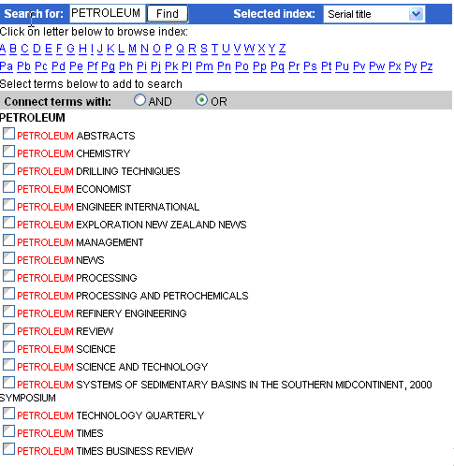
Controlled Term
Free-language retrieval is available with the EnCompassLIT but the most direct access to relevant items is through use of a controlled vocabulary. The controlled vocabulary used to index records in EnCompassLIT can be found in the EnCompass Thesaurus (The Authoritative Guide To Searching The EnCompass Technical Literature And Patent Databases). The latest edition of the EnCompass Thesaurus contains over 6,500 valid controlled terms. New controlled terms are added each year and are selected based on their usage in technical publications and recommendations of industry experts.
"THREE WAY CATALYST"
{ETHYLENE HOMOPOLYMER}
ANILINE
EnCompass controlled vocabulary is a list of subject terms used to describe the content of a document in the most specific and consistent way possible. These terms can be browsed in the Controlled term Browse Index.
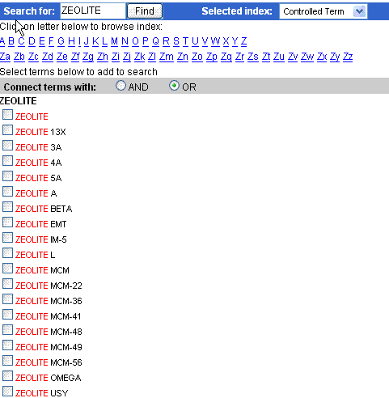
For a more detailed explanation on how to search the EnCompassLIT, please refer to the EnCompassLIT/EnCompassPAT User Manual (A comprehensive manual for searches using the EnCompass technical literature (LIT) and patents (PAT and WPAM) databases).
These terms also appear hyperlinked in the abstract and detailed record format. Clicking on any of these will retrieve records spanning the date range of the original search.
CAS registry number
Search using registry numbers assigned by the Chemical Abstracts Service to chemical compounds. All valid Registry Numbers for EnCompassLIT are listed in Appendix C of the EnCompass Thesaurus.
Displayed CAS registry numbers (with the chemical name) are hyperlinked in the abstract and detailed record format. Clicking on any of these will retrieve records spanning the date range of the original search.

Limit by
Document type
Document types are used to describe the type of source publications from which indexed papers are taken. The document can be selected from a drop down menu. The document types used in EnCompassLIT are:
All document types (default)
Journal article - An independent section of text, usually with its own title and author statement, appearing in an issue of a journal, a journal being a periodical appearing at regular intervals (generally more frequently than annually) and intending to be continued indefinitely.
Conference - A conference paper issued as part of a proceedings whether published in a conference proceeding or in a journal.
Monograph Chapter – A chapter or section of a nonserial publication (i.e. a book), usually containing one volume, but possibly consisting of a finite number of volumes.
Report Chapter – A chapter or section of a report issued by
Report Review
Dissertation
Abstract - Abstracts from numerous other publications selected from secondary sources: Aqualine Abstracts, BMT Abstracts, Chemical Abstracts, Gas Abstracts Online (formerly Gas Abstracts), and Petroleum Abstracts (over 1200 titles).
Other - Dissertations, Reports…
Language
You can limit your search to any language listed in the drop-down menu: All languages, English, Chinese, French, German, Italian, Japanese, Russian or Spanish.
To search for more than one language, or to search for a language not listed in the Quick Search pull-down menu, use Expert Search.
Publication year(s)
Search by publication year of the record. Select the publication date in drop-down boxes, for example, 2000 to 2003
Select the same year in both date range drop-down boxes, for example, 2002 to 2002

Last four updates
Selecting this option allow you to limit your search to the four most recent weekly database updates.
Browse indexes
From the Browse Indexes box (located on the right hand side of the page); select the index you wish to use by clicking on the radio button next to it and then clicking on Browse.
Valid Browse Indexes for Quick Search in EnCompassLIT are:
Author
Author affiliation
Controlled term
Serial title
Publisher
Once the index is loaded, you can navigate by either selecting the first letter(s) of the term you wish to search for or by typing in the first few letters of the term in the SEARCH FOR box and clicking on Find.
In Quick Search, when you select a term from the index, it is automatically pasted into the first available textbox. The SEARCH FOR box will also be changed to the appropriate field. Un-selecting the term from the index will remove it from the textbox. If you select more than three terms, the fourth term will overwrite the term in the third textbox.
You can also choose to have the second and third index terms pasted from the indexes with either a Boolean AND or OR connecting them. See the Boolean Operators section of the Engineering Village Help File for more information on Boolean operators.

EnCompassPAT Search Fields and Limits
All fields
Searching retrieves results from any of the following fields: Accession number, Patent title, Inventor, Patent assignee, Patent country, Publication date, Publication year, Language, Application information, Priority information, International patent classification, Derwent accession number, Abstract, Designated states , Classification code, Controlled terms (displayed also as Major terms and/or Link terms), CAS registry numbers and Uncontrolled terms.
Subject/Title/Abstract
Searching retrieves results from any of the following fields: Abstract, Patent title, Controlled term, and Uncontrolled term. To search for an exact phrase, enclose term within braces or quotation marks:
{EMISSION CONTROL}
"DIESEL FUEL"
Search for chemical compounds with subscript or superscript (in fields other than controlled terms). Perform an exact match search using { }, as follows:
{AL sub 3} to search for Al3
{AL sup 3} to search for Al3
Do not use special characters such as <> ( ) in this syntax. Note, the application does not support concatenation of sub and sup.
Abstract
Search by single terms and/or phrases. To search for an exact phrase, enclose term within braces or quotation marks.
{FLUID CATALYTIC CRACKING}
"PETROLEUM DISTILLATION"
Inventor
Search in the format: LAST NAME - SPACE - FIRST INITIAL - SPACE - MIDDLE INITIAL. This field contains Patent assignee names as well (before 1993).
GARVIN G A
When the initials are not known, use truncation (*):
BOYLE*
When searching for inventor, it is recommended that you use the Inventor Browse Index since inventor names may be cited in a variety of formats.
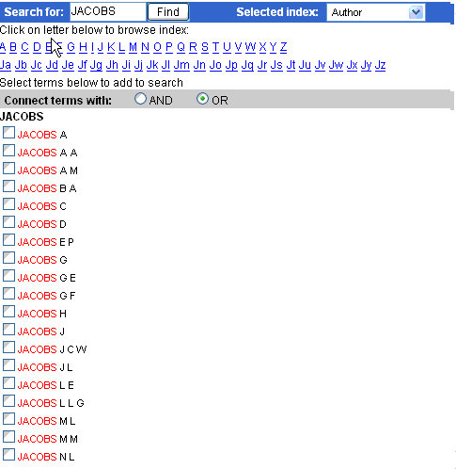
Patent assignee
Search by single words or phrases. To search for an exact phrase, enclose term within braces or quotation marks. Inventors are found in the patent assignee field before 1993.
TOTALFINAELF
"LUBRIZOL CORP"
When the full name of patent assignee is not known, use truncation (*):
EXXON*
When searching for Patent assignee it is recommended that you use the Patent assignee Browse Index since patent assignee names may be cited in a variety of formats.
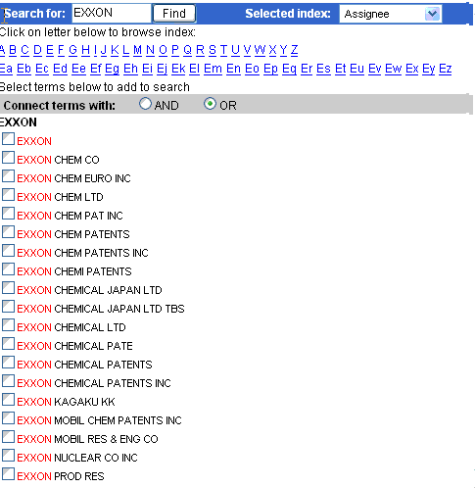
Patent title
Search by single words or phrases. To search for an exact phrase, enclose term within braces or quotation marks.
"EMISSON CONTROL"
CATALYST AND HYDROCONVERSION
Patent number
Search in the format:
NNNNNNN
YYNNNNN
YYYYNNNNN
Combine the patent number search with the Patent country:
0010012 and EP
9859116 and WO
2004000138 and US
Controlled Term
Free-language retrieval is available with the EnCompassPAT but the most direct access to relevant items is through use of a controlled vocabulary. The controlled vocabulary used to index records in EnCompassPAT can be found in the EnCompass Thesaurus (The Authoritative Guide To Searching The EnCompass Technical Literature And Patent Databases). The latest edition of the EnCompass Thesaurus contains over 6,500 valid controlled terms. New controlled terms are added each year and are selected based on their usage in technical publications and recommendations of industry experts.
EnCompass controlled vocabulary is a list of subject terms used to describe the content of a document in the most specific and consistent way possible. These terms can be browsed in the Controlled term Browse Index.
For a more detailed explanation on how to search the EnCompassPAT, please refer to the EnCompassLIT/EnCompassPAT User Manual (A comprehensive manual for searches using the EnCompass technical literature (LIT) and patents (PAT) databases).
"THREE WAY CATALYST"
{ETHYLENE HOMOPOLYMER}
ANILINE
Controlled terms are displayed in control term and/or major term and/or link term fields.
Displayed Controlled terms (including Major terms) are hyperlinked in the abstract and detailed record format. Clicking on any of these will retrieve records spanning the date range of the original search.
International patent classification
Search in the format:
ANNA-NNNNN (from 1970)
ANNA-NNN/nnnn (since 1992)
CAS registry number
Search using registry numbers assigned by the Chemical Abstracts Service to chemical compounds. All valid Registry Numbers in EnCompassPAT are listed in Appendix C of the EnCompass Thesaurus.
Displayed CAS registry numbers (with the chemical name) are hyperlinked in the abstract and detailed record format. Clicking on any of these will retrieve records spanning the default time period of the database.
Patent Country
Search by country using the country codes for patent classifications.
Ex: US = United States of America
EP = European Patent Office
Limit by:
Language
All the abstracts are written in English. Language is provided for EP, and WO patents, and in other cases only where the language is not the normal one for the patent country.
You can limit your search to any language listed in the drop-down menu: All languages, English, Chinese, French, German, Japanese, Russian or Spanish.
To search for more than one language, or to search for a language not listed in the Quick Search pull-down menu, use Expert Search.
Patent (publication) year
Search by Patent (publication) year. Select the Patent year in drop-down boxes, for example, 2000 to 2003
Select the same year in both date range drop-down boxes, for example, 2002 to 2002
Last four updates
Selecting this option allow you to limit your search to the four most recent weekly database updates.
Browse indexes
From the Browse Indexes box (located on the right hand side of the page); select the index you wish to use by clicking on the radio button next to it and then clicking on Browse.
Valid Browse Indexes for Quick Search in EnCompassPAT are:
Inventor (Author)
Assignee
Controlled Term
Country
Once the index is loaded, you can navigate by either selecting the first letter(s) of the term you wish to search for or by typing in the first few letters of the term in the SEARCH FOR box and clicking on Find.
In Quick Search, when you select a term from the index, it is automatically pasted into the first available textbox. The SEARCH FOR box will also be changed to the appropriate field. Un-selecting the term from the index will remove it from the textbox. If you select more than three terms, the fourth term will overwrite the term in the third textbox.
You can also choose to have the second and third index terms pasted from the indexes with either a Boolean AND or OR connecting them. See the Boolean Operators section of the Engineering Village Help File for more information on Boolean operators.

Engineering Index Backfile-Specific fields
The following fields are only available for subscribers of the Engineering Index Backfile since patents have not been covered in Compendex since 1970.
These are searchable in All Fields for Easy, Quick or Expert Search or individually according to the specific search code in Expert Search.
Click here for a full list of all available search fields on Expert search

Assignee
The person or organization that has been assigned a patent.
"rainbow plastics" wn PE

Country of Application
The country or countries where a patent was applied for.
"united states" wn PU

Filing Date
The date the patent was submitted to the patent office
1967 wn PA
Patent Issue Date
The date the patent was issued.
1968 wn PI
Patent Number The number assigned to a patent
3406416 wn PN

Exact Phrase Searching
Phrases entered without braces or quotation marks will return good results because of the relevance sort, but to guarantee that the phrase is an exact match, braces or quotation marks should be used.
{International Space Station}
"solar energy"

Proximity/Near can be used in this case as well.

International ONEAR/0 space ONEAR/0 station

Truncation and stemming cannot be used within quotation marks or braces but stemming can be used with the proximity operators, if all of the terms are stemmed. For example, $electric ONEAR/0 $guitars will find "electric guitar" or "electric guitars" but might also find "electrical guitars."

Executing the Search
Once terms have been selected and placed into the Search Box, you can search them in the database. The terms can be combined with OR (any term may be present) or AND (all terms must be present); OR is the default.
The limits that are available in Quick Search are also available in the Thesaurus.

Expert Search
Expert Search provides more power and flexibility. It incorporates advanced Boolean logic and includes more search options than Quick Search.
A single search box is provided in Expert Search. To execute a search within a specific field, use the "within" command, WN, and a field code. Field codes for each database are displayed below the search box.
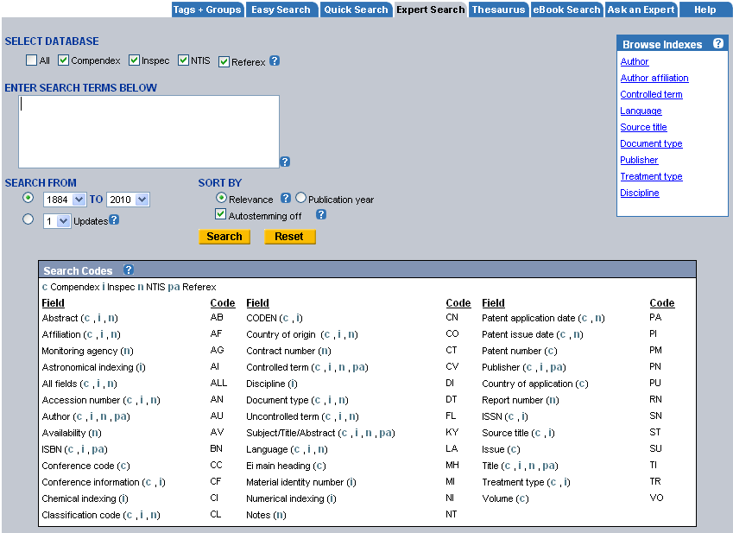
Examples:
"overload" wn AB
((seatbelt* OR (seat belt*)) wn TI
In Quick and Expert search modes, More Search Sources appears on the left side of the screen, to allow you quick access to Referex eBooks, CRC ENGnetBASE, Scirus, etc.
Click Here for A full list of Expert Search Fields and Fields' Codes

Expert Search Fields and Field Codes
In Expert search you can define the fields in which you would like the key words to be searched by using the field code.
Next to each field, in brackets, are the databases in which these fields are available:
c = Compendex
i = Inspec
n = NTIS
pc = PaperChem
cm = Chimica
cb = CBNB
el = EnCompassLIT
ep = EnCompassPAT
g = GEOBASE
f = GeoRef
u = US Patents
pa = Referex
Below are the fields, their corresponding codes, and descriptions.
Field Name | Field Code | Description
All fields (c , i , n, pc, cm, cb, el, g, u, e) | ALL | All available fields.
Abstract (c , i , n, pc, cm, cb, el, ep, g, u, e) | AB | Key words within the abstract.
Accession number (c , i , n, pc, el, ep, g) | AN | A unique number assigned to each record.
Astronomical indexing (i) | AI | Standardized form of the nomenclature of astronomical objects.
Derwent accession number (ep) | AJ | Patent accession number provided by Derwent.
Author/Inventor (c , i , n, pc, el, ep, g, u, e, pa) | AU | Author name or the inventor(s) names of patented item.
Affiliation/Assignee (c , i , n, pc, cm, el, ep, g, u, e) | AF | The affiliation of the corresponding author or the person or organization that has been assigned a patent.
Availability (n, cb) | AV | Information about obtaining the document.
CAS registry number (cm, cb, el, ep) | CR | CAS registry numbers are unique numeric identifiers for chemical substances.
Chemical Indexing (i) | CI | Information about inorganic chemical substances and material systems.
Classification code (c , i , n, pc, cm, cb, el, ep, g) | CL | A numerical hierarchy of general subject categories.
Chemicals (cb) | CM | Chemical terms.
Original classification code (i) | OC | Includes the classification used to order and cross-reference the records in the Science Abstracts. This field will include a numeric code when available.
CODEN (c , i, pc, cm, cb) | CN | A six-character representations of serial titles.
Conference code (c, pc, el) | CC | A number assigned to a conference proceedings record.
Chemical acronyms (cb) | CE | Chemical acronyms.
Companies (pc, cb) | CP | Company names.
Conference information (c , i, pc, el) | CF | Includes the name, date, location, and sponsor of a conference as well as the conference code number.
Contract number (n) | CT | Contract or grant number issued by the federal agency sponsoring the research.
Controlled term (c , i , n, pc, cm, cb, el, ep, g, pa) | CV | A subject term used to describe the content of a document in the most specific and consistent way possible.
Controlled term as a reagent (el, ep) | CVA | Controlled term as a reagent.
Controlled term as a product (el, ep) | CVP | Controlled term as a product.
Controlled term with no role (el, ep) | CVN | Controlled term with no role.
Country of application (c, pc) | PU | The country or countries where a patent was applied for.
Country of origin (c , i , n, cm, cb, el, g, u, e) | CO | The country where the publication or patent originated.
Discipline (i) | DI | The five main subject areas covered by Inspec.
Document type (c , i , n, pc, cm, cb, el, g) | DT | Describes the type of source publications from which indexed papers are taken.
DOI (c, i, pc, cm, el, g) | DOI | The registered DOI for electronic documents.
Patent application date (c, n, pc, ep, u, e) | PA | The date on which the application was filed.
ISBN (c , i , pc, cb, el, g, pa) | BN | A 13-character representation of monograph titles.
ISSN (c , i , pc, cm, cb, el, g) | SN | A nine-character alphanumeric representation of serial titles formatted as two sets of four numbers separated by a hyphen.
Language (c , i , n, pc, cm, cb, el, ep, g) | LA | The language of the document is given at the end of the citation if it is other than English.
Linked term (el, ep) | LT | Linked term.
Ei main heading (c) | MH | Represents the major subject aspect of the document.
Industrial sectors (cb) | GD | Industrial sectors.
Major term (el, ep) | CVM | Major term.
Major term as a reagent (el, ep) | CVMA | Major term as a reagent.
Major term as a product (el, ep) | CVMP | Major term as a product.
Major term with no role (el, ep) | CVMN | Major term with no role.
Material identity number (i) | MI | An internal Inspec code uniquely identifying the publication issue for serials or the entire publication for non-serials.
Monitoring agency (n) | AG | The acronym of the sponsoring organization and may contain a report number as well.
Notes (n) | NT | Notes fields that might include information about the title, a description of the document type, or format.
Numerical indexing (i) | NI | Numerical data indexing standardizes the way values are expressed by the authors within their papers.
Publication date (u, e) | PD | The date on which the patent application was first published.
Patent country (ep) | PC | The country in which the patent was published.
Patent examiner (u, e) | PE | The person responsible for examining the patent application.
Patent issue date (c, n, pc, u, e) | PI | The date the patent was issued.
IPC code (ep, u, e) | PID | The international patent classification code as issued by the World Intellectual Property Organization (WIPO).
Patent number (c, pc, ep, u, e) | PM | The number assigned to a patent.
Patent citation (u, e) | PCI | All patents that cited the searched patent number.
Patent application country (ep, u, e) | PCO | The country in which the patent document was filed.
Patent authority code (ep, u, e) | PAC | The patent preliminary examining authority.
ECLA code (e) | PEC | The classification scheme applied by the European Patent Office.
Patent filing date (u, e) | PFD | The date the patent was submitted to the patent office.
Patent application number (ep, u, e) | PAM | Identification number assigned to applications that have received a filing date.
Patent attorney name (u, e) | PAN | The name of the legal representative of the patent applicant.
Publisher (c , i , pc, cm, el, g, pa) | PN | Identifies publishers or the journals published by a particular publisher.
Patent priority information (ep, u, e) | PRN | A unique number assigned to applications that have issued as patents.
Priority country (ep) | PRC | Patent priority country.
Priority date (ep) | PRD | Patent priority date.
US classification (u) | PUC | The original and cross-reference classes in which the patent was classified at the time of the most recent PTO Master Classification File.
Report number (n) | RN | A unique number assigned to reports.
Role (el, ep) | RO | Role.
Source title (c , i, pc, cm, cb, el, g) | ST | Identifies source titles, e.g., journals, monographs, or conference proceedings.
SIC codes (cb) | IC | SIC Codes.
Subject/Title/Abstract (c , i , n , pc, cm, cb, el, ep, g, u, e, pa) | KY | Retrieves results from fields, including Abstract, Title, Translated title, Controlled terms, and Uncontrolled terms.
Title (c , i , n , pc, cm, cb, el, ep, g, u, e, pa) | TI | Terms within an article's title.
Treatment type (c , i, pc) | TR | Specifies the slant or approach taken in the document.
Uncontrolled term (c, i, n, pc, g) | FL | Free language terms; additional entry, or non-preferred, subject terms assigned by indexers. These terms are derived from the abstract and author keywords.
Regional terms (g) | RGI | Terms describing a geographic region.
Issue (c , i , g , f , cm , pc , el) | SU | The issue of the publication in which the article appears.
Volume (c , i , g , f , cm , pc , el) | VO | The volume of the publication in which the article appears.

Faceted Searching on Patent Information
Use facets to refine a patent search.
When searching patents alone the following facets will be available:
Database - Refine your search to either US or European patents.
Note that patents in the database facet include both applications and grants.
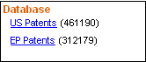

Patent type
Refine your search to either US or European grants or applications. Here you can chose to focus your search on different types of patents

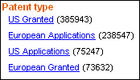

Inventor
Select one or more inventors. In brackets, are the number of records found for each inventor.
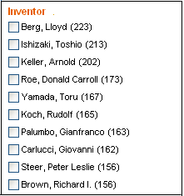

Assignee
Refine your search by assignee. In brackets, are the number of records found for each assignee.
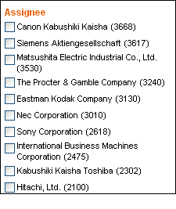

Classification Codes
When placing your mouse on each of the classification codes (including US, IPC and ECLA classification codes), a full description of the classification codes will be presented. The description includes the subclasses (appearing after the / sign). The main class is bolded.
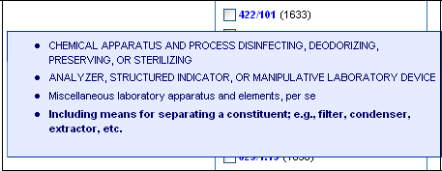

Country
Refine your search by country. The number in brackets specifies how many related patents were issued in a certain country.
Year
Refine your search by year of publication. In this list you can see how many related patents were granted or applied in a certain year

Facets' Export
The Export icon lets you save or open the terms and records counts as a tab file which can be opened with any software. All the terms in a facet are exported at once regardless of the view.
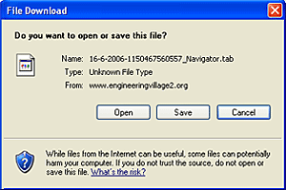
When you click on the icon, a download window will appear. Save or open the tab file. You can select in which software you would like the file to open.
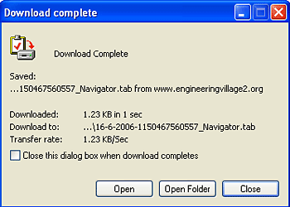
For example, you can export the file to Excel and use the data to create many graphs and charts.
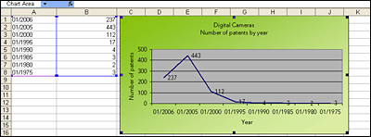

Facets Graphs
The graph and export icons appear next to each facet on the search results screen. They are functional elements which allow you to view your faceted results as a bar graph or download a text file that can be exported to other software.

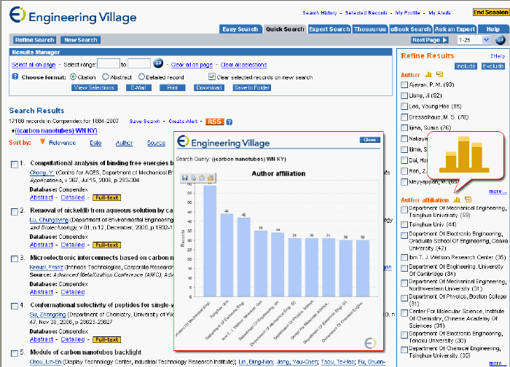

1: When clicked, the bar graph sign Image will open a new window where an image of the top 10 results in the facet will appear. The bar graph will show the current results in the facet. For example, when you click on 'more', adding 10 more terms are added to the facet, the graph will show the terms that appear on the list that you are viewing. You can save, print or email this image using the windows images utility functions as can be seen below.

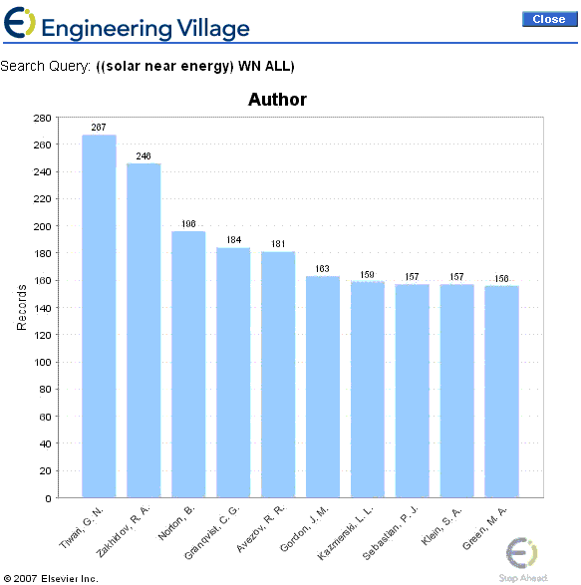

Full-text Links
Your library may choose to display links to electronic full-text available for many publishers' journals through the CrossRef service. These links display as yellow Full-Text graphics. Only citation, abstract and detailed level records with a verified DOI (digital object identifier) associated with them can show a link to the electronic full-text.
Note: A link will appear only if the publisher has made the journal or article available online, and if the CrossRef service provides links to that particular publisher's holdings.

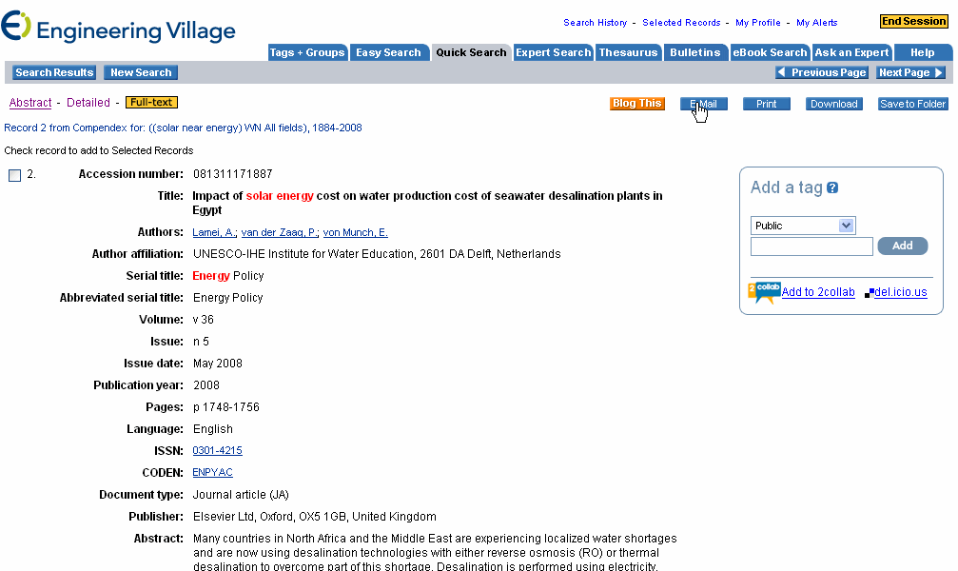

Even if all these criteria are met, access to the full text can still only be granted if your institution carries an electronic subscription to the item.
A list of publishers and journals that participate in the CrossRef service can be found at http://www.crossref.org/.
Full-text documents appear in a separate browser window.

Ei Patents Full-text Access
The 'full-text' link will open the full-text of the patent in PDF format.

Further Assistance
Ask an Expert
The “Ask an Expert” feature provides users with the opportunity to ask questions of either an EV Engineer, the Product Specialist , or the librarian of that user’s organization. The EV engineers are experts in chemical, mechanical, industrial, electrical, manufacturing, materials and computer-related engineering topics.
Feedback
Click on the Feedback link at the bottom of each page for a feedback form. We look forward to receiving your comments. Your input is used to help us create better products for our customers.
Privacy Policy
A copy of Elsevier's privacy policy can be found by clicking the link at the bottom of each page.
GEOBASE Special Index Fields
Click here for a full list of all available search fields on Expert search
Regional descriptor
This data element is used for regional descriptors assigned to the record.
e.g. United States - Arizona - Grand Canyon
Atlantic Ocean - Mid - Atlantic Ridge

Species descriptor
Species are controlled against an authority list introduced in 1999. Taxonomic groups higher than genera (e.g. family names) are also indexed, though less commonly.
e.g. Oscillatoria bourellyi
Gerris buenoi

GeoRef Search Fields and Limits

The following fields are searchable in GeoRef:
Click here for a full list of all available search fields on Expert search
All fields
"All Fields" will retrieve results from any of the following fields: subject/title/abstract, abstract, author, author affiliation, title, source title, country of origin, controlled term, publisher, CODEN, ISBN, and ISSN.
Limiting your search
Searches may be limited by document type, language or publication year.
Document type
You can select one of the following document types to limit your search:
All document types
Journal article
Conference article
Conference proceeding
Monograph chapter
Monograph review
Report chapter
Report review
Dissertation
Map

Language
You can select one of the following languages to limit your search:
All languages
English
Chinese
French
German
Italian
Japanese
Russian
Spanish

Limit by Date
Year Limits
If you do not find what you need, broaden your search by selecting the date range limit and expanding the range of your search to the last year, the last five years, etc.
Updates
Selecting this option allows you to limit your search by the 1, 2, 3, or 4 most recent database updates. GeoRef is updated weekly.
Browse indexes
From the Browse Indexes box (located on the right side of the page), select the index you wish to use by clicking on the radio button next to it and then clicking on "Browse."
Once the index is loaded, you can navigate by either selecting the first letter(s) of the term you wish to search for or by typing in the first few letters of the term in the SEARCH FOR box and clicking on "Find."
In Quick Search, when you select a term from the index, it is automatically pasted into the first available textbox. The SEARCH IN box will also be changed to the appropriate field. Un-selecting the term from the index will remove it from the textbox. If you select more than three terms, the fourth term will overwrite the term in the third textbox.
You can also choose to have the second and third index terms pasted from the indexes with either a Boolean AND or OR connecting them. For more information, refer to the Boolean Operators section.

Including & Excluding Terms
Faceted Searching options:
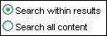

Search Within results: The option of searching within results gives you the flexibility to add your own term and/or others terms from the facets to a search that you have a set of results for.
Search all content: You can also perform a new search using either faceted terms or terms that were freely added.
How does faceted searching works?
You can mix terms from more than one category in a single refining step.
Including or excluding terms from different facets
If you select terms from different facets these are treated as AND. They are either included or excluded from your search. When you use Include this is shown as '+' sign in the search path. See example below:
When including an author and document type the system will search for the original term AND the author and the document type selected.
In the example below we first searched for "acid", than we included an author and a document type which resulted in a query that uses a '+' sign between the initial key word and the added terms from the facets.

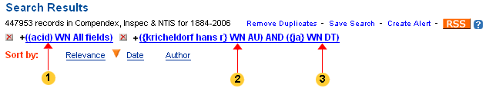
1: Original Term
2: Added term - Author
3: Added term - Document type

When you exclude terms from the facets these are shown in the search path as '-' sign. See example below
For example, when excluding an author and document type the system will search for the original term NOT the author and the document type selected, meaning that both selected terms will be excluded from the new search

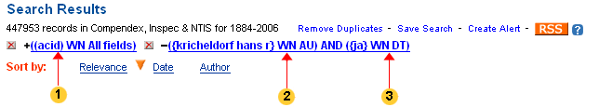

1: Original term
2: Excluded term - Author
3: Excluded term - Document type

Including or excluding terms within facets
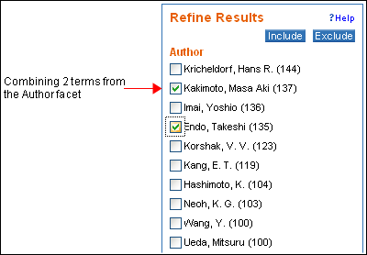

The results will look like this:
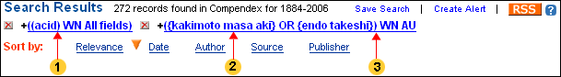

1: Original term
2: Included term 1 from Author facet
3: Included term 2 from Author facet
The same applies for exclusion - terms selected from the same facet are excluded from a search.

AND / OR combinations within and between facets
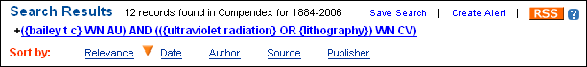

When selecting an author from the 'Author' facet and combining it with 2 terms from the 'Controlled vocabulary' facets, the system will combine the 2 control vocabulary terms with an "OR" and use the AND operator to combine them with the selected author term as shown above.
To continue refining your search, you can choose one of the following options:
Continue refining your search using the facets presented on the right side of the screen
Click on "Refine Search" button on the upper left side of the screen to use Boolean command language. This will bring up the Expert Search screen.

See example below:
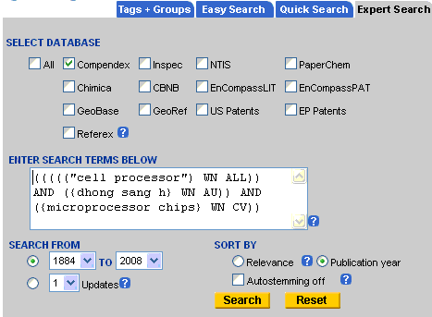

Indexes
The Browse Indexes help you select appropriate terms for your search.
The Browse Indexes provided are restricted to indexes common to combined databases.
The Browse Indexes for combined searches have the database containing terms indicated after each entry.
The field preference takes precedence over the database preference. If, for example you select 'Full text' from the field preference and 'Compendex' from the Database preference and there are no full text records in Compendex, the system will retrieve full text records from Inspec although Compendex was your preferred database.

Inspec and Inspec Archive Search Fields
Click here for a full list of all available search fields on Expert search
Inspec and Inspec Archive Fields
All Fields
Searching All Fields retrieves results from any of the following fields: Abstract, Author, Author affiliation, CODEN, Conference information, Document type, ISBN, ISSN, Material identity number, Monograph title, Publisher, Source title, Accession number, Numeric indexing, Chemical indexing, Astronomical indexing, Controlled terms, Uncontrolled terms, Title, Classification code, Translation Serial title, Discipline, Language and Treatment type.
All Fields is the default for Inspec.

Abstract
Searching Abstract finds terms in the abstract field. To search for an exact phrase, enclose term within braces or quotation marks.
"solar energy"
{graphical user interface}
(gold or fe) wn AB

Accession Number
The accession number is a unique number assigned to each record in Inspec. It is only displayed in the detailed record format. Accession number is searched in All Fields in Easy, Quick or Expert Searches or by itself in Expert Search:
11414022 wn AN

Astronomical Object Indexing
Astronomical Object designations have been indexed in the Astronomical Object field back to 1995. It allows named or numbered objects to be retrieved more efficiently. Three types of designations exist:

Name-based acronyms:
LMC wn AI (Large Magellanic Cloud)
R Sct (object in constellation, e.g., HDW)
Catalog-based acronyms including their catalog entry name. This number may be sequential (NGC 204) or represent a position in the sky, (PRS 1913+16).
"HR 3237" wn AI
Positional information only:
"4U 0115+63" wn AI

Detailed information about Astronomical Object indexing can be found at the IET Web site at http://www.theiet.org/publishing/inspec/about/records/astronomical/.

Author
Inspec does not use authors' first names, but only their initials. The database also includes any suffixes appended to the name. To search on an author name, enter last name, comma, then a space, initial(s) and suffix (if any).
White, A. A.
Brown, A.C., Jr.
Author names can be truncated by using an asterisk (*) as a truncation symbol.
Jones, A* retrieves
Jones, A. A
Jones, A. B.
ones, A. C
Jones, A. D. III
Jones, A. D. R.
Jones, A. D. W.,
Jones, A. D.
Jones A. E, etc.
Be aware that this strategy may lead to false hits because there are many authors with the same last name and first initial. Use of the Author Browse Index is strongly recommended in order to make selections from all the possible variations on an author's name.
Note that only authors whose names are presented in the format given will be retrieved. For instance, searching on Templeton, D.D. will not retrieve articles with the author cited as Templeton, D.
If a single term is entered as an author name, all forms of that name will be retrieved, e.g., entering Fisch will retrieve articles by all of the following:
Fisch, A.
Fisch, A. M.
Fisch, B.
Fisch, B. J.
Fisch, C.
Fisch, C. B.
Fisch, D.
Fisch, D. E.
Fisch, E.
Fisch, E. A.
Fisch, E. E.
Fisch, E. F.
To further refine this search, add the truncation symbol after the first initial.
Fisch, E* will retrieve:
Fisch, E.
Fisch, E. A.
Fisch, E. E.
Fisch, E. F.
When records are displayed, author names are hyperlinked. Click on an author hyperlink to retrieve records with that author from the entire date range of the database.

Author Affiliation
The institutional affiliation at the time of publication is given for the first author of each record as given in the journal if it can be determined from the source document. The affiliation includes the name, city, state and country of the organization where applicable. In some cases, more than one level of the organization is cited as well.
As variations and abbreviations may have been used, it is a good idea to use the Author Affiliation Browse Index.

Chemical Indexing
The Chemical Indexing field is a system of controlled indexing for inorganic substances and material systems.
Every significant substance in a record is given one of three basic role indicators:
element (el), e.g., {Si/el} wn CI
binary (bin), e.g., {Al/bin} wn CI
system (ss), e.g., {Ga/ss} wn CI
Some substances may be assigned special rolls. These are:
interface system (int)
surface or substrate (sur)
adsorbate (ads)
dopant (dop)

Detailed information about Chemical Indexing can be found at the IEE Web site at the IET Web site at http://www.theiet.org/publishing/inspec/about/records/chemical/

Classification Code
The Inspec Classification is divided into five areas.
A (Physics)
B (Electrical and Electronic Engineering)
C (Computers and Control)
D (Information Technology)
E (Manufacturing and Production Engineering)
The single letter and following four digits indicate the levels of classification. The letter (A B C D or E) represents the discipline area. The most general level is represented by the first digit. The second level is represented by the second digit, etc.
A4000 Fundamental areas of phenomenology
A4200 Optics
A4255 Lasing processes
A4255N Fibre lasers and amplifiers
The following table contains the Outline of Inspec Classification scheme.

CODEN
CODEN are six-character representations of source titles. They can be used to limit results to a specific journal. CODEN can be found in Inspec's List of Journals, Ulrich's Periodicals Directory and CASSI: Chemical Abstracts Service Source Index. You can also find a journal's CODEN at the abstract and detailed level of a record.
Conference Information
Conference information includes the name, date, location, and sponsor of a conference.
Controlled Term
The controlled vocabulary used to index records in Inspec can be found in the Inspec Thesaurus available online. These terms can also be browsed in the Inspec Controlled-term Browse Index.
These terms also appear hyperlinked in the abstract and detailed record format. Clicking on any of these will retrieve additional records on that subject spanning the default time period of the database.

ISBN (International Standard Book Number)
The International Standard Book Number (ISBN) is a formerly 10-, now 13-digit number that uniquely identifies a specific title and edition of a monograph or monographic series. It can be used to find chapters from the same monograph or papers from the same conference. The ISBN appears at the abstract or detailed level of a record. An ISBN is searchable in All Fields for Easy, Quick, or Expert Search or individually according to the specific search code in Expert Search.
978-0-87339-255-8 wn BN

ISSN (International Standard Serial Number)
The International Standard Serial Number (ISSN) is a standardized international alphanumeric code that is a unique and precise identifier for a serial publication. The format of the ISSN is an eight-digit number, divided by a hyphen into two four-digit numbers. The last digit, which may be 0-9 or an X, is a check digit. It can be used to limit search results to a specific journal or serial conference proceeding. It can be searched with or without the hyphen. The ISSN is displayed in abstract and detailed formats. There may be an E-ISSN displayed, which is assigned to the electronic version of a serial.

Material Identity Number (1996 - present)
This field contains an internal Inspec code uniquely identifying the publication issue for serials or the entire publication for non-serials. It can be used to find papers from a specific issue of a journal once at least one paper from that issue is located. It can also be used to find all the papers from a conference proceedings or chapters from a book.
"O646-2002-002" wn MI

Numerical Data Indexing
Numerical data indexing standardizes the way values are expressed by the authors within their papers.
For example, 32 megawatts may be cited as:
32 M W
32000 kW
32 MWatts, etc.
Numeric data indexing is composed of three elements:
Quantity, e.g. temperature, wavelength, frequency,
{power 3.5E+07 W} wn NI
Unit, e.g. meter, hertz, Kelvin
"7.151E-10 M" wn NI
Value, range expressed in floating point format
"Temperature 9.5E+01" wn NI

Detailed information about Numerical Data Indexing can be found at the IET Web site at http://www.theiet.org/publishing/inspec/about/records/numerical/.

Publisher
Search on the Publisher field to identify publishers, or find the journals published by a particular publisher. Be sure to look for all versions of a publisher's name. To do so, it is helpful to refer to the Publisher Browse Index. For example, American Institute of Physics can appear as:
AIP
AIP Press
American Inst. Phys

Source Title
Search on the Source Title field if you want to identify source titles, e.g., journals, monographs or conference proceedings, from your area of study.
Searching for polymer* will retrieve citations whose sources will include:
Polymers for Advanced Technologies
Journal of Applied Polymer Science, etc.
To search for a specific source title, enclose the title in braces or quotation marks.
{X-Ray Spectrometry}
"Journal of X-Ray Science and Technology"
As variations of source title names sometimes appear, it is a good idea to use the Source Title Browse Index. The look-up index also includes monographs and conference titles.

Subject/Title/Abstract
Searching for Subject/Title/Abstract retrieves results from any of the following fields: Abstract, Title, Controlled terms or Uncontrolled terms.

Title
If you want to search for specific terms within the title, search on the Title field. Words in a title are often indicators of the main focus of the article. For example, "radio frequency" in the title will likely find articles where radio frequency is an important aspect of the article.
All titles in Inspec are in English.

Uncontrolled Term
Uncontrolled terms, also known as free language terms, are additional subject terms assigned by indexers. These terms are not selected from the Inspec Thesaurus, but can reflect new expressions and terminology used in a particular discipline. These terms allow for further specificity in indexing that is not available using controlled vocabulary. Uncontrolled terms may subsequently become part of Inspec's controlled vocabulary.
{irregular media} wn FL
"stationary phase methods" wn FL

Inspec and Inspec Archive Search Limits
Disciplines
You can limit your search to one of five main subject areas covered by Inspec. In Quick Search, the Discipline is a limit and can be selected from a drop-down menu. In Expert Search, it is searchable. Disciplines are:
Physics
Electrical/electronic engineering
Computers/control engineering
Information technology
Manufacturing and production engineering

Document Type
Document types are used to describe the type of source publications from which indexed papers are taken. In Quick Search, the document type is a limit and can be selected from a drop-down menu. In Expert Search, it is searchable.
The document types used in Inspec are:
All document types (default)
Journal article
Conference article
Conference proceedings
Monograph chapter
Monograph review
Report chapter
Report review
Dissertation
Patent (before 1976)

Language
In Quick Search, language can be applied as a limit from the language pull-down.
In Expert Search, language can be searched directly or selected from the Language Browse Index
chinese wn LA
A complete list of available languages within the Inspec database is in the Language Browse Index in Expert Search.
The language of the document is given at the end of the citation if it is other than English.
If more than one language is given, they are separated by a comma, for example:
French, German

Treatment Type
Treatment types indicate the slant of the article. In Quick Search, Treatment Type can be applied as a limit in the Treatment Type pull-down box.
In Expert Search, the document type can be selected from the Treatment Type Browse Index or searched directly
ECO wn TR

Inspec treatment types:
All treatment types (default)
Applications - when document describes use or implementation of an instrument device, etc.: where an application is involved
Bibliography - anything with 50 or more references
Economic - where document deals with economic commercial aspects: cost, pricing, market forecasts, etc.
Experimental - anything dealing with a test, trial, tentative procedure or policy
General review - overall view of subject. General approaches, state of the art reviews, overviews, etc. Useful to researchers who want an overview of an unfamiliar field. Often layman's language or non-technical
New developments - anything new or novel in patentable sense
Practical - practical use; hands on approach
Product review -- subset of practical, introduced in 1985, includes product comparison tables and buyer's guides
Theoretical - analysis of a set of facts and their relationship to one another
A record may have one or more treatment types. However, not all records have been assigned treatment types.

Lead-in and Prior terms
In thesaurus pages, subject terms are hyperlinked; clicking on a term will bring you to its thesaurus record. Terms that appear in italics are "lead-in terms," which are either synonyms that are not part of the controlled vocabulary or prior terms that were formerly used for indexing and are still in the database in older records, but have been replaced by newer controlled terms. Any database search that involves the entire range of years should include both current and older controlled vocabulary. Prior terms are identified by an asterisk. Lead-in terms that are synonyms only, and that are not prior indexing terms, do not have a Select option.

Limits
Document type
Document types are used to describe the type of source publications from which indexed papers are taken. Users should refer to the individual database help sections for a fuller description of the document types available in each database.
Compendex Document Type
Inspec Document Type
Ei Patents Document Type

Treatment type
The treatment type is used to specify the slant or approach taken in the document. Users should refer to the individual database help sections for a fuller description of the treatment types available in each database
Compendex Treatment Type
Inspec Treatment Type

Discipline (Inspec only)
You can limit your search to one of five main subject areas covered by Inspec. Disciplines are:
Physics
Electrical/electronic engineering
Computers/control engineering
Information technology
Manufacturing and production engineering

Language
You can limit your search to any language listed in the Quick Search drop-down menu: All languages, English, Chinese, French, German, Italian, Japanese, Russian or Spanish.
To search for more than one language, or to search for additional languages not listed in the Quick Search pull-down menu, use Expert Search. A complete list of available languages within the various databases is in the Language Browse Index in Expert Search.

Linda Hall Library Document Delivery Service
The full texts of most documents in Compendex and Inspec are available from the Linda Hall Library of Science, Engineering and Technology in Kansas City, Missouri. You can click on the "Linda Hall Library document delivery service" link beneath the Full-text and Local Holdings Links options bar in the Abstract or Detailed format of an article. How the transaction is handled from this point will depend on whether or not your organization has a deposit account with Linda Hall Library and what type of account it is. Individuals can order documents on their credit cards.
For more information, see http://www.lhl.lib.mo.us/services/document_delivery/index.shtml.

Link to Local Holdings
Libraries have the option to link records to their online public access catalog or other library intranet pages. If your institution's library participates in this service, a link or graphic can appear to the right of the Detailed Record link in the citation and below the blue bar called Full-text and Local Holdings Links in the Abstract and Detailed format views.

Locating Terms
There are several ways to identify controlled vocabulary terms. Type a term in the search box and click either Search, Exact Term or Browse, then click Submit.
Search
This looks for the term you have entered anywhere in a controlled vocabulary term as well as for broader, narrower and related controlled vocabulary terms, either as full terms or fragments of longer ones. The terms appear in alphabetical order.
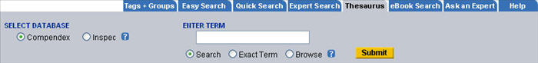

If you enter a term that is not in the controlled vocabulary list, the system will suggest alternate spellings. If any of the suggestions match what you are looking for, check the radio button at that suggestion and click on Search again. The system then searches the thesaurus for that term. You can also click the hyperlinked term and brings you to its thesaurus record.

Exact Term
If you know the exact subject heading you are looking for, and want to see its broader, narrower or related terms directly, you can use the Exact Term function. This takes you directly to the main record for the term, which can also show broader, narrower or related terms to illustrate the heading's context in the controlled vocabulary. For example, the main record for 'Mine ventilation' shows the broader term 'Ventilation' and the related terms 'Mines and mining.'
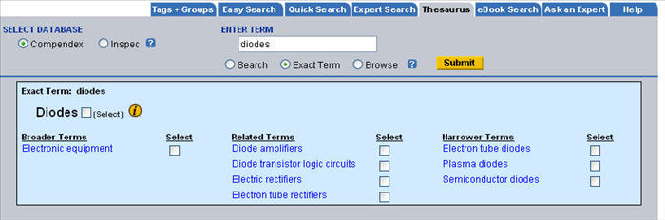

Some Narrower Terms and Related Terms can also have narrower terms of their own. If you wish to do a comprehensive search on a subject, it may be beneficial to explore all likely paths. Here, a comprehensive search for 'Diodes' should include all of the narrower terms, each of which should be explored: 'Semiconductor diodes' has the following narrower terms: 'Avalanche diodes,' 'Gunn diodes,' 'Light emitting diodes,' 'Photodiodes,' 'Tunnel diodes,' 'Varactors' and 'Zener diodes.' These terms cannot be selected from the diodes record. To find and select these narrower terms click on the hyperlink for 'Semiconductor diodes.' The narrower terms should also be selected for a comprehensive search.
If you try to do an Exact Term search for a term that is not a controlled vocabulary term, the thesaurus will suggest alternate spellings. Click any of the hyperlinked suggestions to go to the thesaurus record.

Browse
The Browse command functions as an index does in a printed thesaurus. Selecting Browse takes you to the section of the Thesaurus where the term would appear alphabetically. Use Previous Page or Next Page to scroll through the entire thesaurus alphabetically.

Managing Your Results
Selecting Records
You can select particular records from the search results (Compendex, Inspec or NTIS only) in one of three ways.
You can individually mark the check boxes next to their corresponding records; you can click on the hyperlinked phrase Select all on page (this will select up to 25 records on an individual page of results); you can select a range of records by entering the first and last record numbers to be included within the range and then clicking on the GO button.
The records are then transferred to a Selected Records page. You can add up to 400 records to work with in Selected Records. Click on the Selected Records icon in the top navigation bar to work with your Selected Records.
Only 5,000 results can be retrieved from any search. The display will indicate the number of results that were located but only the first 5,000 will be available to be selected.
Selecting an Output Format
Once you have selected the desired records, you can then choose the format you wish to view them in (citation, abstract or detailed).
You can now select the output action you want for your Selected Records (view selections, email, print, download, save).
View Selected Records
Read the records you have selected on screen in the format you have chosen (citation, abstract, detailed).
Email Selected Records

Email your search results to yourself or others. An email form appears, allowing you to enter the email address of the recipient and yours, as well as any message you wish to add.
Print Selected Records
Format the selected records in a neat, printer-ready format. The printer-ready records will appear in a new browser window with all full-text and local-holdings notations removed. Click on the Print icon in the new window to start printing.

Download Selected Records
Download the records in RIS, RefWorks, BibTex or ASCII text format. RIS is compatible with EndNote, ProCite and Reference Manager. Important: You must have one of these products installed on your computer in order to import your Selected Records to that utility.
Save Selected Records
You can create folders and save search results by using the Personal Account function. If you click on the "Save to Folder" option, you will get a screen asking you to login to your Personal Account. If you do not have a Personal Account, you can create one. (See instructions for registering for a Personal Account).
Once you are registered and logged in, you can select a folder to save the results to, or create a new folder. A "Records Saved" message will appear when your records are successfully saved. This message also states which folder the records were saved to, as well as offering you the option to view its contents.
You are allowed to create up to three Personal Folders. You can edit your Personal Folders (rename folders, delete folders, create folders, view folders) by clicking on the My Profile link at the top right of all pages. Within the My Profile page is a link called "View/Update My Folders." Records can be viewed or removed from this page. You can save up to 50 records within each folder.
In addition, you can delete individual records, or all the records within individual folders while viewing the contents of an individual folder.

Mapping tool
The Mapping tool is standard in GEOBASE and GeoRef databases. It is about graphically showing, or mapping the significant geographic features that are mentioned in the result set of a search. After running a search, users can choose the "Show Map" button and a map of their results will appear. The map plots different geographical data from GEOBASE and GeoRef search results on a digital map utilizing Google map technology.
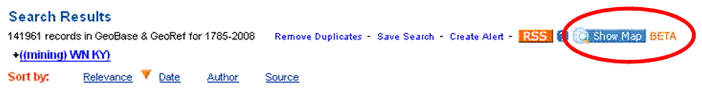
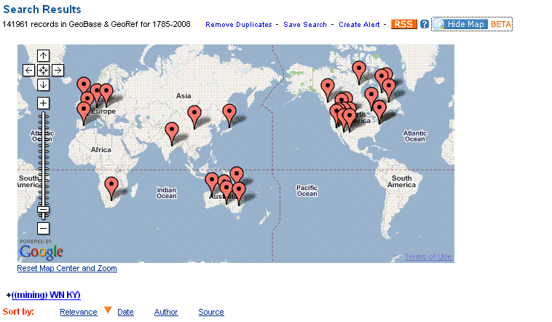

There is also an additional facet included with the mapping tool, called "Geographic Terms". This is not to be confused with the "Country" facet. The Geographic Term represents the geographic locations that are plotted on the map. The Country represents the country in which the Author Affiliation is located.
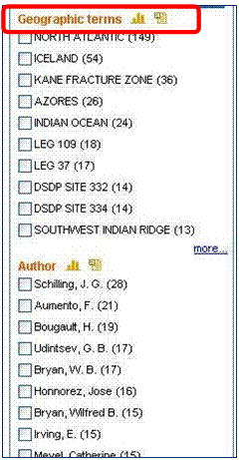

Icons on the map represent geographic terms – roll over icons to display term and record count.
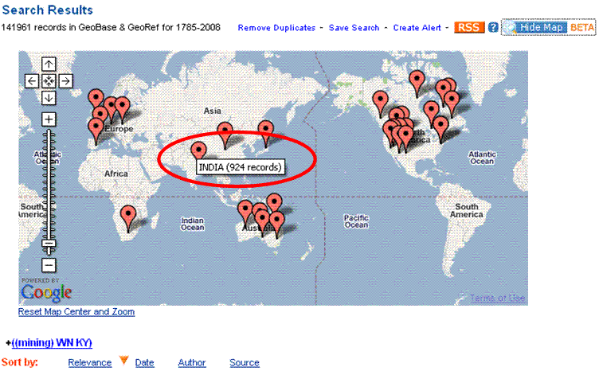

Zoom in and out ; Navigate with arrows or by panning over map.
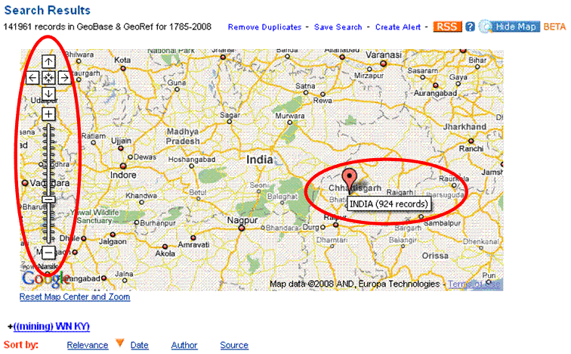

Clicking on map icon generates the subset of search results which include that feature/location (same as selecting term from facets and clicking “include”). Once the new set of search results appears, the map will close. Clicking the "Show Map" button again will bring up the map again.
Users can click the "Hide Map" button again to hide the map.

NTIS
NTIS Search Fields
Click here for a full list of all available search fields on Expert search
All Fields
Searching All fields will retrieve records from the Abstract, Author, Author affiliation, Classification code, Contract number, Country of origin, Monitoring agency, Accession number, Controlled term, Report number, Title, Availability, Language, Notes, Patent filing date, Patent issue date, Uncontrolled term and Document type.

Abstract
Searching Abstract finds terms in the abstract field.
Accession Number
This is a unique NTIS order number. Formats vary. It is searchable in All Fields for Easy, Quick or Expert Search or individually according to the specific search code in Expert Search.
e.g. PB2003-123456
N2003-12345/6

Author
The format of the authors' names varies in the NTIS database. In some instances, the name will appear with the last name, first name and middle name. In some cases, it will be the last name and initial. It might be just the last name. Using the Author Browse Index will help you identify the possible variations.

Author Affiliation
This is the organization where the work was performed. Since 1980, NTIS has maintained a related index of author affiliation codes. The organizational names may vary. Use of the Author Affiliation Browse Index is recommended.

Availability
Information about obtaining the document will be found in this field. This field may also contain notes about the document format or availability of the hard copy. An example of the field is: Order this product from NTIS by: phone at 1-800-553-NTIS (U.S. customers); (703)605-6000 (other countries); fax at (703)605-6900; and email at orders@ntis.gov. NTIS is located at 5285 Port Royal Road, Springfield, VA, 22161, USA.

Classification Code
NTIS uses two sets of classification codes, COSATI and NTIS Subject Category Classification. Since 1986, only the NTIS Subject Category Codes have been used. They can be found in Appendix B of the NTIS help document at http://grc.ntis.gov/grcdbg.pdf

Contract Number
This field contains the contract or grant number issued by the federal agency sponsoring the research.

Controlled Terms
The controlled terms are assigned by indexers to describe the subject of the document. At least three different sets of terms are used in the NTIS database. They include the subject lists from the US Department of Energy, the Department of Defense Technical Information Center and NASA.
Controlled terms can be identified by using the NTIS Controlled Term Browse Index.

Country of Origin
This is the country where the publication or patent originated.

Document Type
The document types are not entered into the NTIS database in standard formats. Some examples of common document types are:
Technical reports
Final reports
Journal articles
Conference papers
Computer products
Dissertations
Note: This is only a partial list, and does not include the hundreds of document type variations found in the database.

Filing Date
This is the date the patent application was filed.

Monitoring Agency
This field contains the acronym of the sponsoring organization and may contain a report number as well.

NTIS Price Codes
The detailed records for NTIS have a field with the NTIS price codes. These indicate the cost of ordering the document from NTIS. The link can be found at http://www.ntis.gov/pdf/pricode.pdf Price codes are not searchable.

Notes
The NTIS database provides several notes fields that might include information about the title, a description of the document type or format.

Patent Issue Date
This is the date the patent was issued.

Report Number
This is the number assigned by the sponsoring agency. It is usually a series of alphanumeric numbers, e.g. EPA/600/J-94/280

Subject/Title/Abstract
This field will retrieve records from the abstract, title, controlled and uncontrolled terms. This is helpful for maximizing the relevance of your search results.

Title
If you want to search for specific terms within a document's title, search on the Title field. Words in a title are often an indication of the importance of those terms in the article. For instance, "radio frequency" in the title will likely find articles where radio frequency is an important aspect of the article.

Uncontrolled Terms
Uncontrolled terms are indexing terms that do not come from the controlled vocabulary lists. They are assigned by indexers when there is no appropriate term available in the controlled vocabulary. They often describe new technology and terminology.

NTIS Search Limits
Language
In Quick Search, you can limit your search to any language listed in the drop-down menu: All languages, English, Chinese, French, German, Italian, Japanese, Russian or Spanish.
In Expert Search, language can be searched directly or selected from the Language
Browse Index
turkish wn LA

A complete list of languages available in the NTIS database is available in the Language Browse Index in Expert Search.
The language of the document is given at the end of the citation if it is other than English.
If more than one language is given, they are separated by a comma, for example: French, German

OpenURL Link Resolvers
Likewise, if your institution maintains an OpenURL compliant link resolver such as Endeavor LinkFinder Plus, Ex Libris SFX, Serials Solutions Article Linker, or Innovative Interfaces Web Bridge, a link or graphic will appear to the right of the Detailed Record link in the citation and below the blue bar called Full-text and Local Holdings Links.

Options
Overview
Subscribers of Engineering Village have many customization options to choose from. To have any of these customizations added for your library's usage, please have the account administrator contact Ei Customer Support at eicustomersupport@elsevier.com.
Ask an Expert
Your library can have Ask a Librarian questions sent to local reference staff instead of to Ei librarians. This option facilitates communication between local reference staff and the end-user via Engineering Village. Customers who prefer that the Ask an Expert tab be removed completely can have this done as well.
Autostemming in Quick Search
Customers can request this default to be on or off.
Default Database
Customers can choose which database or combinations of databases to have as a default search page.
Default Home Page
Customers can now choose Easy Search, Quick Search, Expert Search, eBook Search or Thesaurus as the default search page.
Default Sorting
Customers can have Ei set their pre-search default to Date or Relevance.
Document Delivery
Ei can display links to your preferred document delivery service or to Linda Hall Library at the Abstract or Detailed Records.
Full Text Links
Links to full text may be displayed at the citation, abstract and detailed record level. This feature can be disabled by request.
Limit by Year Default
Customers can have Ei set their default beginning search year to the earliest supported in the subscribed database(s).
Linking Options (external)
Customers can provide text or graphical Local Holdings, Document Delivery, or OpenURL (LinkFinder Plus, SFX, etc.) links to Ei for deployment at citation, abstract and detailed views.

PaperChem Search Fields and Limits
The following fields are searchable in PaperChem:
Click here for a full list of all available search fields on Expert search
All fields
Searching "All Fields" retrieves results from any of the following fields: Abstract, Title, Translated Title, Author, Author affiliation, Serial title, Monograph title, CODEN, ISSN, ISBN, Publisher, Accession number, Conference name, Conference date, Conference location, Sponsor, Index terms, Language, Document type.
"All Fields" is the default for PaperChem.
Abstract
Searching "Abstract" finds terms in the abstract field.
To search for an exact phrase, enclose term within braces or quotation marks. For example:
"Dutch elm disease" wn AB
{quality control} wn AB
Accession number
The accession number is a unique number assigned to each record in PaperChem. It is only displayed in the detailed record format.
7601917 wn AN
Author
Since author names may be cited in a variety of formats, use of the Author Browse Index is highly recommended. PaperChem cites authors' names as they appear in the original document. Surnames appear first, usually followed by a comma and the remainder of the name as it appears in the original document. Initials may appear with or without periods.
If the document is cited by initials and a surname, but a full name is indicated somewhere in the original publication, such as in the table of contents, then all the known information is provided. Titles such as Sir and Mister and educational degrees are not included.
Author names can be truncated by using an asterisk (*) as the truncation symbol:
Smith, A* wn AU will retrieve Smith, A., Smith A. D., Smith Alan, Smith, Ann, etc.
Be aware that this strategy may lead to false hits because there are many authors with the same last name and first initial.
Note that only authors whose names are presented in the format given will be retrieved.
Searching on Smith, A. B. wn AU will not retrieve articles with the author cited as Smith, A.
If a single word surname is entered as the author's last name, all of the forms of that name will be retrieved.
Brown wn au will retrieve:
Brown, C., Brown, James T., Brown, Sheila, etc.
To further refine this search, add the truncation symbol after the first initial.
Brown, A* wn au will retrieve:
Brown, A, Brown, A.F., Brown, A.L., Brown, Alan J., Brown, Alex, etc.
When records are displayed, author names are hyperlinked. Click on an author hyperlink to retrieve records by that author from the entire date range of the database.
Author affiliation
The formats and abbreviations used in author affiliations have changed over the years. Use of the author affiliation Browse Index is highly recommended. Author affiliations are displayed in the detailed record.
CODEN
CODEN are six character representations of serial titles. They can be used to limit results to a specific journal. You can find a journal's CODEN at the abstract and detailed level of a record.
Conference information
Conference information includes the name, date, location and sponsor of a conference.
Index Term
The controlled vocabulary used to index records in PaperChem can be found in the Thesaurus of Pulp and Paper. The 3rd edition contains 22,000 terms. Approximately 50% of the entries are preferred key terms; the rest are cross-reference terms. For each preferred term there are, on average, 12 analytical entries, including, homonym resolutions, scope notes, definitions, warning notes, broader terms, narrower terms, cluster terms, other related terms, cross-references and inverse-reference or USED FOR entries. Nearly 25% of the entries are Latin and common names of trees and other biological species.
These terms appear hyperlinked in the abstract and detailed record format. Clicking on any of these will retrieve records spanning the date range of the original search.
Document type
Document types are used to describe the type of source publications from which indexed papers are taken. In Expert Search, the document type can be searched directly or selected from the Document Type Browse Index, e.g. JA wn DT
The document types used in PaperChem are:
All document types (default)
Conference article
Conference proceeding
Dissertation
Journal article
Monograph chapter
Monograph review
Patent
International Standard Book Number (ISBN)
ISBNs are 10 or 13 character representations of monograph titles. They can be used to find chapters from the same monograph or papers from the same conference. The ISBN will be given at the abstract or detailed level of a record.
8985203494 wn BN
International Standard Serial Number (ISSN)
ISSNs are nine character alphanumeric representations of serial titles formatted as two sets of four numbers separated by a hyphen. The last digit can be an X. They can be used to limit results to a specific journal. You can find a journal's ISSN at the abstract and detailed level of a record as well as in the Serial Title Browse Index.
Language
In Expert Search, language can be searched directly or selected from the Language Browse Index, e.g. Turkish wn la.
A complete list of available languages within the PaperChem database is in the Language Browse Index in Expert Search.
The language of the document is given at the end of the citation if it is other than English
If more than one language is given, they are separated by a comma, for example:
French, German
Patent Information
The patent information field contains the patent number, application number, priority number, assignee and patent classification code
Publisher
Search on the "Publisher" field to identify publishers, or find the journals published by a particular publisher. Be sure to look for all versions of a publisher's name. To do so, it is helpful to refer to the Publisher Browse Index.
TAPPI is referred to as:
TAPPI, TAPPI Press, TAPPI/CPPA, Technical Association of the Pulp and Paper Industry (TAPPI).
Serial title
Search on the "Serial Title" field if you want to identify serial titles, e.g., journals, monographs or conference proceedings, from your area of study.
Searching for pulp wn st will retrieve citations whose sources will include:
Walden's North American Pulp Paper Report
PPI Pulp and Paper International
Process Control News (for the Pulp and Paper Industries)
As variations of serial title names sometimes appear, it is a good idea to use the Serial Title Browse Index. The look-up index also includes serial monograph and conference titles. The Serial Title Browse Index also allows you to limit the search to an exact title match, e.g. "Science."
Subject/Title/Abstract
Searching "Subject/Title/Abstract" retrieves results from any of the following fields: Abstract, Title, Translated title, Index terms.
Title
If you want to search for specific terms within the title, search on the "Title" field. Words in a title are often an indication of the importance of those terms in the article.
"Conservation" in the title will likely find articles where "conservation" is an important aspect of the article.
Limit by Date
Year Limits
If you do not find what you need, broaden your search by selecting the date range limit and expanding the range of your search to the last year, the last five years, etc.
Updates
Selecting this option allows you to limit your search by the 1, 2, 3, or 4 most recent weekly database updates.
Browse Indexes
The Browse Indexes help you select appropriate terms for your search. PaperChem Expert Search has indexes for author, author affiliation, serial title, publisher, index term, treatment type, document type and language.
From the Browse Indexes box (located on the right hand side of the page), select the index you wish to use by clicking on the radio button next to it and then clicking on "Browse."
Once the index is loaded, you can navigate by either selecting the first letter(s) of the term you wish to search for or by typing in the first few letters of the term in the SEARCH FOR box and clicking on "Find."
In Expert Search, when you select a term from the index, it is automatically pasted into the textbox with the wn (within) command and the field code. You can select as many terms as needed, e.g. (({SMITH, JOHN}) WN AU) OR (({SMITH, JOHN A}) WN AU) OR (({SMITH, JOHN L})
The Author Browse Index is useful for searching on author names, especially for searching for authors with very common surnames. For example:
Searching on author Alan Smith, as Smith, A* will retrieve records by other authors such as Smith, Ann or Smith, Anthony.
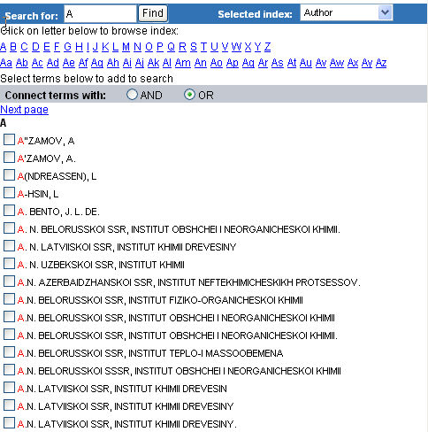

Patents Results Sorting
Ei Patents Sort Options
You can sort your search results by date, author or 'Cited by patents'
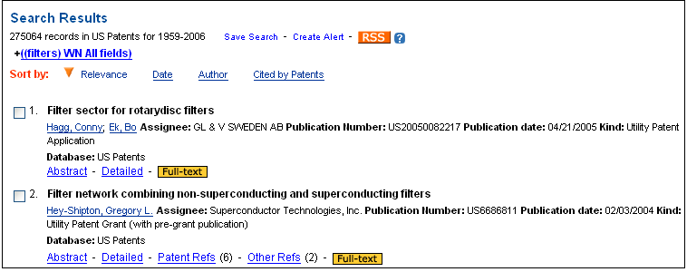

Clicking on 'Cited by patents' will arrange the results by the most cited patents to the least cited ones.
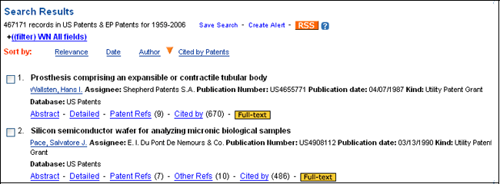

Proximity/Near Operator
Proximity/Near allows you to search for terms that are near or adjacent to each other within the text of the record.

Search for terms that are within 0-x terms of one another in any order:
laser NEAR/4 diode

Search for terms that are within 0-x terms of one another and searched in the order entered:
laser ONEAR/5 diode
Search for terms that are near and within the same index:
laser NEAR/4 diode wn AB
laser ONEAR/5 diode wn TI
Search for terms that are adjacent:
Space NEAR/0 stations

If no number of words if specified, four is assumed.
laser NEAR diode is the same as laser NEAR/4 diode

The near and onear commands do not work with truncation, wildcards, parenthesis, quotes or braces.

Proximity operators only work with Compendex, Inspec, NTIS and Referex. They do not work with CRC ENGnetBASE or USPTO.

Quick Search
Quick Search is designed for quick, straightforward searches. The interface allows you to select databases and search on a variety of fields from pull-down menus. Limits can be applied to restrict searches.
Enter search terms in one or more of the three Search For search boxes.

You may search in a specific field by selecting the field from the Search In pull-down menu to the right of the search box. See the help sections of the individual databases for a description of the search fields available.

When searching more than one database, the search fields showing in the drop-down menu are limited to the common fields of all databases selected.
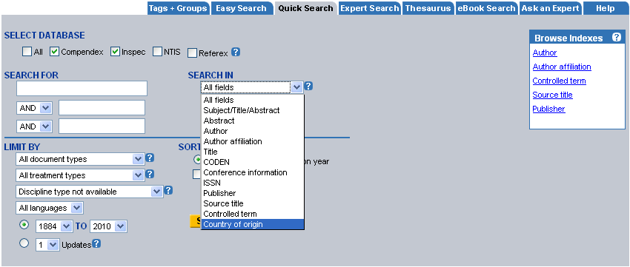

Record Attributes
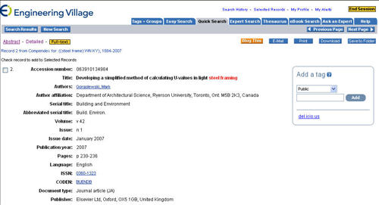
Search results from the bibliographic databases appear by default in the citation format, which provides enough information to identify the source publication. To view a record in its abstract or detailed format, click on the Abstract or Detailed Record hyperlinks beneath each individual citation.
To email, print, download or save one or more individual citations, abstracts or detailed records, mark it with a checkbox, choose a format and then pick an output option from within the Results Manager box. See Working with Selected Records for more information on outputting records.
When records are displayed in the Abstract format, Compendex, Inspec and NTIS controlled terms and author names are hyperlinked. By clicking on a controlled term, the system retrieves all records indexed with that term from the date range and database specified in your original search. By clicking on an author name, the system will retrieve all records with that author from the beginning of the database.
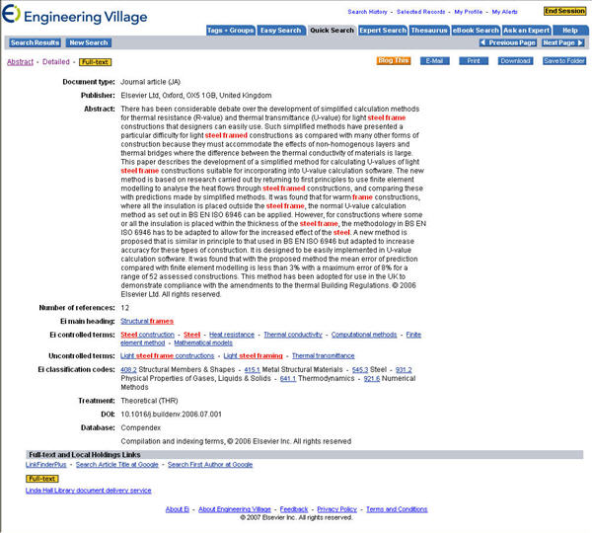
The Detailed Record format also includes hyperlinked classification codes, CODEN, ISSN, ISBN, Conference Code (Compendex), Materials Identity Number (Inspec) uncontrolled vocabulary terms, Contract number (NTIS), Project number (NTIS)and Monitoring agency (NTIS). Clicking on any of these retrieves records spanning the default time period of the database.
In the Citation, Abstract and Detailed Record formats, links to full text or local holdings may be provided by your library. The links can provide access to full text at the publisher site, direct you to the copy from within your library's local OPAC, or provide a document delivery or interlibrary loan form for ordering the found document.

Referex Keyword Cloud
The Referex Keyword Cloud feature displays which keywords appear in a particular book most frequently. The Keyword Cloud offers visualization of word frequency within the book. The size of each term is determined with corresponding weights. Font sizes are used to indicate frequency of use.
When a user clicks on the “Book Details” link of a particular result, the Keyword Cloud will appear next to the Table of Contents.
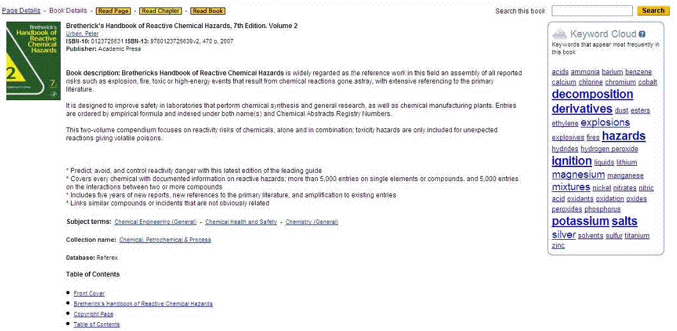
Hovering over a keyword with the mouse shows how many times the keyword appears in that book.
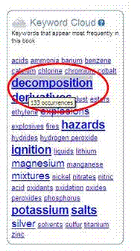
By clicking on the keyword, the user will see the pages on which the word is mentioned.

Referex Search Fields
The following fields are searchable in Referex:
- Keyword
- Author
- ISBN
- Title
- Publisher
- Subject
Keyword
Keyword is the default search field for Referex. Searching by keyword locates terms within the text of the eBook. Results are returned by relevance. The relevance sort is based on an algorithm that takes into account the following:
- Whether the words are found as an exact phrase or separately;
- When words are found separately, closer proximity ranks higher;
- The number of times that the word/phrase appears in the section of an eBook;
- The word's location within the section (words found at the beginning of the section rank higher than words found towards the end); and
- How often the word appears in the database as a whole (words used often are less relevant than words that are less common)
To search for an exact phrase, enclose term within braces or quotation marks:
Example: "solar energy"; {avalanche diodes}
Author
Referex cites author, editor or contributors' names as they appear in the eBook.
Surnames appear first, followed by a comma and the remainder of the name as it appears in the publication. Editors and contributors are also listed in the author field.
Author names can be truncated by using an asterisk (*) as the truncation symbol:
Example: carpenter, p*
When records appear, author names are hyperlinked. Click on an author hyperlink to retrieve additional eBooks by that author from the Referex database.
ISBN (International Standard Book Number)
ISBN are ten-character alphanumeric representations of book titles. The ISBN can be used to limit results to a specific book. You can find a book's ISBN at the citation and Book Description level of a record:
Example: 0884156516
Title
If you want to search for specific terms within the title of the eBook, search on the Title field:
Example: "air cushion craft"; {petrochemical plant}
Publisher
Search on the "Publisher" field to identify publishers, or find the eBooks published by a particular publisher.
Note: If you want to limit a search to a publisher name fragment (e.g. Elsevier instead of Elsevier Newnes or Elsevier Academic Press) enclose it in quotations or brackets:
Example: "elsevier"; {elsevier}
Subject
Referex contains controlled vocabulary, which is represented as a list of subject terms used to describe the content of an eBook in the most specific and consistent way possible. You can see them in the Browse eBooks section of the eBook search.
You can also search for controlled vocabulary by entering a term and selecting Subject from the "Search In" pull-down menu.
Subject terms appear hyperlinked in the Book Description format. By clicking on a subject term, this will retrieve additional records from within the collection(s) included in the original search.
Example: clicking on Aircraft design in a book description record retrieves more books on this subject.

Referex Search Overview
Referex is the name of the eBooks collection on Engineering Village. Referex can be searched in two ways:
1. Search Referex from the Easy Search, Quick Search or Expert Search tab. Selecting any one of these tabs allows you to combine your Referex search with other EV databases such as Compendex, Inspec, etc., Alternatively, you can limit the search to Referex by checking off only the Referex checkbox.
2. Search Referex from the “eBook” tab: This option restricts your search to only eBooks. In addition, it gives you the ability to limit your search by Referex collection and to browse collections.
The example below illustrates a combined search from the Quick Search tab.
First, select the database. In this case, two databases have been selected: Compendex and Referex. Then, enter terms in the Search For field. You can limit your search by selecting a specific field using the pull-down menu to the right of the search box. For a combined Compendex & Referex search the pull down menu will present Keyword, Author, Title, and, Publisher. The specific pull down choices are dynamic and change according to the databases selected.
Keyword, the default search field, searches the text of the book collection and journal articles and returns pages of the book combined with records from Compendex. Several key words can be combined using Boolean operators. Note: keyword searches can only be combined with other keyword searches. If one or more of the Search In boxes has keyword selected, author, ISBN, publisher, subject or title, cannot be searched. Non-keyword search terms can be combined.
eBook Search Tabs
Referex can also be searched using the eBook Search tab. Here you can select a specific collection or you could select all collections to search. Once the collection has been selected, you can then perform the search in the same manner as a Quick Search.
The example below illustrates the eBook Search screen.
Performing the search will generate a Search Results page, which lists all relevant book pages with full bibliographic information, including title, page number, chapter, author(s), ISBN, publisher and year published. Results can be sorted by relevance, author, source or publisher. You can further refine your results using the facets listed in the panel on the right of the screen (see Search Result section of Help File for more information).
From the Search Results page, you have the ability to view Page Details, Book Details or you could read the full text of the relevant page or chapter in PDF format.
Browse eBooks by Collection or Subject
To view a particular collection or subject, simply click its hyperlink under Browse Books by Collection or Subject. The search results will contain a complete list of titles by collection or subject, sorted by alphabetical order.
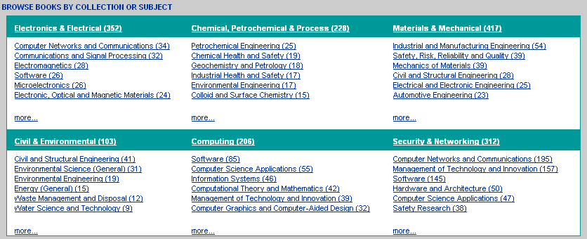

Refine Within Easy Search
Search Form
You can refine your search from the Search Results page. Easy Search provides a search box above the results set that allows searching within results, or allows you to start a new search by selecting all content from the drop-down menu.
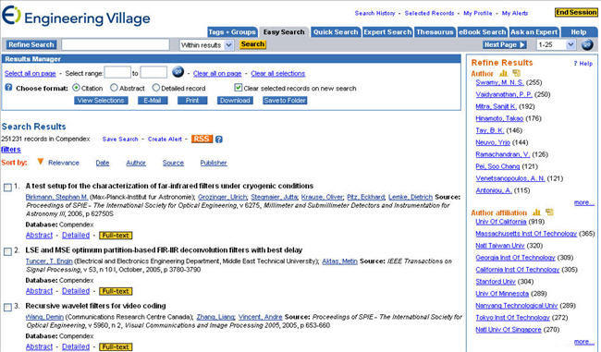

Refine by Results Facets
You can easily refine or narrow your results set by clicking on any of the supplied clusters of terms and other data elements (publication years, languages, etc.) derived from the records in your result set. These terms appear on the right hand side of the Search Results screen. Numbers in parentheses adjacent to each term indicate the number of records found for each within the search already created. Click More to expand each list up to 60 terms that will be displayed for each cluster.
Clicking on a term or other data element in Refine Results creates a search path, or "breadcrumb" above the search results list, and further limits your original search set, resulting in a smaller, more focused answer set. Terms that are added in this way are "AND"-ed together.
New "breadcrumb" terms will appear at the top of each new Search Results screen with a red "X" icon. To eliminate a breadcrumb term from a query, simply click its red X.
For example, a large answer set on diodes, with thousands of citations, can easily be reduced to a more manageable size by clicking on additional terms from the Refine Results list at right; click to add a publication year (2004), an additional controlled term (semiconductor lasers), etc.
If you click on a hyperlinked term in the "breadcrumb," all terms after it will be deleted from the "breadcrumb."
Note: Not every field has been used consistently over the years. For example, publisher name was not always given for journal articles, so a publisher may be under-represented in the clusters. Also, items in clusters may be represented in more than one format, for example, a publisher may be clustered as IEEE, Institute of Electrical and Electronic Engineers, Publ by IEEE, Publ by Institute of Electrical and Electronic Engineers, Publ by Inst of Electr and Electron Eng, etc.

Refine within Quick Search or Expert Search or Thesaurus Search
After performing an initial search, a list of facets will appear on the right side of the search results screen. These facets (categories) include: Databases, Author, Controlled vocabulary, Classification code, Document type, Language, Year, and Publisher. Under each facet, a list of the most recurring terms in that category will appear in descending order. For example, in the selected databases, under "Authors" a list of most published authors related to the search term will appear;
Example: A search for "High resolution wafer" will result in a list of terms under different categories with the number of record they hold in brackets.

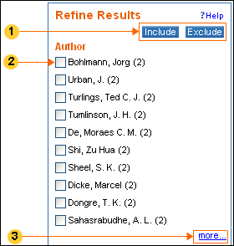
1: Include / Exclude: Terms in the facets can be included or excluded from your initial search.
2: The list of facets includes: Databases, Geographic Terms, Author, Author Affiliation, Country, Controlled vocabulary, Classification code, Document type, Language, year, and publisher.
3: Each facet displays the first 10 items that are relevant for your search. Click on more to find further information within each facet.
The result of including terms to the initial search will look as the example below
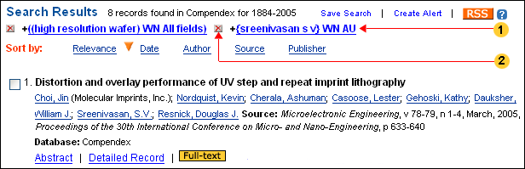

1: When you check one or more boxes under the Author facets and click 'include', the author/s that you selected will be added to your initial search terms, therefore refining the results set. This is similar to doing an AND search with these terms.
2: When using faceted search, every term receives an 'x' marked in red which can be removed to change your search strategy. As can be seen in the example above, the initial search resulted in 1627 hits, while limiting it to one author, resulted in 8 records only.
A number of search terms can be added to the same search, i.e. combining author, year and publication or any other combination which is most appropriate to the search.
When clicking on the 'x' mark next to the terms, the search removes these terms from your search query. In the example below, removing the term "high resolution wafer" actually expanded the search to include all of the author's publications, resulting in 58 records.
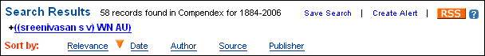
Author affiliation
This facet presents the most prominent institutions which published literature on the searched subject. Next to each name, in brackets, are the number of records associated with each institution.
"Add a Term" Option
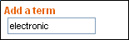

This option allows you to add your own terms for search refinement and can be combined with other terms in the faceted list.
In our example, adding the key word "electronic" to our search will result in further refinement of the search, yielding only 4 records with all the terms that were added.
If you are using command language in Expert search, you can use the 'Add Term' box to add or exclude terms within a certain field. For example, the phrase 'electronic WN ti' can be entered into this box and than included or excluded from the initial search.

Reset
When starting a new search within a search session, click the reset button to clear the previous search. Clicking on reset ensures that no traces of the old search remain to affect the results of the new search and resets all the options to the default settings.

RSS Feature
RSS stands for Really Simple Syndication or Rich Site Summary. It is an XML-based format for content syndication. RSS is a way of publishing and distributing content from one Web site to another. It's an easy way for you to keep updated automatically on web sources that you follow.
You need to have an RSS reader or aggregator to make use of RSS. RSS reader will display information feeds from your selected sites on your computer without visiting each Web site. You will automatically receive the most current information whenever these sources are updated. It will also allow you to share information with others in your research or study group.
With an RSS aggregator, you will be able to find technical information from Engineering Village, latest news from your library (if your library is providing an RSS feed), or latest technology news from the New York Times.
There are several types of RSS readers. Some are Web-based, such as My Yahoo, Bloglines or NewsGator, some are extensions of Web browsers such as Mozilla Firefox, and some are desktop readers like FeedDemon or Awasu. You can find a list of RSS readers and other information about RSS at the RSS Compendium.
Engineering Village provides RSS feeds of your search queries. Once you have executed a search, you can post the latest updated records that match your query to your RSS aggregator and share the results with others within your institution. Engineering Village RSS feed includes titles of the records and links back to Engineering Village for the detailed record. You need to be in an IP authenticated environment that has access to Engineering Village to view the detailed record. You won't be able to view the detailed record if you are accessing to Engineering Village through a proxy.
This feature will allow you to get automatic weekly updates of your search queries' results within your RSS readers.
To use the RSS feeds from Engineering Village, execute and refine your search until you have the search strategy that you wish to use as your feed.
When you click on the RSS feed button you will get a pop-up message that will look like the example below.
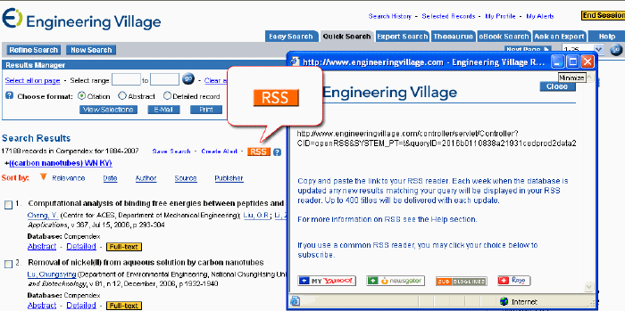
You can then copy and paste the link to your RSS reader. Each week when the database is updated, any new results matching your query will be delivered to your RSS reader. Up to 400 titles will be delivered with each update.

Scope Notes
The scope notes can be found by clicking on the orange "i" icon on the thesaurus record.
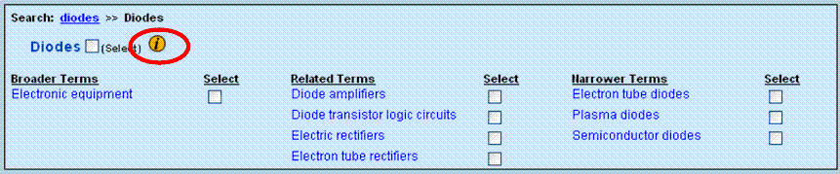
Scope notes are available in the thesaurus record for most controlled terms. The scope notes may include the dates that the term was in use (or introduced), plus related Classification Codes. Scope notes may also include usage notes.
For GeoRef, scope notes often include maps allowing term visualization.
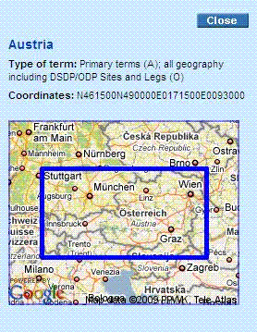

Search History Features
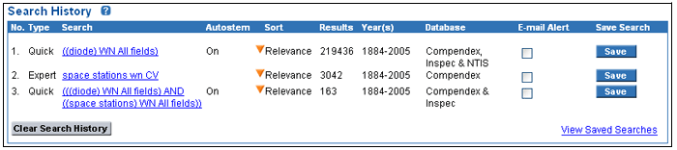
Overview
A Search History appears for each search done in Engineering Village. The Search History appears only after clicking the Search History link in the top middle of all pages. The Search History indicates the search number, whether the search was done in Easy, Quick, Expert or Thesaurus mode, the search strategy, whether autostemming was on or off, the sort chosen, the number of results, the database the search was done in and the years searched.
You can click on any search in the Search History to re-run the search.
From the Search History, you can choose to save the search or create an Email Alert from an individual search.

Combining Previous Searches
You can combine previously done searches from the Search History function. Click Search History from the top of all pages.
Use the box under the Combine Previous Searches heading to enter the item numbers of the searches you wish to combine. The item number must be preceded by a hash mark, #.
#1 and #2
You can combine the searches using Boolean AND, OR, NOT operators. When combining searches, use nesting parentheses to specify the order of processing.
(#1 or #2) and #3
You can also add additional search terms with item numbers:
#1 and diodes wn KY
(#1 and #2 ) and Elsevier wn PU
Only searches run in the same database, or combination of databases, are combinable. However, within the same database, or combination of databases, any combination of Easy, Quick, Expert or Thesaurus searches can be performed.

Saving Searches
To save a search strategy, select the query you want to keep from the Search History and click Save. The button will change to Saved. You can save up to 125 searches. Searches can also be saved by clicking the Save Search link near each search statement in Easy, Quick, Expert or Thesaurus Search
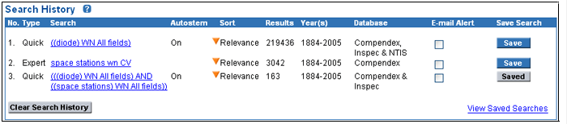
A Personal Account is required to save searches. If you are not already logged into your Personal Account, you will be prompted to do so. If you are not registered for a Personal Account, you will be prompted to register now (see instructions for registering for a [link] Personal Account).
To view saved searches, click on the My Profile link located on the top right on any Engineering Village page. In My Profile, click View/Update Saved Searches. You can delete individual Saved Searches by clicking the Remove button; or, you can delete all your Saved Searches by clicking on the Clear All button.

Create Email Alerts
Create up to 125 weekly Email Alerts from the Search History. A Personal Account is required to set up email alerts.
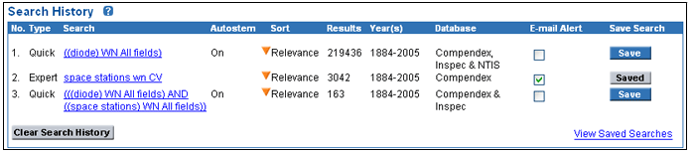

From the top of any Engineering Village page, click Search History. Select the box next to the search you wish to set up as an alert. If you are not already logged into your Personal Account, you will be prompted to do so. If you are not registered for a Personal Account, you will be asked if you want to register now. (See instructions for registering for a Personal Account).
You can also set up Email Alerts from the Saved Searches page if you are logged into your Personal Account.
Email alerts can also be setup by clicking the Create email link near each search statement in Easy, Quick, Expert or Thesaurus Search.
Up to 25 records are sent within an email alert. If more records were retrieved from the weekly update, a hyperlink appears in the body of the email alert linking you to Engineering Village. The full update retrieval set will appear when you click on the link. You can also link from email alerts to individual records by clicking an Abstract or Detailed Record hyperlink.

Search Overview
Engineering Village offers four ways to search the bibliographic databases: Easy Search, Quick Search, Expert Search, and Thesaurus. Referex Books are available from the eBook Search tab.

Search Results
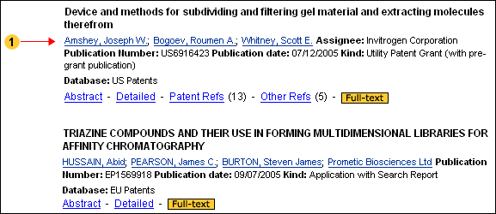
Records retrieved from a patents search have the inventor/s name hyperlinked from the search results screen. When clicking the name a new search will be performed on the inventor's name, retrieving only patents that were granted to that person, whether alone or in collaboration with others.
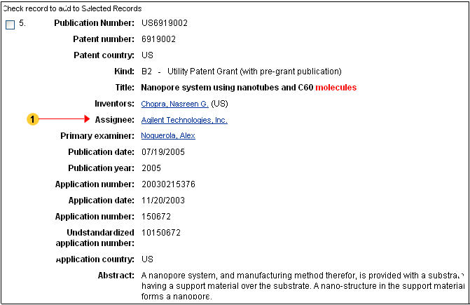
To perform a search on the assignee to discover other patents issued to it, click on the detailed record view. The assignee name is hyperlinked within this view.

Searching Fields and Limits Introduction
The available search fields in Engineering Village correspond to the database/s that you are searching.
When combining databases, fewer fields will be available, featuring the fields common to the databases that you are searching
For more information please see the following fields and limits by database:
Compendex and Engineering Index Backfile Search Fields
Engineering Index Backfile-Specific Fields
Ei Patents
Compendex and Engineering Index Backfile Search Limits
Inspec and Inspec Archive Search Fields
NTIS
GEOBASE Search Limits
GeoRef Search Fields and Limits
Combined Databases

Select Database
In Easy, Quick, and Expert Search (optional in Easy Search) use the Select Database list of check boxes to select a database (s) to search.
The database selections displayed are dependent upon the databases to which your institution has subscribed. Launch Referex Engineering eBook searches from the eBook Search tab.
Detailed information on specific databases can be found at Content Sources Introduction.

Select Thesaurus
Thesauri can be accessed by clicking on the Thesaurus tab at the top of any Engineering Village page. If you have access to more than one thesaurus, you need to choose the thesaurus you wish to search by clicking on the radio button beneath Select Database. Each database is indexed with its own thesaurus.
Terms chosen from the thesaurus automatically appear in a Search Box so that they can be included in a query.
If you switch from one thesaurus to another, the selections in the Search Box will be deleted. Some terms are common to both databases, but many controlled terms are unique to a database.

Selecting Terms
Controlled terms in the thesaurus are accompanied by a Select box. Checking the Select box posts the associated term in the Search Box.

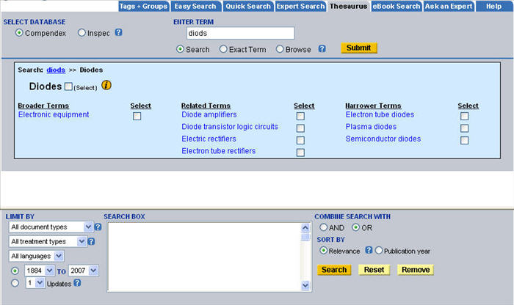
You can remove terms from the Search Box by de-selecting the Select box in the results set, highlighting the term in the Search Box and clicking on Remove, or resetting the Search Box.

Session Information
When you begin a session, Engineering Village will keep track of all your session's searches in the Search History. Furthermore, you can maintain a list of records that you select over the course of a session. When your current session ends, you will automatically lose your Search History and Selected Records unless you save them to a Personal Account.
(See instructions for registering for a Personal Account).
You can end your session by clicking on the End Session button at the top right corner of the screen. Otherwise, your session will expire after 20 continuous minutes of inactivity.

Software Requirements for Viewing Referex eBook Content
To read the full text of Referex pages, chapters or books, you will need to ensure that the following is installed and configured on your computer:
• Adobe Acrobat 5.0 or later (Reader or full version). Adobe 7.0 is recommended.
• Click here to see settings for the Adobe Acrobat Reader
If you need to install Adobe Acrobat, new versions and updates to previous versions can be downloaded from: http://www.adobe.com/products/acrobat/readstep2_allversions.html
Note: if this is not your personal computer, you may need a system administrator to install new software to this computer.

Sorting From the Search Form
Search results can be sorted by either relevance or publication year.

Relevance
The relevance sort is based on an algorithm that takes into account the following:
Whether the words are found as an exact phrase or separately
When words are found separately, closer proximity ranks higher
The number of times that the word/phrase appears in the record
The word's location within the record (words found at the beginning of the field rank higher than words found towards the end)
Whether the words are found within fields designated as particularly relevant, i.e., the title field
How often the word appears in the database as a whole (words used often are less relevant than words that are less common)

Publication Year
Records are sorted by year in descending order. The most recent years in your publication year search range are displayed first: 2010, 2009, 2008, 2007, 2006, etc.
See also Search Results, Sorting Results.

Sorting Results
Results can be sorted by relevance, date (publication year), author, source or publisher. Choose a sort option from the Sort by options at the top of the Search Results list. To change the sort order - i.e., date descending, with newest publications appearing first - click the hyperlink for the sort you wish to use. The arrow will change from pointing up to pointing down and the results will be re-sorted.
Relevance "direction" cannot be changed.
Records that do not contain author names or cited as Anon will be placed after records that contain author names if Author, ascending is used as the sort for the Author field.
Records that do not contain publisher information will be placed after records that contain publishers if Publisher, ascending is used as the sort.
Records sorted by date will be sorted first by year and then by an internal weekly load number.

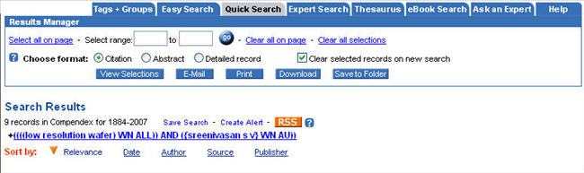

Special Characters
Most special characters, anything other than a-z, A-Z, 0-9, ?, *, #, ( ) or { }, are ignored by the search engine.
To include special characters within the search phrase, place the term within braces or quotation marks; they are ignored but the spacing will be maintained.
{M/G/I}
Operators (?, *, #, ( ) or { }) have meaning in Engineering Village search syntax and should not be entered as part of a search. For example to search for AU(III) enter the search as AU III, or search as "AU (III)" or {AU (III)} i.e., exact phrase match.

Stop Words
Stop words are words that have significance within Engineering Village's search engine, and therefore require special handling to search.
If you need to search for a phrase that contains stop words (and, or, not, near) place the phrase within braces or quotation marks.
{block and tackle}
"water craft parts and equipment"
{near earth objects}

Tagging a Record
From a record view you can assign one or more tags to a record
You can decide to make a tag publicly viewable, keep it private or limited its view to your institution. When you create a group, you will also have an option to share the tags you assigned with a group. See Creating Groups for more details.
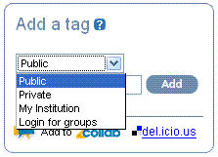
Tagging on Engineering Village can be shared and viewed by customers only. If you would like to make the tags available on public tagging services such as the 2collab or del.icio.us, click on the 2collab or del.icio.us link at the bottom the Tag this page/abstract box.
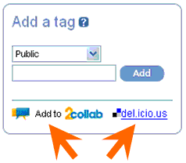
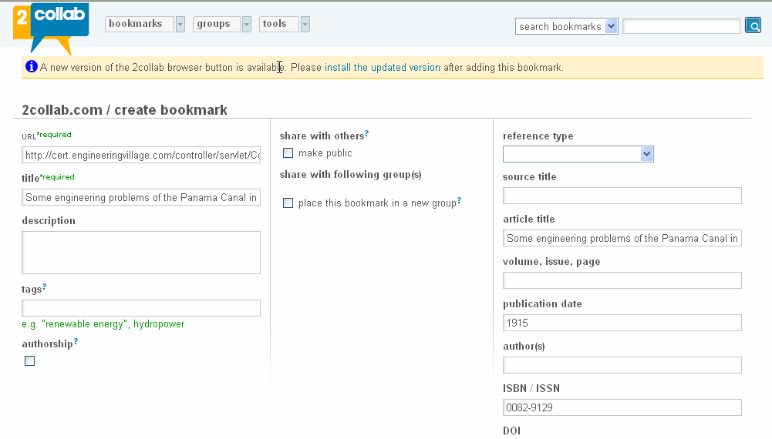
There are three main types of tags that can be assigned to records:
Public – these tags can be viewed by all Engineering Village customers.
My Institution – these tags can be viewed by all uses logged in from your institution.
Private – these tags will be viewed only by you.
Note: When groups are created, you can choose to assign tags to groups. In the example below a group titled "carbon nanotubes" was created.
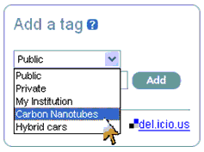
Select your own key words (tags) to be assigned to a record in the space provided and click “add”. Separate each term with a comma.
When you type a word, a drop down menu will open up containing terms from our free language vocabulary. You may choose to use one of these terms or assign your own term/s to the record. If you would like to tag a phrase such as carbon nanotubes do not use quotations, rather separate between the single terms and the phrase by either a space or a comma as shown below.
After adding tag/s the record view will show the following tag box
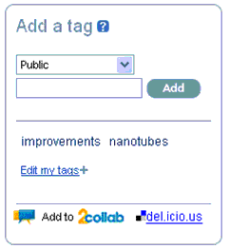
From here you can edit your tags by clicking the green - sign. When finished editing, click on ‘goEdit’ to save the changes you made

Introduction to Tags & Groups
Tagging is a user-defined taxonomy. Such taxonomy is sometimes called a folksonomy and the bookmarks are referred to as tags.
For more information about tagging, its benefits and usages please see: www.en.wikipedia.org/wiki/Folksonomy
With Engineering Village tagging you can add, edit ad share tags you assigned to records.
You can create groups by inviting people with the same research interest as you to join a group with which you can share tagged records and view records shared by the group.
See viewing tags + groups for more information
Note: Tagging records on Engineering Village requires having a personal account

Thesaurus Search
The thesauri are guides to the controlled vocabulary used in indexing articles for Compendex, Inspec, GEOBASE, ad GeoRef. Indexers choose terms from the controlled vocabulary to describe the article they are indexing. The controlled vocabulary is used to standardize the way the articles are indexed. The thesauri are hierarchical in nature. Terms are organized by broader, narrower or related concepts.
The GEOBASE database contains multiple types of controlled terms. General controlled terms are stored in the Controlled Term field, which is searchable with the CV search code. Regional controlled terms are stored in the Regional Term field, which is searchable with the RGI search code. (More information about all search codes is available on the Expert Search screen.)
Because the GEOBASE thesaurus contains both general controlled terms and regional controlled terms, thesaurus queries on this database will search both these fields. This search structured is slightly differently than the structure for Compendex, Inspec, and Georef queries which each search the Controlled Term field (CV) only.

Top Terms
Inspec thesaurus entries include a top term. Top terms are the highest or most general terms in the hierarchy.

Update Account Information
Once you login to your Personal Account, you can edit your account information by clicking on the My Profile link located on the top right on any Engineering Village page. In the My Profile page, click Edit/Remove Account. You can modify your name or email address, or change your password; you can delete your account as well.

USPTO Patent Search
USPTO provides access to a full text patent database, which currently contains over six million patents recorded at the U.S. Patent and Trademark Office. Records cover the period from 1790 to the most recent weekly issue date. Patents from 1790-1975 can be searched and retrieved by patent number or current US classification code only.
Further information about this database can be found at the USPTO Web site, at http://www.uspto.gov/.

Selecting fields to search
In Quick Search, you can specify the parts of the record to search by selecting one of the following options from the Search In pull-down menus beside each search box.

In Expert Search, the search fields are listed below the search box.
All fields
Title
Abstract
Issue date
Patent number
Application date
Application serial number
Application type
Assignee name
Assignee city
Assignee state
Assignee country
International classification
U.S. classification
Primary examiner
Assistant examiner
Inventor name
Inventor city
Inventor state
Inventor country
Government interest
Parent case info
Attorney/Agent
PCT information
Foreign priority
Reissue data
Related US Application data
US references
Foreign references
Other reference
Claim(s)
Description/Specification.

Complete information on the contents of all USPTO fields and how to search them can be found at http://www.uspto.gov/patft/help/helpflds.htm

Format for Names
Names should be entered as: last name first name initial, with no punctuation:
Yeh George
Clark George C

Date Formats
You can use several formats to search any of the date fields:
YYYYMMDD
For example, use 20020604 to retrieve June 4, 2002. Truncation can be used: 200206* will retrieve documents from June 2002.
Month-Day-Year
Month can be the number of the month, the full name of the month, or an abbreviation (i.e. 6, June or Jun). Day must be a number between 1 and 31. Year must be a four-digit year (2002).
Use 6-4-2002, Jun-4-2002 or June-4-2002 to retrieve documents from June 4, 2002.

Publication Year
Records cover the period from 1790 to the most recent weekly issue date. Patents from 1790-1975 can be searched and retrieved by patent number or current US classification code only. To limit a search by publication year, select the range of years from the pull-down menu. 1976-present is the default for USPTO on Engineering Village.
Variations of application numbers for US design patents
LexisNexis Univentio US application numbers and priority numbers are standardized in the format:
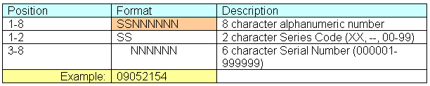

This is the official format of the United States Patent and Trademark Office, although they use it not very consistently. The Series Code is necessary to make the Numbers unique. The United States Patent and Trademark Office search engine for example returns for APN/123456 four different publications. Therefore LexisNexis Univentio uses the whole application and priority numbers.
Below is the official information on the series codes that the USPTO uses:
Table 1
Concordance table for applications and grants.
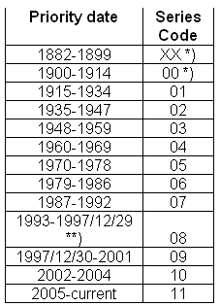
*) Defined by LexisNexis Univentio, to create uniform Numbers
**) except publication number US6987583, which should get Series Code 09.

Table 2
Concordance table for first provisional applications.
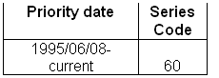

Table 3
Concordance table for design applications.
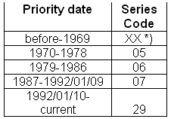

*) Defined by LexisNexis Univentio, to create uniform Numbers

View the Patents Records
Abstract view - this option will show the patent abstract
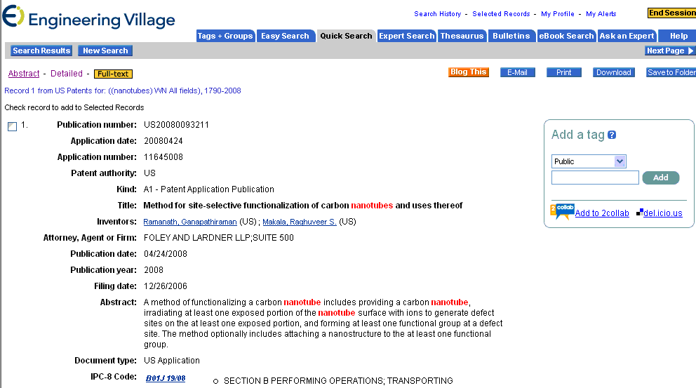

From this window you can navigate through different views by clicking any of the hyperlinked options at the top of the page i.e. detailed, patent references, non patent references, cited by or full text.

Other features:
The key words searched are highlighted in red.
The initial search string is showing at the top of the record.
Detailed view
The detailed view of the patents shows the bibliographic information associated to the patent. This includes:

Publication Number - patent number with the appropriate patent authority ( i.e. US or EU).
Patent number - Patent number excluding the country code.
Patent country - in which country was the patent issued
Kind - These codes indicate the version or the level of examination of a patent. Kind codes are issued by different patents authorities and are country specific. The bibliographic information provides you with the kind code and its description (i.e. A- Utility Patent Grant).Full list of Kind codes by country
Title - Patent title is presented with the key words highlighted in red when applicable.
Inventor/s - presents the name of the person/s who invented the patent. All the names are hyperlinked. In order to perform a search on an author, you can click the name.
Assignee - the person or entity to which the patent was issued is hyperlinked within the record. To perform search on the assignee to discover other patents issued by it, click on the name that appears in the detailed record.
Primary Examiner - a patent office official who is appointed to determine the patentability of applications.
Attorney, Agent or Firm - (may be referred to as a practitioner or representative) - an individual who is a member in good standing of the bar of any United States court or the highest court of any State and who is registered to practice before the Office. An agent (may be referred to as a practitioner or representative) - one who is not an attorney but is authorized to act for or in place of the applicant(s) before the Office, that is, an individual who is registered to practice before the Office.
Publication date - a patent publication date
Publication year - a patent publication year
Application Number - The unique number assigned to a patent application when it is filed. The application number includes a two digit series code and a six digit serial number
Unstandardized Application Number - Application serial number
Abstract - an abstract as it appears on the patent's cover sheet
Field of search - what technological field/s were searched by the examiner when checking application patentability.
Document type - states whether the patent is an US or EU application or grant
International Patent Classification - The International Patent Classification (IPC) is a hierarchical system in which the whole area of technology is divided into a range of sections, classes, subclasses and groups. This system is indispensable for the retrieval of patent documents in the search for establishing the novelty of an invention or determining the state of the art in a particular area of technology. For more information see http://www.wipo.int/classifications/fulltext/new_ipc/
US patent classification - patents are classified (organized) in the U.S. by a system using a 3 digit class and a 3 digit subclass to describe every similar grouping of patent art. A single invention may be described by multiple classification codes. To find out more about classification numbers see the Manual of Patents Classification at: http://www.uspto.gov/web/patents/classification/
ECLA Codes - European classification codes. For more information see http://v3.espacenet.com/eclasrch
Database: from which patent database was the patent retrieved.
Other features: The key words searched are highlighted in red.
The initial search string is showing at the top of the record.

Patent References
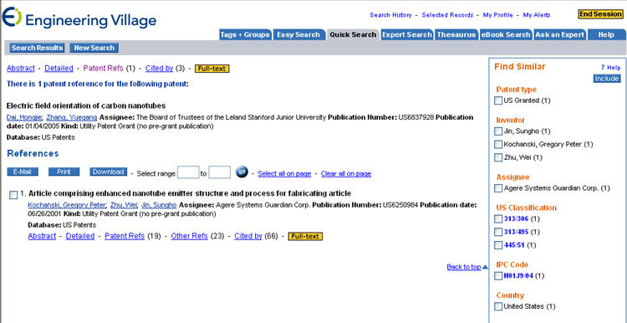
In the patent references view you can see all the patents that are being cited in the patent. (i.e., There are nine patents references for the following patent)
These references are considered a part of the 'prior art' that the inventor must refer to when applying for a patent grant.
Prior art is a broad term that describes all information that has been disclosed to the public in any form before a given date. However, under United States patent law, secret prior art, such as secret sales, qualifies as prior art in certain circumstances. In Europe, prior art does not include information kept secret, whether from trade secrecy or just a simple lack of interest in publication.
A list of all the referenced patents is shown.
The records will be automatically selected.
The records can be emailed, printed or downloaded.
Other References
There are cases in which a patent will cite literature that is not patent such as conferences proceedings or articles. These references are listed in the 'Other References' list
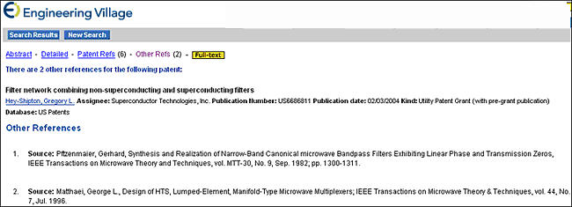

Cited by Patents (when available)
If a patent is cited by other patents, a list of all the citing patents will appear in t he 'cited by' list. Each patent can be viewed by clicking on 'abstract' or 'detailed' view. An additional view of the patent references is also available. When clicking on "Cited by Patents" the facets will change according to the new patent set showing information related to the citing patents
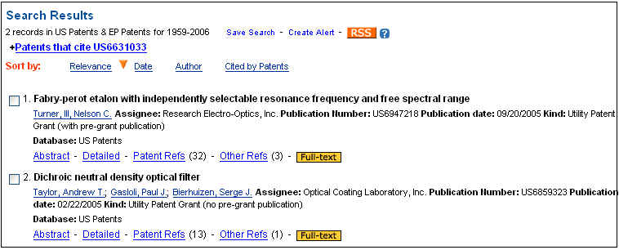

Viewing Tags and Groups
You can view tags from the Tags + Groups tab.
When clicking on this tab the following window appears:
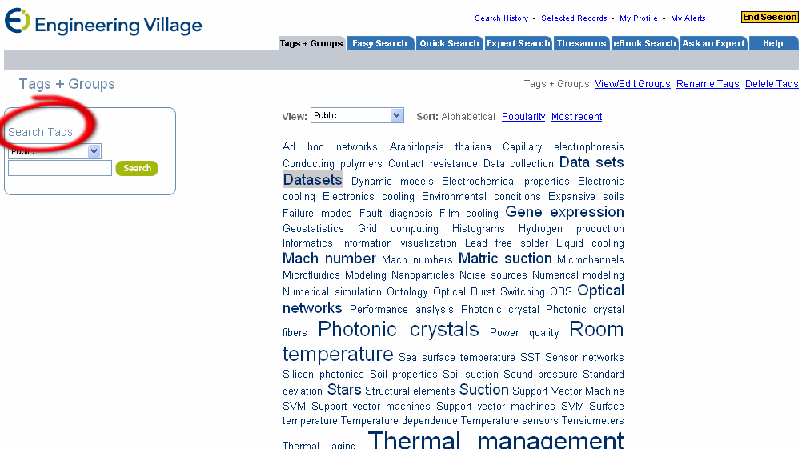
Search Tags: you can limit your search to search tags in the public, private or “My institution” repositories. For example, selecting public will perform the search on all publicly made tags.
Type the key word / tag you are looking for. A drop down menu will show up with tags containing the letters that you are typing. You can select a tag from the list or continue to type the term/s that you are looking for.
The tag cloud in the center of the page maps the existing tags in the public, private or “my institution” depositories. Large and bold words indicate the existence of a large number of records tagged with them.
You can click any of the terms and review the records tagged with them.
Rename Tags: use rename tags to edit the tags you assigned.
Delete Tags: use delete tags to remove tags you assigned
View/Edit groups: use view/edit groups to create new group, add or remove email address from groups you created or review groups you created.

Viewing your Referex Results
There are four options for viewing specific citations in your search results:
1. Page Details
2. Book Details
3. Read Page
4. Read Chapter
Page Details
Page details displays bibliographic information on the citation as well as a brief excerpt from the text with search terms highlighted. Hyperlinked elements facilitate easy navigation to other key information including authors, ISBN, Keywords, Subject Terms and Referex Collection. From the Page details screen you can navigate to Book Details, Read Page, Read Chapter, or Read Book.
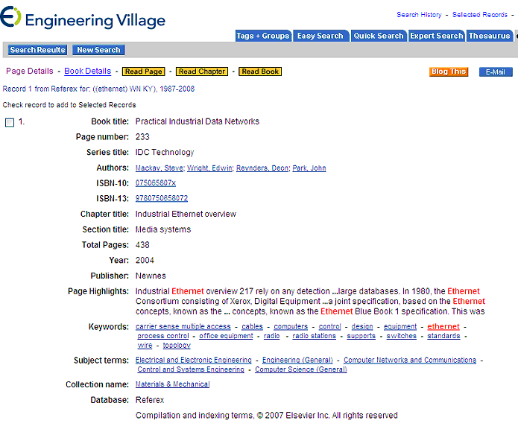

Book Details
The Book Details view displays abbreviated bibliographic information on the title as well as an informative and detailed synopsis of the book contents. There is also a full table of contents for the book which is hyperlinked to book chapters. Clicking on any item in the table of contents brings up the full text of the relevant chapter. Hyperlinked elements within the Book Detail screen enable further flexible navigation and include author name, subject terms and collection. From the Book details page you can navigate to Page Details, Read Page, Read Chapter, or Read Book.
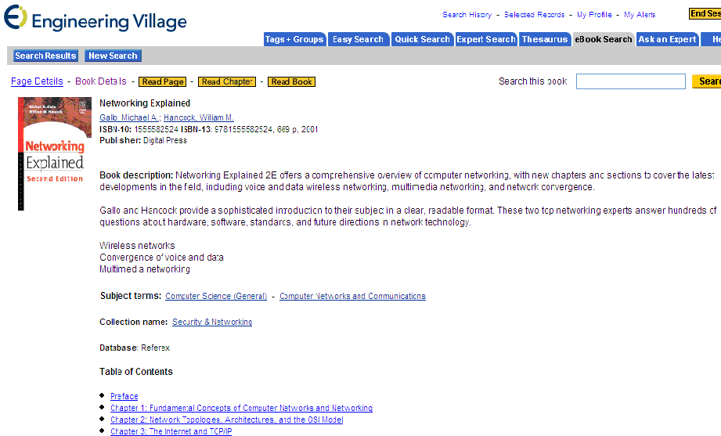
Read Page
Read page displays an enhanced PDF version of the page with multiple options for navigating through the rest of the chapter or book. Search terms are highlighted within the page; alternatively, highlighting can be turned off by clicking on the pen icon in the top of the display.
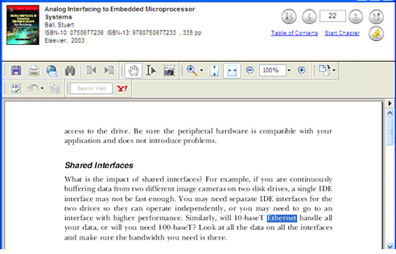

Read Chapter
Read Chapter opens an enhanced PDF file in a new window. It displays the full text of the chapter in which the citation occurs. You can read the chapter by scrolling through the text or you can print out the full chapter. Search term highlighting is not used on Read Chapter.
Read Book
The Read Book viewing option is accessible via the Page Details and Book Details views. It is not accessible from the Search Results page. Read Book will open a PDF file in a new window. You can scroll through the book using the Bookmarks on the left.
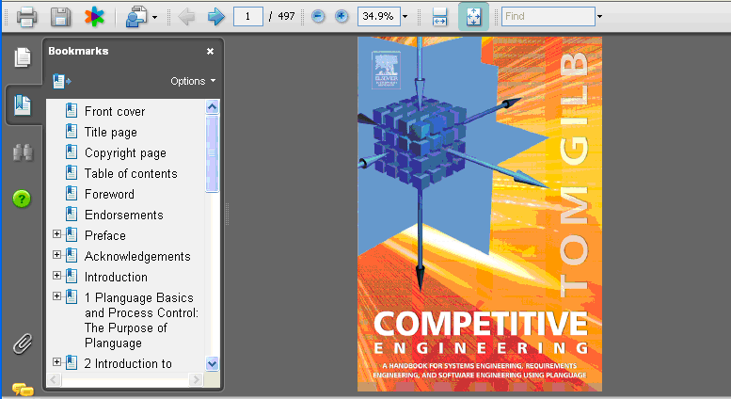

Wildcards and Truncation
Wildcard (?)
A wildcard will replace a single character.
wom?n finds woman, women
t??th finds tooth, teeth, truth, tenth

Multi-Character Wildcard (*)
A multi-character wildcard can be used to replaces 0-x number of characters anywhere in a word.
h*emoglobin finds hemoglobin, haemoglobin, hemidemiphosphorylmontotremoglobin

Truncation (*)
The truncation command retrieves all the words that start with the same letters as the truncated term, up to the point that the truncation symbol is used.
Comput* will return computers, computing, computerize etc.

Left Truncation (*)
The left truncation command retrieves all terms ending with the same letters as the truncated term.
Example: *sorption returns adsorption, absorption, resorption
To avoid unexpected results, truncation should be used with care.
color* retrieves color, colored, colors, Colorado.
Truncation and wild cards cannot be used within quotation marks or braces or used with the near or onear command.
Using truncation or wildcards will turn off the stemming feature.

Glossary
C
Chemical Business NewsBase (CBNB): The leading provider of worldwide chemical business news and information, CBNB covers over 300 core trade journals, newspapers and company newsletters, market research reports, annual and interim company reports, press releases and other “grey literature” sources. See the topic CBNB for more information.
Chimica: Chimica provides access to over 600 of the most influential international journals related to chemistry and chemical engineering. Chimica provides exceptional focuson applied and analytical chemistry. See the topic Chimica for more information.
Compendex: A bibliographic database of engineering research containing over nine million references and abstracts taken from over 5,000 engineering journals, conferences and technical reports.
E
Ei Patents: The patents databases on Engineering Village include US and European patents grants and applications. Ei Patents offers sophisticated search and retrieval tools across all 9.5 million patents registered with the US and European Patent Offices. US and European patent sources can be searched together or individually using Ei Patents on Engineering Village. See the topic Ei Patents for more information.
EnCompass Bulletins: In addition to EnCompassLIT and EnCompassPAT, EnCompass Bulletins are also available. Sent weekly via email, subscribers can choose particular areas of interest for updates on additions to the database. This is a great way to keep up-to-date on trends. See the topic EnCompass Bulletins for more information.
EnCompassLIT: EnCompassLIT™ is a bibliographic database specifically devoted to covering technical literature published worldwide on the downstream petroleum, petrochemical, natural gas, energy and allied industries. See the topic EnCompassLIT for more information.
EnCompassPAT: EnCompassPAT is the most authoritative patent database uniquely devoted to covering worldwide patents on the downstream petroleum, petrochemical, natural gas, energyand allied industries. For more information see the topic EnCompassPAT.
Engineering Index Backfile: The Engineering Index (Ei) Backfile comprises 1.7 million records from the printedEngineering Index from 1884-1969. Users with access to the Ei Backfile can performseamless searches of Engineering Index (Compendex) data from 1884 to the present.
esp@cenet: esp@cenet provides access to patents produced by national patent offices in Europe as well as the European Patent Office (EPO), the World Intellectual Property Organization (WIPO), and Japan. See Additional Search Sources for more information.
G
GEOBASE: GEOBASE is a multidisciplinary database of bibliographic information and abstracts that deeply indexes research literature across the earth sciences including geology, human and physical geography, environmental sciences,oceanography, and geomechanics. For more information see the topic GEOBASE.
GeoRef: GeoRef is a database of abstracted and indexed geosciences literature published by the American Geological Institute (AGI). GeoRef provides a comprehensive history of geology and its subfields with expertly indexed records from over 3,500 scholarly journals, books, maps, and conference proceedings. For more information see the topic GeoRef.
GlobalSpec: GlobalSpec is a leading business-to-business Web site, http://www.globalspec.com, that connects engineers and technical buyers with products and services they need. See Additional Search Sources for more information.
I
IHS Standards: IHS Global allows you to search the world's largest collection of technical standards from over 460 standard developing organizations. Over 500,000 standards are available for electronic download. See Additional Search Sources for additional information.
Inspec: Inspec is a leading bibliographic database providing access to the world's scientific literature in electrical engineering, electronics, physics, control engineering, information technology, communications, computers, computing, and manufacturing and production engineering. For more information see the topic Inspec.
Inspec Archive: The Inspec Archive provides access to historical scientific records in the fields of physics, electrical engineering, electronics computing and control engineering. With the digitizing of the entire collection of Science Abstracts Journals, which were the precursors to the Inspec database, librarians, academics, and students are provided access to over 873,000 abstract records spanning the years 1898 through 1968.
Intute: Science, Engineering and Technology offers a free, easy to use and powerful tool for discovering the best Internet resources for teaching, learning and research, covering the physical sciences, engineering, computing, geography, mathematics and environmental science. See Additional Search Sources for additional information.
L
LexisNexis News: LexisNexis provides press releases related to engineering. The site is updated daily. You can search for a single word or phrase, or use the connectors AND or OR to join search words and identify the relationship between them. Titles are hyperlinked. See Additional Search Sources for more information.
N
NTIS: The National Technical Information Service (NTIS) database from the U.S. Department of Commerce is the premier source for accessing unclassified reports from influential U.S. and international government agencies. The database contains access to over two million critical citations from government departments. For more information see the topic NTIS.
P
PaperChem: PaperChem is a comprehensive bibliographic database covering international literature related to pulp and paper technology. It includes abstracts of journal articles, conference papers, and technical reports with more than 590,000 records. For more information see the topic PaperChem.
R
Referex (eBooks): A specialized electronic reference database, Referex Engineering draws on hundreds of premium engineering books to serve as a pool of answers to your reference questions. Referex Engineering has six editorially crafted collections of professionally focused e-books which bring together key sources of reference material. For more information see the topic Referex (eBooks).
S
Scirus: Scirus is the most comprehensive science-specific search engine available on the Internet. Driven by the latest search engine technology, it enables scientists, students, and anyone searching for scientific information to pinpoint data, locate university sites, and find reports and articles quickly and easily. See Additional Search Sources for more information.
U
USPTO Patents: The United States Patent and Trademark Office (USPTO) offers access to its full-text patent database. Full-text patents are available from 1790 to date, with weekly updates. See Additional Search Sources for further information.

Index

A
Absorption 57
Abstract 16, 57, 149, 217
Account Registration 25
Advanced Technologies 57, 149
AIP 57, 149
AIP Press 57, 149
Applications 111
ASCII 169
Ask 27
Author 31, 57, 149
except 31
Author Affiliation 57, 149
Author Affiliation Browse Index 149
use 149
Author Browse Index 37, 57, 149
Use 57, 149
Autostemming 31, 217
B
BibTex 169
Blog 33
Book
Book Description 199
Boolean operator 43
Boolean Operators 35
Browse
Browse eBooks 199
Browse Indexes 37, 57, 147
C
Case Sensitivity 41
Chemical 22, 149
Chemical Abstracts Service Source Index 57, 149
Chemical Indexing 149
Chemistry Preprint Server 9
Chimica Search Fields 47
Chinese 69
Cited 51, 189
Cited by 51
Classification 149
Classification Codes 57, 149
Clear All button 217
Clicking 35, 169, 217, 233
Abstract 217
Clear All button 217
Create 217
End Session button 233
GO button 169
My Profile 169
Remove button 217
Save Search 217
Search History 35, 217
CODEN 57, 149
Codes 119
CogPrints 9
Coll 57
Combining 217
Combine Previous Searches 35, 217
Previous Searches 217
Compendex 57, 69, 85, 111, 147, 169
Conference Code 57
Conference Information 57, 149
Contains 149
Outline 149
Controlled Term 57, 149
Country 171
CRC ENGnetBASE 9, 75
CRC 75
CRC Press 9, 75
CRC Press ENGnetBASE site 75
subscribe 75
Create E-mail Alerts 217
CrossRef 133
CV 57
D
Database 147
Date 111
Filing 111
Default 149, 199
Inspec 149
Referex 199
Detailed Record 217
Discipline 149
Document 57, 149
Document Type 69, 149
Document Type Browse Index 69
DOI 133
Download Selected Records 169
E
Easy Search 85, 205, 227
EBook 22, 23, 199
EBook Search 87, 227
EBooks 22, 199
find 199
title 199
EEVL 9
Ei Patents 85
Ei Patents Full-text Access 133
Ei Patents Indexes 37
Ei Patents Sort Options 189
Ei Thesaurus 57
Ei's Controlled Vocabulary 57
part 57
Elsevier 9, 199
Elsevier Academic Press 199
Elsevier Newnes 199
Elsevier wn PN 57
Elsevier wn PU 217
E-mail Alert 23, 217
create 217
EnCompassLIT Search Fields 97
EnCompassPAT Search Fields 105
End Session button 233
EndNote 169
Engineer 27
Engineering 57
Engineering Index 57, 69, 85, 111
Engineering Index Backfile 57, 69, 85, 111
Engineering Index Backfile Search Fields 57
Engineering Index Backfile Search Limits 69
Engineering Index Backfile-specific fields 111
Engineering Village 25, 41, 57, 217, 233
ENGnetBASE 9, 75
ENGnetBASE Web 75
Esp@cenet 9
Europe 9
European 9, 37
European Patent Office 9
Expert 23, 27, 119, 217, 227
Expert Search 35, 37, 57, 69, 111, 119, 149
Expert Search Fields 119
F
Fields 119
Filing 57, 111
Date 111
Frequency 57
Full-text
Full Text 133
Full-text Links 133
G
General Review 69
Geobase 16, 171
Geobase Search Limits 137
Geobase Special Index Fields 137
Geographic 171
Geographic Terms 171
GeoRef 139, 171
GlobalSpec 9
GlobalSpec website 9
Guru 27
I
IHS Global 9
IHS Standards 9
Include / Exclude
Including 149
ISSN 149
Indexes 147
Inspec 18, 19, 85, 147, 149, 169
default 149
Inspec Archieve 19
Inspec Archive 19, 85
Inspec Archive Fields 149
Inspec Archive Search Fields 149
Inspec Archive Search Limits 149
Inspec Classification 149
Inspec Controlled Term Browse Index 149
Inspec Thesaurus 149
Inspec's List 149
Journals 2004 149
part 149
Inventor - This 37
ISBN 57, 149, 199
ISSN 57, 149
including 149
incorporating 57
J
Jones 149
L
Language Browse Index 69, 149
LexisNexis 9
Librarian 27
Limits 47, 97, 105, 139
M
Main Heading 57
Management Aspects 69
Map 171
Mapping 171
Mapping Tool 171
Monograph 57, 149
My Profile 169, 217
clicking 169
N
Non-English 16, 57
Corresponding 57
NTIS 20, 85, 169
Number
Numeric 149
Numerical - Used 69
Numerical Data Indexing 149
O
Outline 149
contains 149
Output Format 169
Selecting 169
P
Patent 57, 69
Patent Assignee 37
Patent Issue Date 111
Patentable 149
Patents Results Sorting 189
type 69
PDF 75, 133
Personal Account 23, 25, 169, 217, 233
Personal Account Login 23
Personal Folders 169
registering 169, 217, 233
plot 171
Previous Searches 217
Combining 217
Print icon 169
Print Selected Records 169
Process 22
ProCite 169
Product Specialist 27
Production Engineering 149
Publication 69
Publisher 57, 149, 199
Publisher Browse Index 57, 149
refer 57, 149
Q
Quick Search 35, 37, 69, 149
R
RDN 9
Records 169
Selecting 169
Records Saved 169
Reed Business Information 9
ReedLink 9
Reference Manager 169
Referex eBooks
Referex 22, 199
default 199
Referex Engineering 22
Referex Engineering eBook 87, 227
Referex Search Fields 199
Refining
Refine Results 205
Refine Results list 205
Refine Within Easy Search 205
RefWorks 169
Register 25, 169, 217, 233
Personal Account 169, 217, 233
Register Now 23
Reliability 57
Remove button 217
clicking 217
Representations 57, 149, 199
Results Facets 205
Reviews/technical 69
S
Save 169, 217
change 217
Folder 169
Save Selected Records 169
Searches 217
Save Search 217
clicking 217
Science Abstracts Journals 19
ScienceDirect 9
Science-related Web 9
Scirus 9
Scopus 51
Search 47, 57, 97, 105, 139, 149, 217
Abstract 57, 149
All Fields 57, 149
Saving 217
Subject/Title/Abstract 57, 149
Search Form 205
Search History 35, 217, 233
clicking 35, 217
Search History Features 217
SEARCH IN 37, 199
Search Results 205
Select Database 227
Select Database list 227
Selected Records 169, 233
Selecting 169, 199
Output Format 169
Records 169
Subject 199
Use 227
Serial 57, 149
Serial Title 57, 149
Serial Title Browse Index 57, 149
use 57, 149
Session Information 233
Subject 199
selecting 199
Subject/Title/Abstract 57, 149
Searching 57, 149
Subscribe 75
CRC ENGnetBASE 75
T
Technology 9, 57, 149
Thesaurus 217
Thesaurus Search 23, 217
Title 57, 149, 199
eBook 199
Trademark Office 9
Translated Title 57
Translation Serial 149
Treatment 57, 149
Treatment Type 69, 149
Treatment Type Browse Index 69, 149
U
U.S. 20
UK 9
Uncontrolled 57, 149
Uncontrolled Term 57, 149
United States Patents 9
USPTO 9
US Patent Office 9
USPTO Patents 9
USPTO Web site 9
V
View
View Selected Records 169
View/Update My Folders 169
View/Update Saved Searches 217
Volume 57
W
Web 33
WIPO 9
WN 37
Wn AB 57, 149
Wn AI 149
Wn ALL 35
Wn AN 57, 149
Wn BN 57, 149
Wn CC 57
Wn CF 57
Wn CI 149
Wn CL 57
Wn CV 57
Wn dt 69
Wn FL 57, 149
Wn KY 35, 217
Wn ky NOT 35
Wn MI 149
Wn NI 149
Wn PA 111
Wn PE 111
Wn PI 111
Wn PN 57, 111
Wn PU 111
Wn SN 57
Wn ST 57
Wn TI 35, 57
Word/phrase 199
World Intellectual Property Organization 9
Worldwide Web 9

